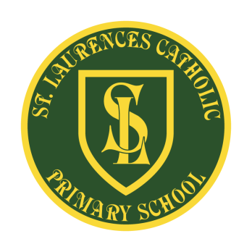
St Laurence’s Catholic Primary School
Leeside Avenue
Southdene
Kirkby
L32 9QX
Telephone: 0151 546 4733
Headteacher: Miss SJ Carroll
FREE SCHOOL MEALS
Dear Parent/Guardian,

Free School Meals are different to Universal Free School Meals which are provided automatically to all children in Reception, Year 1 and Year 2. Free School Meals are allocated according to family income and therefore available to any child, in any year group, that qualifies, regardless of their age. For every child registered for Free School Meals then St Laurence’s gets £1320 per year.

With this money we could provide extra resources towards helping our children and our staff. If you are able to help us, then it is important to register to make sure your child and others in their class don’t miss out. You can register if you get any of these benefits:
Income Support, Income Based Job Seekers Allowance, Income related Employment and Support Allowance, Support under Part VI of the Immigration and Asylum Act 1999, the guaranteed element of Pension Credit, Child Tax Credit (provided you are not entitled to working tax credit and hand an annual gross income of no more than £16,190, Working Tax Credit run-on paid for 4 weeks after you stop qualifying for working tax credit), Universal Credit – if you apply on or after 1 April 2018 your household income must be less than £7,400 a year (after tax and not including any benefits you get.

How does it work?
- First, check if you qualify – it is not just if you are unemployed.
- Registering is really quick and easy – if you think you qualify you can log on and register at www.knowsley.gov.uk and select school meals.
- If you want your child to have a free, healthy meal at lunchtime that’s great – they will get the free meal (saving you more than £350 a year), extra benefits and the school gets £1320 extra.
- If you don’t want your child to have our school meal they can continue as normal – as long as you qualify and are registered, our school still gets £1320 extra.

It is really important that if you are unsure whether or not you are entitled to Free School Meals then please go onto the website and check. It only takes a couple of minutes. No one will know you have registered and it will not affect any other benefits you are claiming. Please help our school and register your child today.

Yours sincerely

Miss S J Carroll
Headteacher

