St Laurence’s Catholic Primary School
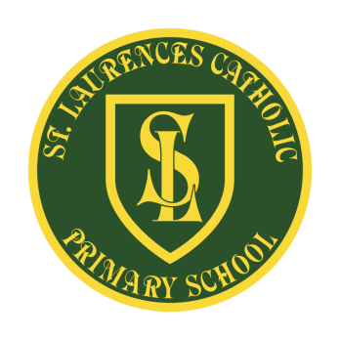
E Mail: stlaurence@knowsley.gov.uk
Website: www.stlaurences.co.uk
Twitter: @slaurences
Leeside Avenue
Southdene
Kirkby
L32 9QX
Telephone: 0151 546 4733
Headteacher: Mrs SJ Carroll-McKevitt
Date: 17th November 2022
Dear Parent/Guardian,

Christmas is quickly approaching. Below is a list of events and dates of things happening within school over the festive period.

Any support you can offer, no matter how small, would be greatly appreciated.

Best wishes
Mrs Carroll-McKevitt and all of the St Laurence’s Team

Friday 25th November – Christmas Friday - Key Stage One children. Gifts/Gift sets to help build up our Christmas Raffle Prizes (Non Uniform Day)

Friday 2nd December - Christmas Friday - Key Stage Two children. Bottle to help build up our Christmas Raffle Prizes (Non Uniform Day)

Thursday 8th December – 10.45am EYFS AM Performance, 2.15pm EYFS PM Performance

Friday 9th December – Christmas Jumper Day, Santa Dash Day,
One class will visit Heaven Sent

Tuesday 13th December – 9.30am KS1 Christmas Performance (TICKET ONLY)
2.00pm KS1 Christmas Performance (TICKET ONLY), 5pm Christmas Bingo

Wednesday 14th December – Reception and KS1 Christmas Dinner

Thursday 15th December – 9.30am KS2 Carols (TICKET ONLY)
2.00pm KS2 Carols (TICKET ONLY)
Friday 16th December – KS2 Christmas Dinner, 2.15pm Year One Christmas Arts and Craft

Monday 19th December – Own clothes Day (FREE), 9.30am Christmas Mass, Christmas Film Afternoon, 2.15pm Reception Arts and Crafts

Tuesday 20th December – Christmas Party Day (Own Clothes)

Wednesday 21st December – Non Uniform Day (£1.00) School finishes at 2.00pm

This Photo by Unknown Author is licensed under CC BY

