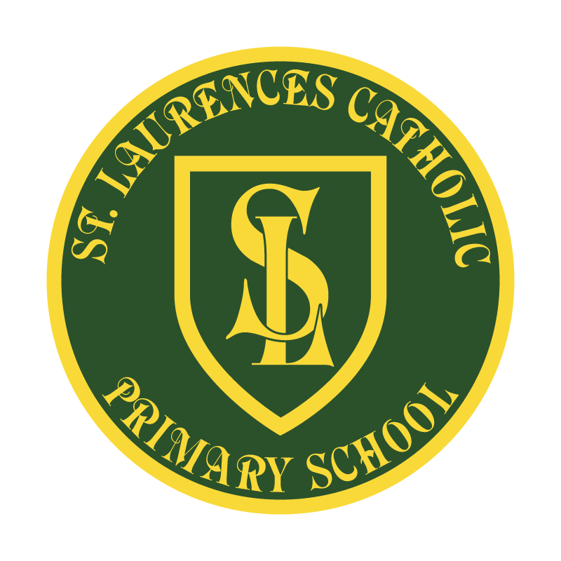

St Laurence’s Catholic Primary School
Policy Statement
For
Art and Design

This policy was adopted on | July 2022
By name | Mr John Holmes
Position | Chair of Governors
Signature | J Holmes

Our Mission Statement
We aim to celebrate our partnership with the families we serve and the community we live in.
We aim to provide an education that enables each child to reach their full potential.
Our aim is the creation of an atmosphere where all are valued, gifts and talents are celebrated and the gospel values of love, respect and justice are at the heart of all we do.

Our Vision
Everyone feels a sense of belonging,
Has the opportunity to shine,
To enjoy their teaching and learning
But most of all – to dream big!

ART AND DESIGN POLICY

Introduction: This policy outlines the learning, teaching, organisation and management of Art and Design at St Laurence’s. The implementation of this policy is the responsibility of all teaching staff.

The importance of Art and Design
Art and Design stimulates creativity and imagination through visual, tactile and sensory experiences. It provides a unique way of freely expressing and responding to the world in ways they could not access in other areas of the curriculum. It enables pupils to communicate what they see, feel and think, using colour, form texture pattern and different materials and processes. Pupils learn to make aesthetic judgements and to become involved in shaping environments.

“Art and Design is not just a subject to learn, but an activity that you can practise: with your hands, your eyes, and your whole personality.” Quentin Blake, Children’s Laureate.

Intent

At St Laurence’s Primary, we believe that high-quality Art lessons will inspire children to think innovatively and develop creative procedural understanding. Our Art curriculum provides children with opportunities to develop their skills using a range of media and materials. Children learn the skills of drawing, painting, printing, collage, textiles, 3D work and digital art and are given the opportunity to explore and evaluate different creative ideas. Children will be introduced to a range of works and develop knowledge of the styles and vocabulary used by famous artists. It is paramount that art work be purposeful; be this as a means of expression or to explore the styles of other artists that inspire our own work. Pupils should be clear what the intended outcomes are and have a means to measure their own work against this. In Art, children are expected to be reflective, evaluate and share their work, thinking about how they can make changes and keep improving. This should be meaningful and continuous throughout the process, with evidence of age-related and progressive vocabulary and written reflection. Children are encouraged to take risks and experiment and then reflect on why some ideas and techniques are successful or not for a particular project.
Implementation
Our Art curriculum provides a clear and comprehensive scheme of work that will show progression of skills and vocabulary across all key stages within the strands of art. The children are given an opportunity to present their sense of vision through observation, experimentation and illustration. Pupils are encouraged to use their imagination through a wide variety of media and manipulative skills are developed as well as an awareness of colour, texture, design and dimension. Because the children will have access to key knowledge, enriched vocabulary and meanings, they will be able to apply this to their work in Art and across the wider curriculum. There will be, where applicable, links to develop the children’s learning experiences, which could take the form of whole school workshops or be linked to a wider cross curricular project. Each year the children are given opportunities to experience different cultures through art. Teaching should plan for a final piece of artwork to be produced/displayed and shared at the end of each topic.
Impact

Our Art curriculum is high quality, well thought out and is planned to demonstrate progression. We measure the impact of our curriculum through the following methods:

Monitored by the Subject Lead throughout the year in many forms. E.g. Book scrutiny, pupil interviews to discuss their learning and understanding, lesson observations etc.

Teachers assessing the learning of each term against the planned outcomes and skills for their specific Art topics.
Our aims
At St. Laurence’s Primary School we aim to provide opportunities for children to:
- Develop a visual awareness.
- Develop the capacity to express observations and feelings, fostering their creativity.
- To develop their knowledge and understanding to select materials and techniques to communicate ideas and meaning in their work.
- To foster an enjoyment and appreciation of the visual arts and develop an awareness of the work of artists, craftspeople and designers from their own and other cultures.
- Understand the visual elements of colour, texture, line, tone, form, pattern and shape, in order to effectively express themselves artistically.
- Know about the work of famous and local artists, designers, craft-makers and architects.
- Develop progressive skills for working in two or three dimensions, using art, craft and digital media.
- Learn to analyse and refine their work and the work of others to reflect their own view of its purpose and intentions.
- To acquire a powerful and enriching bank of vocabulary.
- To promote the act of investigating and making, including exploring and developing ideas.

Planning for Teaching and Learning at St. Laurence’s
Children are taught to work with various mediums in order to develop their: fine-motor control, observational skills and appreciation of the use of colour, texture, line and form. Children explore the work of artists, designers, craft-makers from other cultures and times which in turn enables them to look with interest and understanding at a variety of creative expression in 2D and 3D forms.
Teachers plan together, ensuring all skills have been covered for their specific themes. Art is taught in blocks of work to allow for consistent and effective learning. The time allocated to Art depends on the specific theme being covered. A variety of teaching and learning styles are used in Art and Design to accommodate all children. Art teaching focuses on the development of Art and Design skills, knowledge, vocabulary and understanding. We aim to promote the act of investigating and making, this includes exploring and developing ideas. Encouraging the children to evaluate and refine their ideas by working collaboratively to give reflective responses to their own and others work, ensures children develop visual and tactile awareness. Children are also given opportunities to work alongside a variety of art professionals and local craft workers.

Expressive Art and Design in the Foundation Stage
In the Foundation Stage Art is taught as an integral part of the topic work covered during the year, as well as developing basic skills and vocabulary. Aspects of Art within the children’s work is related to the objectives set out in the Early Year Development Matters, which underpin the curriculum planning for children aged three to five. Art makes a significant contribution to the creative development of the child by allowing them to explore colour, texture, shape, form and space, responding to what they see, touch and feel, and express their ideas by using a widening range of materials and tools. It further supports the other areas of the curriculum through the choices the children make and the exploration and language.

Art and Design in relation to the National Curriculum
The national curriculum for Art and Design aims to ensure that all pupils:
- Produce creative work, exploring their ideas and recording their experiences.
- Become proficient in drawing, painting, sculpture and other art, craft and design techniques.
- Evaluate and analyse creative works using the language of art, craft and design.
- Know about great artists, craft makers and designers, and understand the historical and cultural development of their art forms.

In St Laurence’s we have planned our curriculum. Please see appendix 1.

Health and Safety
The school Health and Safety procedures are followed when activities are planned. Appropriate precautions are taken, and supervision provided, when pupils are using materials and equipment. Children are taught to use items of protective clothing where appropriate and are encouraged to develop safe and tidy work practices.

Assessment and Record Keeping
The children’s topic workbooks and sketchbooks are a good source of evidence showing good practice.
Photographs and examples of children’s work are also regularly added into the whole school big Art book to show progress across the whole school.
Pupils’ progress is reported to parents annually as part of the child’s school report as well as updates on class seesaw.
Work is also showcased around our school in our casing frames on corridors.

Equal Opportunities
The teaching of Art and Design is in accordance with St Laurence’s Equality Plan. We aim to provide equal access to Art and Design irrespective of ability, ethnicity, gender or disability.

Resources and Resource Management
Funding for Art and Design will be within the school budget plan for each financial year. This budget covers the purchase of equipment, materials, sketchbooks and tools. The Subject Leader will be responsible for ordering equipment and materials related to class themes. It is the responsibility of each class teacher to identify additional resource needs in relation to their project. Each class has a set of art resources that is the responsibility of the class teacher and teaching assistant. Additional resources are stored within school.

Monitoring and Evaluation
The Art Subject Leader monitors planning, assessments and samples of work each term. The results of this monitoring are shared with the staff through verbal and written feedback. An evaluation of standards, achievement, leadership and the curriculum in Art is carried out each year by the Subject Leader and subject strengths and areas for each development are identified. This then forms the basis for an annual action plan which is shared with staff and leadership.

Policy written: Summer 2022 by Christine Kirkby (Art and Design Subject Leader)
Policy to be reviewed: Summer 2023

Appendices Appendix One
Year Group | Autumn |  | Spring |  | Summer
Nursery | Wassily Kandinsky | Christmas Decorations | Colour Mixing | Chinese New Year | Minibeasts | French Art
Vocabulary | paint, colour, primary, mix, draw | make, glitter, glue, stick | paint, colour, primary, mix, draw | red, yellow, dragon, make, food | design, join, construct, cut | paint, colour, primary, mix, draw
Trips/ Visitors
Reception | Pablo Picasso | Christmas Cards | Colour creation | Food (Pancakes and Porridge) | Superhero Finger Puppets | Spanish Art
Vocabulary | paint, primary/ secondary colours, mix | join, glue, stick, cut | paint, primary/ secondary colours, mix | mix, stir, ingredients, methods | join, glue, stick, cut | Gaudi, colours, shapes, buildings
Trips/ Visitors
Y1 | Henry Rousseau | Moving Pictures | Earth Art | Eat more fruit and vegetables | Homes | African Art
Vocabulary | scene, nature, perspective, tranquil | sliding, lever, pull, push | contrast, dramatic, scene, light | cutting, seed, skin, taste | model, materials, stronger, weaker | bright, vibrant, alive, bold
Trips/ Visitors
Y2 | Andy Goldsworthy | Puppets | Super Sculptures | Perfect Pizza | Vehicles | Aboriginal Art
Vocabulary | natural, unnatural, earthy, technique | template, join, fabric, decorate | clay, rigid, sculpture, 3D | ingredients, healthy, slicing, arranging | axles, wheels, chassis, body | painting, print, different, compare
Trips/ Visitors
Y3 | Vincent Van Gogh | Sandwich Snacks | Plant Art | Making Mini Greenhouses | Moving Monsters | Indian Art
Vocabulary | shading, sharp, painting techniques, drawing | nutrition, ingredients, cutting, equipment | observation, perspective, sketching, drawing | stability, strengthen, frame structure, join | pneumatic, control, process, mechanism | contrasting, observation, technique, painting
Trips/ Visitors
Y4 | Sonia Delaunay | Alarms | Famous Buildings | Story Books | Money Containers | Italian Art
Vocabulary | Media/medium, pencil, heavy/ light, delicate | circuit, diagram, purpose, materials | observation, shading, 2d/3d/4d, landscape | Exploded diagram, lever, slider, join | Annotated sketches, prototype, label, user | clay, watercolours, background, expressive
Trips/ Visitors
Y5 | Frida Kahlo | Making African Instruments | A Sense of Place | Building Bridges | Great British Dishes | Japanese Art
Vocabulary | bold, vibrant, intriguing, deep | annotated sketch, | perspective, natural, manmade, view finders, | structure, reinforce, support, stability | protein, nutrients, vitamins, utensils | colourful, vibrant, dramatic, flowing
Trips/ Visitors
Y6 | Gustav Klimt | Programming Pioneers | Street Art | Chinese Inventions | Funky Furnishings | Chinese Art
Vocabulary | gold, mustard, honey, warm | model, test, construction, mechanism | Graffiti, fluorescent, shape, curved | strengthen, cutting, join, invention | textiles, reinforce, prototype, purpose | landscape, scene, bold, delicate
Trips/ Visitors

REVIEW OF POLICY
The effectiveness of this policy will be reviewed annually by the Senior Leadership Team and every three years by the Governing Body. If changes are made to the policy, the Governing Body will ratify amendments.

This policy was accepted on: 18th July 2022

Signed: Mr J Holmes

Designation: Chair of Governors

Date: 18th July 2022

Review Date:

