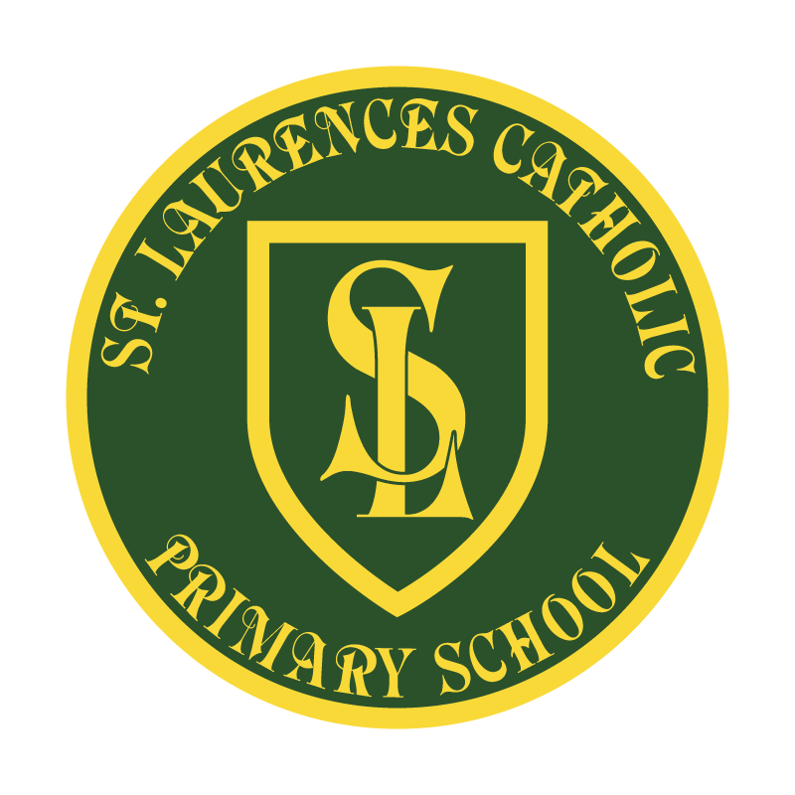

St Laurence’s Catholic Primary School

Policy Statement
For
Prayer
This policy was adopted on | October 2022
By name | Mr John Holmes
Position | Chair of Governors
Signature | J Holmes

Our Mission Statement
We aim to celebrate our partnership with the families we serve and the community we live in.
We aim to provide an education that enables each child to reach their full potential.
Our aim is the creation of an atmosphere where all are valued, gifts and talents are celebrated and the gospel values of love, respect and justice are at the heart of all we do.

Our Vision
Everyone feels a sense of belonging,
Has the opportunity to shine,
To enjoy their teaching and learning
But most of all – to dream big!

At St Laurence’s Catholic Primary School we are a Catholic Christian community where everybody is valued and recognised for their unique gifts and talents. We provide a children-centred education in a positive learning environment in which all children may reach their full potential and shine brightly. The Gospel values of love, respect and justice are at the heart of our partnerships with parents, carers, Governors, the parish and wider community.

Pope Francis reminds us:

‘Dear friends, one of the most effective ways we have to help is that of prayer. Prayer unites us; it makes us brothers and sisters and reminds us of the beautiful truth which we sometimes forget.’

As with every relationship, our experience with God can only grow through communication. Prayer is the way in which we engage in communication with God.
Prayer consists of :-

Listening- being attentive to the voice of God in every moment;
Speaking- expressing the deepest longings and desires of our hearts to the one who knows and understands us better than we know ourselves;
Reflecting- thinking about our relationship with God;
Resting- simply being consciously in the presence of God, knowing that we are loved;

As teachers in our catholic school, every member of staff is expected to:
- actively engage with pupils in Catholic prayer
- ensure that there are opportunities for pupils to pray

Traditionally there are three points in each day when prayer should take place:
- morning;
- evening;
- night.

In addition, it is customary to pray:
- before and after meals;
- before the beginning of any significant action.

In our school it is expected that teachers will:
- provide opportunities for pupils to pray;
- provide pupils with meaningful prayer experiences;
- assist pupils to develop the language of prayer;
- teach pupils the traditional prayers of the Catholic Church;
- help pupils to develop habits of prayer.

They will do this in order that pupils will be able to:
- contemplate something of the mystery of God;
- reflect on moral and spiritual issues;
- explore their own Catholic beliefs;
- experience a sense of belonging and develop community spirit;
- develop a common sense of ethos and shared values;
- enrich religious experience;

Come and See for Yourself/Staff Liturgy
Staff pray together at the beginning of each new Come and See topic following the Come and See for Yourself session. Staff will also participate in prayers incorporated into the weekly staff meetings and reflections at the start of every INSET day.

Prayer Policy
The prayers below are used throughout the school. A comprehensive list of prayers is listed on the Come and See Website and is incorporated through the RE curriculum along with resources on the school shared area for RE.

Early Years (Nursery)
Sign of the Cross
Prayer before snack

Reception
Sign of the Cross
School Prayer
Grace before Meals
Our Father
Hail Mary
Act of Sorrow
Mass Response

Key Stage 1
Sign of the Cross
School Prayer
Grace before Meals
Our Father
Hail Mary
Glory be to the Father Angel of God
Goodnight God
Angelus
Benedictus (Luke 1:67-69)
Magnificent (Luke 1:46-55)
Eternal Rest
The Mysteries of the Rosary
Prayers at Mass
Saints’ prayers
Simple phrases from psalms

Key Stage 2
Sign of the Cross
School Prayer
Grace before Meals
Our Father
Hail Mary
Glory be to the Father
Angel of God
Eternal Rest
Act of Contrition

NB Conscious of the revised wording of the Mass, we will endeavour to introduce common responses which will be new to all worshippers, e.g. The Lord be with you. And with your spirit.

PRAYER LISTING

Morning prayers
Morning offering
The School Prayer

Mealtime prayers
Grace before meals

Evening prayers
Use a variety of the following prayers during the week:
- Act of Contrition (Key Stage Two)
- Act of Sorrow (Key Stage One)
- Our Father
- Hail Mary
- Glory be to the Father

Rosary – A week in October, the month of the Rosary
- Our Father
- 10 Hail Marys
- Glory be to the Father
Focus on the Joyful, Sorrowful and Glorious Mysteries – 1 each day
- The Annunciation
- The Visitation
- The Nativity
- The Presentation
- The Finding in the Temple

School Prayer
Dear God Our Father
We pray today for our school,
To help us to get along, to care and share and not leave anyone out.
Help us to remember that we have to make this world a better place for other people,
Where we are all equal.
Amen

Morning Offering
Father in Heaven,
I give you today
All that I think and do and say and I join it with all that was done
All his life by your dearest son.
Amen.

Grace before meals
Dear God Our Father,
Thank you for the food we are about to eat.
Thank you for all the people who prepared this meal.
Help us to remember all of the people who don’t know where their next meal is coming from.
Amen.

Act of Contrition (KS2)
O my God,
because you are so good
I am very sorry that I have sinned against you and by your help
I will try not to sin again. Amen.

Act of Sorrow (Infants)
I'm sorry dear God.
Forgive me please do.
I'll try to do better
and always love you. Amen.

Our Father
Our Father, who art in heaven, hallowed be thy name.
Thy kingdom come, thy will be done on earth as it is in heaven.
Give us this day our daily bread and forgive us our trespasses
as we forgive those who trespass against us and lead us not into temptation
but deliver us from evil.
Amen.

Hail Mary
Hail Mary, full of grace, the Lord is with thee.
Blessed art thou amongst women
and blessed is the fruit of thy womb, Jesus.
Holy Mary, Mother of God,
pray for us sinners, now and at the hour of our death. Amen.

Glory be to the Father
Glory be to the Father
and to the Son
and to the Holy Spirit
as it was in the beginning,
is now and ever shall be world without end. Amen.

