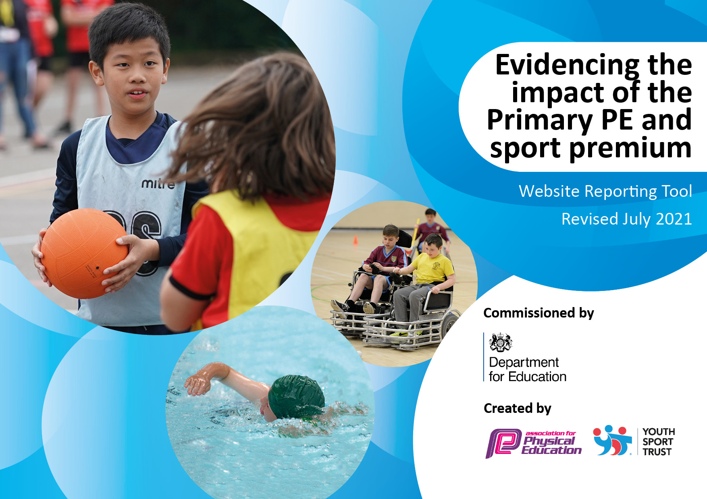
St Laurence’s Catholic Primary School
2021- 2022
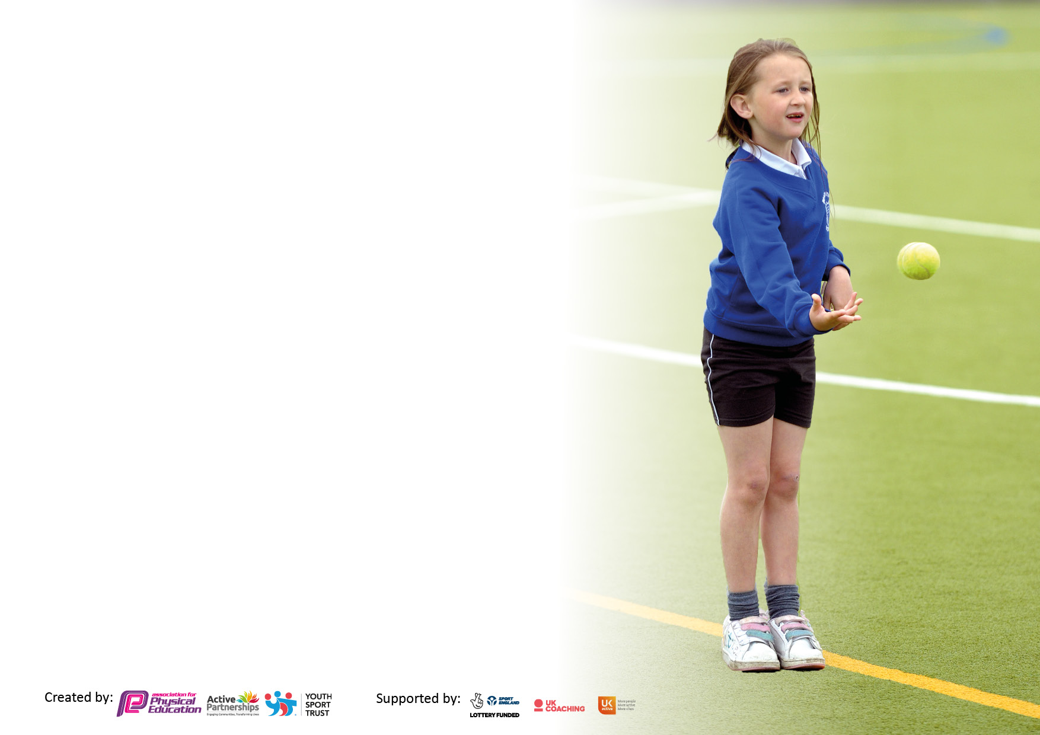

It is important that your grant is used effectively and based on school need. The Education Inspection Framework makes clear there will be a focus on ‘whether leaders and those responsible for governors all understand their respective roles and perform these in a way that enhances the effectiveness of the school’.

Under the Quality of Education Ofsted inspectors consider:
Intent - Curriculum design, coverage and appropriateness
Implementation - Curriculum delivery, Teaching (pedagogy) and Assessment
Impact - Attainment and progress

To assist schools with common transferable language this template has been developed to utilise the same three headings which should make your plans easily transferable between working documents.

Schools must use the funding to make additional and sustainable improvements to the quality of Physical Education, School Sport and Physical Activity (PESSPA) they offer. This means that you should use the Primary PE and sport premium to:

- Develop or add to the PESSPA activities that your school already offer
- Build capacity and capability within the school to ensure that improvements made now will benefit pupils joining the school in future years
- The Primary PE and sport premium should not be used to fund capital spend projects; the school’s budget should fund these.

Pleasevisitgov.ukfortherevisedDfEguidanceincludingthe5keyindicatorsacrosswhichschoolsshoulddemonstrate animprovement.Thisdocumentwillhelpyoutoreviewyourprovisionandtoreportyourspend.DfEencouragesschools to use this template as an effective way of meeting the reporting requirements of the Primary PE and sport premium.

We recommend you start by reflecting on the impact of current provision and reviewing the previous spend.

Schools are required to publish details of how they spend this funding, including any under-spend from 2019/2020, as well as on the impact it has on pupils’ PE and sport participation and attainment. All funding must be spent by 31st July 2022.

We recommend regularly updating the table and publishing it on your website throughout the year. This evidences your ongoing self-evaluation of how you are using the funding to secure maximum, sustainable impact. Final copy must be posted on your website by the end of the academic year and no later than the 31st July 2021. To see an example of how to complete the table please click HERE.

Details with regard to funding
Please complete the table below.

Total amount carried over from 2019/20 | £13,341
Total amount allocated for 2020/21 | £18730
How much (if any) do you intend to carry over from this total fund into 2021/22? | £12343
Total amount allocated for 2021/22 | £18730
Total amount of funding for 2021/22. To be spent and reported on by 31st July 2022. | £17859
Swimming Data
Please report on your Swimming Data below.

Meeting national curriculum requirements for swimming and water safety.

N.B. Complete this section to your best ability. For example you might have practised safe self-rescue techniques on dry land which you can then transfer to the pool when school swimming restarts.
Due to exceptional circumstances priority should be given to ensuring that pupils can perform safe self rescue even if they do not fully meet the first two requirements of the NC programme of study
What percentage of your current Year 6 cohort swim competently, confidently and proficiently over a distance of at least 25 metres?  N.B. Even though your pupils may swim in another year please report on their attainment on leaving primary school at the end of the summer term 2020.  Please see note above | 80%
What percentage of your current Year 6 cohort use a range of strokes effectively [for example, front crawl, backstroke and breaststroke]?  Please see note above | 80%
What percentage of your current Year 6 cohort perform safe self-rescue in different water-based situations? | 80%
Schools can choose to use the Primary PE and sport premium to provide additional provision for swimming but this must be for activity over and above the national curriculum requirements. Have you used it in this way? | Yes/No

Action Plan and Budget Tracking
Capture your intended annual spend against the 5 key indicators. Clarify the success criteria and evidence of impact that you intend to measure to evaluate for pupils today and for the future.

Academic Year: 2021/22 | Total fund allocated:£18,730 | Date Updated: July 22
Key indicator 1: The engagement of all pupils in regular physical activity – Chief Medical Officers guidelines recommend that primary school pupils undertake at least 30 minutes of physical activity a day in school |  |  |  | Percentage of total allocation:
 |  |  |  | 51% £9,771.25
Intent | Implementation |  | Impact
Your school focus should be clear what you want the pupils to know and be able to do and about  what they need to learn and to  consolidate through practice: | Make sure your actions to achieve are linked to your intentions: | Funding allocated: | Evidence of impact: what do pupils now know and what can they now do? What has changed?: | Sustainability and suggested next steps:
- To encourage all pupils to partake in regular exercise, also ensuring PE kits are always in school and encourage healthy eating and lifestyles.  - To continue to improve Playground improvements e.g. Court/pitch/ Daily markings, and also accessibility to adventure trail. To aid active break/lunchtimes and promote healthier lifestyles in addition to being utilised for curricular and extra-curricular activities.  - To target less active pupils to encourage engagement in more physical activity.  - To continue to provide activities which ensure children have access to developing their own motor skills through climbing, balancing and strengthening their core. | All classes have two hour timetabled PE sessions along with the timetabled Daily mile sessions during curriculum time and be able to access lunch time and after school clubs. Each class was given a sports resource bag for break time and lunch times.  Ensure all children participate within school curriculum PE lessons.  Teachers will provide extra-curricular sports before and after school when it’s safe to do so.  Ensure the promotion of the Health for Schools Initiatives are implemented.  To upgrade playground equipment to ensure sustainability. Outside Gym, Adventure trail.  Update lunchtime PE equipment to encourage more challenge during physical activity during breaks and dinner.  To continue to update PE resources and kit to enhance (sustainability) provision in lessons and extra-curricular activity.  To purchase bikes, trikes, scooters, balance beams within EYFS, climbing wall within the main playground. This will support children with their physical, fine and gross motor skills. | £1,000  £8771.25 | School Games Platinum certificate was presented to the PE lead in relation to PE Tasks completed whilst in school and completion of a KSSP competitions calendar.  Teachers were able to provide extra- curricular activities with the children near the end of the academic year which were a huge success with all the children.  Twice a week Family Fitness Sessions with children and parents was completed by Mr Cushion.  Children were able to participate in a variety of different activities on the playground which included: daily mile, PE Lessons, Orienteering which they all thoroughly enjoyed.  New lunchtime and after school clubs were created which allowed less active pupils to take part which included: cross country, indoor athletics and table tennis. PE resources were purchased and this had a massive impact on these pupils in relation to their fitness which impacted on their health and wellbeing.  Outside climbing wall was erected and the children have thoroughly enjoyed climbing and balancing which has strengthened their core. | Continue to refresh and review of lunchtime provision including:  The replacement and enhancement of play equipment.  Teachers to continue to support extra-curricular activities in 2022/2023 once children are able to access PE inside and outside safely within school.
Key indicator 2: The profile of PESSPA being raised across the school as a tool for whole school improvement |  |  |  | Percentage of total allocation:
 |  |  |  | 20% £ 3785
Intent | Implementation |  | Impact
Your school focus should be clear what you want the pupils to know and be able to do and about  what they need to learn and to  consolidate through practice: | Make sure your actions to achieve are linked to your intentions: | Funding allocated: | Evidence of impact: what do pupils now know and what can they now do? What has changed?: | Sustainability and suggested next steps:
- Continued involvement with Knowsley Children’s University SLA. (Children will earn University credits for every hour of extra-curricular activity they participate in and they will receive recognition when 30+ hours is reached).  - Use of PE across the curriculum, linking with other subjects (Active Maths). | Try to increase the numbers of children attending the children’s club and ceremony in summer term for recognition of their achievements in extra-curricular activities by increasing the variety of clubs within the school.  The re-purchase and continue to implement of Active Maths across the school (by doing this it will help with children’s physical fitness after lockdown). | £2.000.  £1875 (three year budget.) | The repurchase of several schemes relating to PE has had a massive impact on the students and teachers. The impact of this was that teachers became more confident within lessons and were able to deliver high quality PE lessons.  The repurchase of several cross curricular schemes relating to PE has had a massive impact on the students and teachers. Teachers especially as this up skilled teachers to deliver higher quality cross curricular PE lessons. This was evident this year as termly assessments in this area improved across the year groups.

Key indicator 3: Increased confidence, knowledge and skills of all staff in teaching PE and sport |  |  |  | Percentage of total allocation:
 |  |  |  | 30% £5650
Intent | Implementation |  | Impact
Your school focus should be clear | Make sure your actions to | Funding | Evidence of impact: what do | Sustainability and suggested
what you want the pupils to know | achieve are linked to your | allocated: | pupils now know and what | next steps:
and be able to do and about | intentions: |  | can they now do? What has
what they need to learn and to |  |  | changed?:
consolidate through practice:
- To continue to provide high quality, focused continuous professional development for staff to support the delivery of high quality physical education and school sport.  - To continue to use Everton in the Community (ETIC)  - Ensure that new staff responsible for teaching swimming attend appropriate course and gain qualifications in order to teach swimming effectively. | To continue to identify the teaching strengths in PE within our own staff and continue to ‘buddy’ teachers up to develop each other skill sets. EITC.  To up skill staff to deliver high quality PE lessons to ensure sustainability of a High Quality PE & School Sport Programme. Try to encourage several members of staff complete a Level 5/6 PE qualification.  To improve staff knowledge and understanding of Physical Education by the use of key vocabulary and keeping abreast of new initiatives within it.  As above – by being supported by Everton within school this will also help up-skill our teachers and children and help us maintain and sustain a high quality PE programme across the whole of the school.  To continue to access online appropriate swimming courses from KSSP for all new staff. | £650  £4,500  £500 | The Everton in the community PE coach supported staff throughout the school year and upskilled them in different sports and activities. The children were actively engaged with both teacher and coach listening and participating well in all lessons.  Several teachers within school have attended and completed level 5/6 PE qualification which has enabled them to bring new ideas into school and pass this knowledge onto fellow teachers which has improved their knowledge and understanding of the subject.  Everton in the community PE coach supported staff and upskilled them in different sports and activities. Children have become more actively engaged with the EITC coaches in school. The major benefits of having the coaches within our school are: it improves learning in the classroom – it raises self-awareness, deepens self-reflection, and delivers the most effective progress and results.  As a result, staff will feel more confident to deliver PE lessons.  Several teachers have completed online swimming courses which has given them confidence in this area and when attending our annual swimming lessons at our local leisure centre. (see certification and Photographic evidence in big book). | Everton sports coach will continue to work with teachers to up-skill them throughout the year 2022/23. This will be monitored by PE lead through Planning, observations, assessment and consultation with the EFC coach.  Everton sports coach to continue to work upskilling teachers who are less confident throughout 2022/23.
Key indicator 4: Broader experience of a range of sports and activities offered to all pupils |  |  |  | Percentage of total allocation:
 |  |  |  | 14 % £2600
Intent | Implementation |  | Impact
Your school focus should be clear | Make sure your actions to | Funding | Evidence of impact: what do | Sustainability and suggested
what you want the pupils to know | achieve are linked to your | allocated: | pupils now know and what | next steps:
and be able to do and about | intentions: |  | can they now do? What has
what they need to learn and to |  |  | changed?:
consolidate through practice:  • To continue to use Knowsley School Sports Partnership (KSSP) which provides the co-ordination and delivery of regular high quality school and borough wide competitions in a wide and diverse range of sports, ensuring that the players/teams have the opportunity to link into county, regional and national competitions in line with national governing bodies of sport and the national School Games programme. The SLA also aims to increase the number of young people participating in competitive opportunities and the depth of competitions offered.  • To continue to provide after school sports clubs that are not part of the curriculum for lower key stage 2, e.g. Boxing, judo and fencing.  - To continue to provide extra- curricular activities for all year groups in one skilled area. | To continue to develop a range of extra-curricular activities which will help the children achieve, we currently offer a range of sports clubs across the school. Football occurs on a weekly basis across several year groups, whereas other clubs will change term by term dependent on upcoming events and seasonal changes (for example cross country club changes to indoor/ outdoor athletics club in the winter summer terms). By doing this the children will be recognised for their participation through gaining Children’s University credits.  Key Stage 1 and 2 children to take part in Quidditch tournament over two days.  Dance for EYFS, KS1 and KS2 after school. (Tammy) | £1395  £895  £400 | We have continued to buy into Knowsley Schools Sports Partnerships. The children did complete lots of competitions this year that was organised by KSSP which all the children enjoyed thoroughly, this boosted their confidence and general well-being. Registers of sessions are used to monitor the engagement of all children.  The children enjoyed our Quidditch day event which was supplied through ENRICH. The children have expressed an interest in doing this event again next year as it had a positive effect on the children’s health and well-being.  The children have said that they really enjoy the dances sessions and have asked if we could be increase the amount of sessions per week.
Additional achievements:

Key indicator 5: Increased participation in competitive sport |  |  |  | Percentage of total allocation:
 |  |  |  | %
Intent | Implementation |  | Impact
Your school focus should be clear | Make sure your actions to | Funding | Evidence of impact: what do | Sustainability and suggested
what you want the pupils to know | achieve are linked to your | allocated: | pupils now know and what | next steps:
and be able to do and about | intentions: |  | can they now do? What has
what they need to learn and to |  |  | changed?:
consolidate through practice:
• To continue to encourage all children to participate in competitive sport and any involvement in clubs outside of school is highlighted and celebrated. | To continue build up a strong relationships with several community based clubs outside of school. (Quarry Green Football Club and Kirkby Town FC) | £ | Our relationship with this club has become even stronger and they are now using our school field for a number of events throughout the year. Children from the school now participate in a wide range of sports outside of school hours which is helping grow confidence and the health and well -being of every child who attends. Pupils from all year groups compete at a local level with teams progressing to competition finals. Academy achievements celebrated and recognised. | Our next steps are to further promote other sports and links with other local sporting communities such as:  - Kirkby Milers cross country club  - Performance Dance studios.

Signed off by
Head Teacher:
Date:
Subject Leader:
Date:
Governor:
Date:

