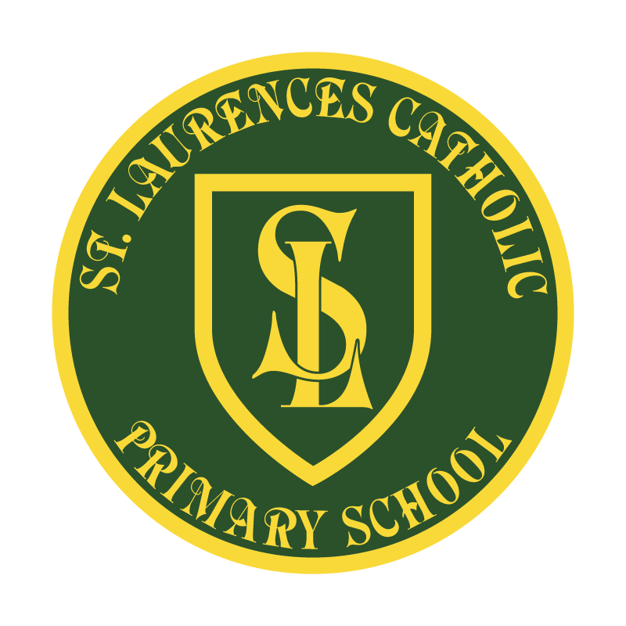

St Laurence’s Catholic Primary School

Policy Statement
for
Science

This policy was reviewed: | September 2022
By name: | Mr John Holmes
Position: | Chair of Governors
Signature: | J Holmes

Our Mission Statement
We aim to celebrate our partnership with the families we serve and the community we live in.
We aim to provide an education that enables each child to reach their full potential.
Our aim is the creation of an atmosphere where all are valued, gifts and talents are celebrated and the gospel values of love, respect and justice are at the heart of all we do.

Our Vision
Everyone feels a sense of belonging,
Has the opportunity to shine,
To enjoy their teaching and learning
But most of all – to dream big!

Science Policy

Rationale

At St Laurence’s we believe that science stimulates and excites children’s curiosity about phenomena and events in the world around them. It also satisfies their curiosity with knowledge. Because science links direct practical experience with ideas, it can engage learners at many levels.

We believe that developing science knowledge will lead to a better understanding of ourselves and the world. It provides opportunities to appreciate scientific facts and concepts and to experience scientific discovery.

Science at St Laurence’s, is about developing children’s ideas and ways of working that enable them to make sense of the world in which they live through investigation, as well as using and applying working scientifically skills.

Intent

All pupils at St Laurence’s Catholic Primary School are entitled to be taught the key: knowledge, vocabulary and skills in the scientific disciplines to develop an understanding of the world around them at an age-appropriate level and in line with the National Curriculum. We aim to harness children’s natural excitement and curiosity and inspire them to pursue scientific enquiry. Throughout the primary years, children should learn to explain and analyse phenomena, make predictions and solve problems.

Teachers should aim to nurture a love for the natural world, excitement for future possibilities in science and provide many opportunities for pupils to respond creatively in their learning. Reading is at the heart of our curriculum at St Laurence’s, within science children are given opportunities to read a range of texts and extracts that are linked to all topics within the science curriculum. Children also have access to variety of science based texts within class to allow them to apply their understanding in context and to enrich their learning experience. Within science, there is a wealth of technical and challenging vocabulary and through our carefully designed curriculum we aim to close the gaps in children’s vocabulary and strive to allow all children to become confident and fluent in using a range of scientific vocabulary, developing their understanding along the way.
In addition to this, we will continue to raise the profile and quality of science across the whole school and put in place a development cycle that leads to sustained progress in science across the school. As a school within a deprived area, we will look to develop children’s science capital and aspirations through: interactions with adults in STEM careers, involving families and creating a curriculum that includes lessons with real life contexts.

Implementation

To implement a clear and comprehensive scheme of work in line with the National Curriculum that is informed by research evidence and best practice data, where teaching and learning show progression across all key stages within the strands of Science. Key vocabulary and meanings will be taught within each topic with a clear progression between year groups in order to understand and readily apply to their written, mathematical and verbal communication of their skills. The Science curriculum at St Laurence’s is designed and taught using strategies to enable children to embed their learning in their long-term memories. Clear and well thought out sequences of learning and ongoing assessments ensure that new knowledge and skills build on prior learning.
During science lessons, children will use a range of resources to develop their knowledge and understanding that is integral to their learning and develop their understanding of working scientifically, using increasingly complex equipment as they progress through the school. A clear and comprehensive scheme of work will be embedded, where teaching and learning will plan for practical investigative opportunities and, where possible, allow for links to be made to real life contexts. There should be opportunities for children to reflect on previous learning and be able to build on prior knowledge and link ideas together, enabling them to question and become enquiry based learners.
Where applicable, links to Science will be made to develop the children’s topical learning (cross-curricular) and opportunities to work with local scientists or visit local institutions (in person or virtually) will be actively encouraged to build children’s science capital. -
Subject lead and staff’s knowledge and confidence of teaching and delivering excellent science lessons will continue to be developed. CPD will be available for all staff enabling them to develop their own knowledge and skills, transferring this back into the classroom and onto our children.
Science will be monitored termly throughout the academic year in-line with the school monitoring cycle through: book scrutinies, learning walks and questionnaires. Evaluations and changes are made when necessary. All evaluations are shared with our SLT and governing body to ensure that all stakeholders have an understanding of our curriculum offer.

Assessment and tracking individual children’s progress is based on half termly assessments that ensure good or better progress. This impacts on accelerating the rate of progress for all, including those children with special educational needs. Vulnerable children and children with learning difficulties are identified early and well supported through intervention programmes that are individually tailored, effectively taught and closely monitored in terms of pupil outcomes. Using our Primary Progress tracking system in Years 1 to 6, we are able to see which pupils have made progress against the key objectives for Science, this is in-line with the other core subjects of English and Maths.

Impact
As a result of the above actions:
- Primary Science Quality Mark Awarded 2021
- Children are engaged and enjoy their science lessons.
- Children make good progress, building and consolidating their knowledge and skills, developing positive attitudes about science and its value to their lives and globally.
- Children’s knowledge and working scientifically skills are built on in each year group.
- Most children will achieve age related expectations in Science at the end of their cohort year.
- Children can retain knowledge that is pertinent to Science with a real life context.
- Children are be able to question ideas and reflect on knowledge, work collaboratively and practically to investigate and experiment and be able to explain the process they have taken and be able to reason scientifically.
- Children are confident in using and applying vocabulary across a range of scientific topics
- Teachers show consistent standards of teaching in each year group.
- Accurate assessment for learning takes place across the school.
- Children are well prepared for the next stage of education
At St Laurence’s good science lessons should:

- Give a learning objective at the start which is referred to throughout the lesson and is evaluated at the end.
- A hook/starter or wow opener is used to engage children in concept to be taught
- Give opportunities for speaking and listening.
- Have questions of different levels and styles with opportunities for children to confer and discuss their ideas.
- Have interesting and varied activities.
- Have opportunities for assessment for learning such as self marking to evaluate own understanding.
- Allow for discussion of misconceptions.
- Look for opportunities to develop cross-curricular links.

Science is not just a question of knowing facts and understanding concepts. It is also about encouraging children to behave scientifically (posing questions to be investigated, hypothesising, recording and analysing).

At St Laurence’s, teachers aim to present science in practical contexts which are relevant to the children's experiences (developing their science capital). This will involve learning in class, group and individual situations. Some content is taught directly but enlivened through practical demonstrations. Small group activities follow on from class discussion and encourage collaboration. Where possible, children are encouraged to investigate their own questions, making decisions for themselves and maintaining a high level of motivation. Children communicate their findings in a variety of ways such as written reports, short talks, demonstrations and presentations, which can be shared with parents via Seesaw.

At St Laurence’s, we use ICT widely in science. Children are given the opportunity to practice science skills and enhance their presentation using software. We use ICT for enquiry work, including microscopes, with digital cameras, video capture of images and activities, and data logging.

At St Laurence’s, science is celebrated around the school through displays of work, materials and objects. We use cross-curricular links to further deepen conceptual knowledge within science. For example, linking Design and Technology topics like bridges in Year 5 to forces. We develop science informally through our STEM club, school visits and science capital focused celebrations such as: World Space Week, British Science Week and the Great Science Share.

At St Laurence’s to deliver the national curriculum, staff aim to promote a broad and balanced science education which enables progression and continuity between classes. We aim to teach science in ways that are imaginative, purposeful, well managed and enjoyable. Teachers will give clear and accurate explanations and offer skilful questioning, whilst making links between science and other subjects.

At St Laurence’s, the practical nature of science is recognised and opportunities for learning through play and firsthand experience should be provided, especially in the early years. Science plays an important role in the development of investigative skills and draws upon strong mathematical links, for example measurement, pattern recognition, graphical skills and data handling. Curricula links to other areas, for example, language, are recognised and developed.

Early Years Foundation Stage

At St Laurence’s children in EYFS will be introduced to science through the Early Years Foundation Stage (EYFS) Curriculum Guidance. The Early Learning
Goals (ELGs) for ‘Understanding of the World’ forms the foundation for later work in science, design and technology, history, geography and ICT.

Wherever possible the children are provided with activities based on firsthand experience that encourage exploration, observation, problem solving, prediction, critical thinking, decision making and discussion. We provide an environment with a wide range of indoor and outdoor experiences that stimulate their interest and curiosity. Children are provided with a broad range of opportunities and experiences in science, enabling them to work towards their Early Learning Goals.

At St Laurence’s children develop their understanding of the world around them on a daily basis, using their senses to explore and learn about objects and materials. Children are given holistic learning experiences, incorporating elements of science in their everyday activities.
KS1

At St Laurence’s children observe, explore and ask questions about living things, materials and physical phenomena. They begin to work together to collect evidence to help them answer questions and to link this to simple scientific ideas. They begin to evaluate evidence and consider whether tests or comparisons are preparing for the future in a caring environment.

In KS1 children begin to use reference materials including ICT to find out more about scientific ideas. They share ideas and communicate them using scientific language, drawings, charts and tables with the help of ICT where appropriate.

The KS1 curriculum follows the National Curriculum, ensuring all areas of the Programme of Study are covered across both Years 1 and 2. Children further develop their understanding of the world around them which they have gained in the Foundation Stage. Children are able to observe, explore and ask questions about living things, materials and physical phenomena.

Children begin to work collaboratively with others, enabling them to develop their scientific knowledge and understanding and to link scientific concepts. Children communicate ideas orally using taught scientific language and begin to develop written methods for communicating their ideas (to include drawings, diagrams, use of ICT, tables and charts).

KS2

At St Laurence’s children learn about a wider range of living things, materials and physical phenomena. They make links between ideas and explain things using simple models and theories. They apply their knowledge and understanding of scientific ideas to familiar phenomena, everyday things and their personal health. They think about the effects of scientific and technological developments on the environment and in other contexts. They carry out more systematic investigations, working on their own and with others. They use a range of reference sources including ICT in their work. They talk about their work and its significances, using a wide range of scientific language, conventional diagrams, charts, graphs and ICT to communicate their ideas.

At St Laurence’s the KS2 curriculum follows the National Curriculum, ensuring all areas of the Programme of Study are covered across Years 3, 4, 5 and 6. Children learn, explore and ask questions about a wider range of living things, materials and physical phenomena. Children think about the impact of scientific developments and technologies on themselves and the world around them.

At St Laurence’s children are encouraged to develop an independent approach to their science learning, through asking questions, suggesting improvements to their work and supporting each other towards achieving a heightened understanding of scientific concepts.
Children are given the opportunity to plan, carry out and evaluate experiments. Children are encouraged to develop their own methods for presenting their ideas (to include drawings, diagrams, use of ICT, tables and charts.)

Progression

At St Laurence’s as children move from Early Years to KS1 and up to KS2, science teaching and effective assessment should allow opportunities for them to progress in a range of ways.

We ensure progression in the following key concepts:
- Conceptual understanding
- Scientific vocabulary
- Skills of enquiry
- Scientific attitudes

- From using everyday language to increasingly precise use of technical, scientific vocabulary, notation and symbols;
- From personal scientific knowledge in a few areas to understanding in a wider range of areas and knowing how these links together;
- From describing events and phenomena to explaining events and phenomena;
- From explaining phenomena in terms of their own ideas, to explaining phenomena in terms of scientifically accepted ideas or models;
- From participating in adult lead practical, scientific investigations to developing and undertaking their own scientific investigations, independently;
- From unstructured exploration to more systematic investigation of a question or questions developed independently;
- From using simple drawings, diagrams and charts to represent and communicate scientific information, to using more conventional diagrams and graphs.

Health and Safety

At St Laurence’s all children will be made explicitly aware of the relevance of health and safety issues when undertaking scientific work. This will be specifically highlighted when they are asked to undertake scientific investigations, with additional adults being used effectively to assist with the safe running of all science lessons.

Resources

At St Laurence’s, each topic covered within the school science curriculum has its own resource box in the science stock cupboard. There is also generic science equipment within this storage area. Equipment will be updated as required, within the allocated science budget.

ICT

At St Laurence’s, our children will be given opportunities to apply and develop their ICT capability throughout their science lessons, through the use of science/ICT software, allowing them to utilise equipment such as Data Loggers and Interactive Microscopes, as well as Graph and Chart software using apps such as Arduino science app.

Monitoring

At St Laurence’s Catholic Primary School, the monitoring of the standards of children’s’ work and of the quality of teaching in science is the responsibility of the Science Lead to ensure continuity and progression throughout the school. This takes place in accordance with the schools monitoring cycle. The role of science lead also involves being informed about current developments in the subject and providing a strategic lead and direction for the subject in school. An annual summary of science (subject development plan) is made in which strengths and weaknesses in the subject are evaluated, and an action plan to address any issues arising is formulated for the forthcoming year.

Equal Opportunities

At St Laurence’s, we believe that every individual within the school has the opportunity to achieve their full potential and equal access to all areas of the curriculum.

In science this means that all children will have the opportunity;

- To develop the process of systematic enquiry
- To relate their understanding of science to everyday life and in environmental contexts
- To communicate using appropriate vocabulary and present scientific information in a number of ways
- To explore aspects of health and safety when working with living things and materials
- To carry out experimental and investigate science
- To develop and apply their ICT capability in their study of science Staff members make every effort to use stimuli that reflect the cultural diversity of our school and to draw on children own experiences.

Assessment

At St Laurence’s Catholic Primary School, a range of assessment techniques are used depending on the nature of the lesson, knowledge acquired, or the process skills used. They may be assessed through close teacher observation or discussion and sometimes small tests or problem-solving tasks may be set. Resources such as: Explorify, PSTT Big Questions and TAPS focused assessment lessons have also been resourced to support teachers in their assessment.

Science will be assessed in line with our assessment policy.

The Role of the Science Subject Leader

At St Laurence’s Catholic Primary School, the Science subject leader will:

- Ensure the development of a progressive curriculum map, monitor its implementation and impact.
- Promote the integration of Science within appropriate teaching and learning activities;
- Manage the provision and deployment of resources and give guidance on classroom organisation support;
- inspire colleagues to deliver high quality teaching and learning opportunities;
- lead INSET where applicable within the school, and investigate suitable CPD opportunities for both themselves and others;
- Act as a contact point between the school and support agencies, including the LA;
- Analyse data to identify strengths and weaknesses in outcomes; planning for improvement accordingly.
- write, monitor and evaluate an action plan for Science for the School Improvement Plan
- Lead the evaluation and review of the school’s Science policy.
- Bid for and manage the budget for this curriculum area;
- Monitor and review the science provision within the school

Disability Equality Impact Assessment
This policy has been written with reference to and in consideration of the school’s Disability Equality Scheme. Assessment will include consideration of issues identified by the involvement of disabled children, staff and parents and any information the school holds on disabled children, staff and parents.

Any questions or concerns regarding this policy should be made to our Science Lead, Mr. Biggs.

REVIEW OF POLICY
The effectiveness of this policy will be reviewed annually by the Senior Leadership Team and every three years by the Governing Body. If changes are made to the policy, the Governing Body will ratify amendments.

This policy was reviewed:

Signed: J Holmes

Designation: Chair of Governors

Date: 22nd September 2022

