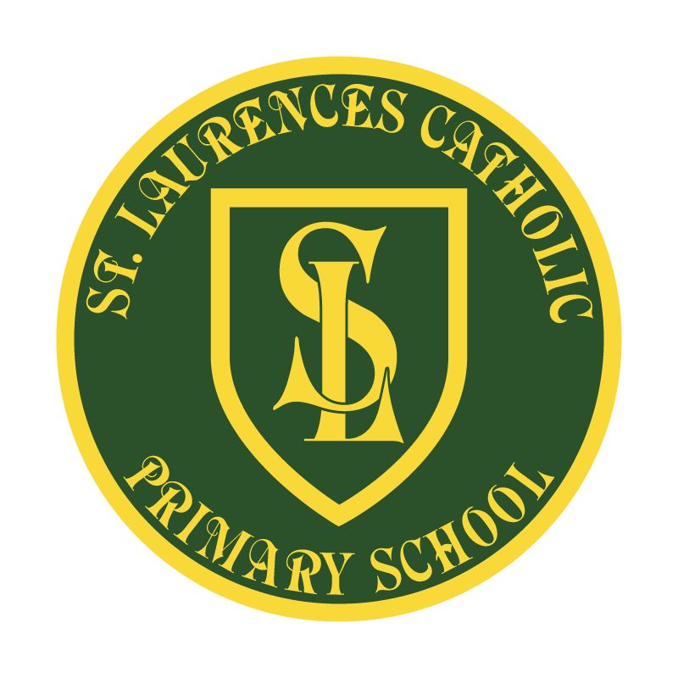

St Laurence’s Catholic Primary School

Policy Statement
for
School Uniform

This policy was reviewed: | September 2022
By name: | Mr J Holmes
Position: | Chair of Governors
Signature: | J Holmes

Our Mission Statement
We aim to celebrate our partnership with the families we serve and the community we live in.
We aim to provide an education that enables each child to reach their full potential.
Our aim is the creation of an atmosphere where all are valued, gifts and talents are celebrated and the gospel values of love, respect and justice are at the heart of all we do.

Our Vision
Everyone feels a sense of belonging,
Has the opportunity to shine,
To enjoy their teaching and learning
But most of all – to dream big!

St Laurence’s Catholic Primary School
School Uniform Policy
Introduction
It is our school policy that all children wear school uniform when attending school, or when participating in school-organised events outside normal school hours. We ask children to wear their shirts tucked into their skirts or trousers and to take pride in their personal appearance. Some items of uniform can be bought from our school uniform suppliers (currently Kids Kirkby and Liverprint), whilst others are easily available, at very competitive prices, at local shops including supermarkets. A complete list of the items needed for school uniform including those for Physical Education, is provided in the section below: Our School Uniform.
Aims and Objectives
Our policy on school uniform is based on the belief that school uniform:
• promotes a sense of pride in our school;
• helps to create a sense of community and belonging towards the school;
• identifies the children with the school;
• supports our commitment to inclusion;
• is practical, smart and designed with health and safety in mind

Our school’s legal duties under the Equality Act 2010
The Equality Act 2010 prohibits discrimination against an individual based on the protected characteristics, which include sex, race, religion or belief, and gender reassignment.
To avoid discrimination, our school will:
- Avoid listing uniform items based on sex, to give all pupils the opportunity to wear the uniform they feel most comfortable in or that most reflects their self-identified gender
- Make sure that our uniform costs the same for all pupils
- Allow all pupils to have long hair (though we reserve the right to ask for this to be tied back)
- Allow all pupils to style their hair in the way that is appropriate for school yet makes them feel most comfortable
- Allow pupils to request changes to swimwear for religious reasons
- Allow pupils to wear headscarves and other religious symbols
- Allow for adaptations to our policy on the grounds of equality by asking pupils or their parents to get in touch with the school office who can answer any questions about the policy and respond to any requests

Limiting the cost of school uniform
Our school has a duty to make sure that the uniform we require is affordable, in line with statutory guidance from the Department for Education on the cost of school uniform.
We understand that items with distinctive characteristics (such as branded items, or items that have to have a school logo or a unique fabric / colour / design) cannot be purchased from a wide range of retailers and that requiring many such items limits parents’ ability to ‘shop around’ for a low price.
We will make sure our uniform:
- is available at a reasonable cost
- provides the best value for money for parents/carers

We will do this by:
- carefully considering whether any items with distinctive characteristics are necessary
- making the wearing of items with the school logo on non-compulsory
- allowing the wearing of cheaper alternatives to school-branded items
- keeping the number of optional branded items to a minimum, so that the school’s uniform can act as a social leveler
- no difference in uniform requirements for different years (Reception to Year 6)
- avoiding different uniform requirements for extra-curricular activities
- making sure that arrangements are in place for parents to acquire second-hand uniform items
- avoiding frequent changes to uniform specifications and minimising the financial impact on parents of any changes
- consulting with parents and pupils on any proposed significant changes to the uniform policy and carefully considering any complaints about the policy

Jewellery, Hair accessories and Headscarves
For health and safety reasons we do not allow children to wear jewellery. The exceptions to this rule are small ear studs in pierced ears, small objects of religious significance and a wrist watch (not smart). Wherever possible children are required to remove any jewellery items during PE lessons to prevent them from causing injury. Please note: Teachers are not permitted to remove earrings for pupils.
Headscarves, if worn for religious reasons, should be plain and without embellishments.
Footwear
For health and safety reasons we do not allow children to wear shoes with heels. All children are required to wear plain black shoes (no boots or trainers of any kind are allowed).
Roles and Responsibilities
The Governing Board is responsible for:
- In consultation with the Head Teacher and school community, establishing a practical and smart school uniform that accurately reflects the school’s vision and values.
- Ensuring that equal opportunities are considered regarding the school’s uniform and that no person is discriminated against.
- Listening to the opinions and wishes of parents/carers, pupils and the wider school community regarding changes to the school’s uniform.
- Ensuring that the school’s uniform is accessible and affordable.

The Head Teacher is responsible for:
- Enforcing the school’s uniform on a day-to-day basis.
- Ensuring that school staff understand this policy and know what to do if a pupil is in breach of the policy.
- Listening to the opinions and wishes of the school community regarding the school’s uniform and making appropriate recommendations to the Governing Board.
- Providing pupils with exemptions as appropriate e.g. for a pupil who has a broken arm and requires a loose-fitting top.

Teaching and support staff are responsible for:
- Ensuring that pupils dress in accordance with this policy at all times.
- Taking appropriate action when pupils are in breach of this policy.
- Ensuring that pupils understand why having a consistent and practical school uniform is important e.g. to establish school identity.

Parents/carers are responsible for:
- Providing their children with the correct school uniform as detailed in this policy.
- Informing the Head Teacher if their child requires a more relaxed uniform policy for a period of time, including why.
- Ensuring that their child’s uniform is clean, presentable and the correct size.

Pupils are responsible for:
- Wearing the correct uniform at all times, unless the Head Teacher has granted an exemption.
- Looking after their uniform as appropriate.
- Respecting why a school uniform is important to the school e.g. to develop a sense of belonging.

Cost and Availability
In accordance with the School Admissions Code, St Laurence’s Catholic Primary School ensures that the School Uniform Policy does not discourage parents/carers from applying for a place for their child.
The school is committed to meeting the DfE’s recommendations on costs and value for money.
Every care is taken to ensure that our uniforms are affordable for all current and prospective pupils, and that the best value for money is secured through reputable suppliers.
The school works with multiple suppliers to obtain the best value for money possible.
The school does not enter into exclusive single supplier contracts or cash-back arrangements.
The school does not amend uniform requirements regularly and takes the views of parents/carers and pupils into account when considering changes to school uniforms.
Where changes are required, the school ensures that assistance is provided to parents/carers struggling to meet the associated costs.
School Uniform Supplier
Our school uniform suppliers are:
*Kids Kirkby
*Liverprint

Our School Uniform
The school endeavours to ensure that our uniform is as gender neutral as possible.

The uniform is as follows:
Reception to Year 6
- Green jumper or green cardigan (with the school badge)
- White school shirt
- School tie (Bottle green/gold striped)
- White polo shirt (summer months only)
- Grey trousers/shorts
- Grey pinafore or skirt (in summer, a green and white summer dress may be worn)
- Black, sensible shoes (not trainers)
- Grey, green or white socks
- Grey or black tights
- Green book bag (with or without the school badge)

Nursery Uniform
- Green tracksuit bottoms
- Green tracksuit jumper
- Yellow polo t shirt
- Velcro fastening shoes/trainers

Trainers, jelly shoes, sandals and large, thick boots are not considered suitable footwear for school.
High heels are not permitted: sensible, plain black shoes must be worn by both boys and girls.
Black jeans and leggings are not permitted in day-to-day uniform.
All items of clothing and footwear must be labelled with the pupil’s name.

Our PE Kit (Reception to Year 6)
Children are asked to come into school on the day of their PE lesson wearing their PE kit. They can wear it for the full school day.
Parents/carers are responsible for ensuring their child is dressed appropriately for PE.
The PE kit is as follows:
- Plain white T-shirt (with the school badge)
- Green sweatshirt or normal school jumper (OPTIONAL)
- Black tracksuit bottoms or leggings (OPTIONAL)
- Green shorts
- Plain, suitable trainers or black pumps

All items of clothing and footwear must be labelled with the pupil’s name.

School Bag/Lunch Bag
Pupils must use an appropriately sized bag to carry their belongings and any equipment. Large bags containing lunches are asked to be avoided due to room needed on tables for other children’s lunches etc. Please put your child’s lunch in an adequate sized bag.

The school encourages pupils to bring non-valuable bags to school. The school will not be liable for lost or damaged school bags.

Additional book bags can also be purchased from our school office at any time.

Water Bottles
All children should bring a water bottle into school every day: this can be refilled by children whenever necessary during the day.

Water bottles must be labelled with the pupil’s name.

Hair Styles
Hairstyles should be smart and moderate in style. Brightly coloured hair is not permitted.
Pupils with what could be deemed extreme hairstyles may be exempt from the rule above on racial or religious grounds. The Head Teacher will take each individual pupil’s scenario into consideration.

Long hair should be tied up. This is to avoid health and safety risks and ensure that children’s vision is not impeded.
Large, excessive hair accessories should not be worn; however, small hair clips or plain headbands are acceptable.
Hair extensions are not permitted.
At the Head Teacher’s discretion, there may be exceptions to the above in extreme circumstances e.g. a pupil may be permitted to cover their hair if they have hair loss / illness etc.

Make-Up
False nails and nail extensions are not permitted.
Only clear nail varnish may be worn.
Children are not allowed to wear make-up.
Pupils wearing make-up are required to remove it or, if appropriate, will be sent home to remove it.
At the Head Teacher’s discretion, there may be exceptions to the above in extreme circumstances e.g. a pupil may be permitted to cover heavy scarring/skin damage.

Adverse Weather
Hot Weather
Everyone working at/attending the school during hot weather conditions is required to wear sun-safe clothing that covers as much of their skin as possible.
This includes wearing:
- Loose fitting tops with collars or covered necklines
- Tops that cover the shoulder area
- Grey shorts or green and white summer dresses of an appropriate length (if families wish to)
- Sun-safe hats
- Sunglasses with UV protection
- Sunscreen (children must be able to apply this themselves and it must be labelled and handed to the child’s class teacher)

During hot weather, lightweight clothing is required to reduce the risk of overheating. Pupils are not required to wear their jumpers/cardigans during heatwaves.
If outside during break and lunch times, pupils not wearing sun-safe clothing/sunscreen are advised to stay in an area protected from the sun.

Cold Weather
During cold weather, pupils are required to wear scarves, gloves, coats and hats when they are outside.
Additional layers underneath the usual school uniform are accepted.
Where possible, pupils not wearing warm clothing are provided with spare clothing if going outside during break and lunch times.

Labelling
School staff encourage good organisation of clothing and footwear, for example, designated spaces for children to keep belongings in and checking of labels. However, all pupils’ clothing and footwear must be clearly labelled with their name.

Clothing and footwear are the responsibility of the pupil and not the school.

If a child goes home in another child’s clothing by accident, for example, their jumper, parents/carers should send the clothing not belonging to them back into school to their child’s class teacher.

Any lost clothing is to be taken to the lost property box. All lost property is retained for a term and is disposed of if it is not collected within this time.

REVIEW OF POLICY
The effectiveness of this policy will be reviewed annually by the Senior Leadership Team and every three years by the Governing Body. If changes are made to the policy, the Governing Body will ratify amendments.

This policy was ratified and reviewed: September 2022

Signed: J Holmes on behalf of the governing body
Designation: Chair of Governors
Date: 22nd September 2022

Review date: September 2025

