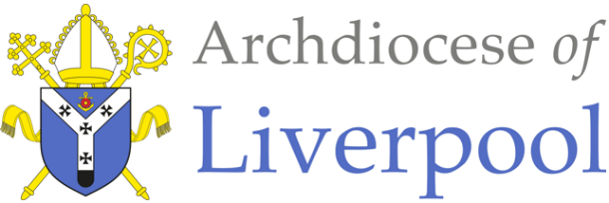
Belonging – A Sacramental Topic
*Note to parents.
This work comes from the Come and See Religious Education programme which is taught in all Catholic schools in the Archdiocese of Liverpool. We have given a general guide to the learning opportunities that your child may have come across in school and have only suggested and selected a small amount of the programme. The activities aim to keep Religious Education practical and fun. They are in Year groups however, there is no harm in completing other lower year group work as well as this will help your child to remember and strengthen their learning.
The first part of learning is called – EXPLORE. This shares your child’s everyday experiences and helps them to see how the Catholic faith is lived in their everyday lives as the theme progresses. The second part, called – REVEAL shares bible stories, religious teachings, lives of saints etc. that can relate to their everyday life. There are suggested activities for each section. Choose those you wish to do and record them as best as you can sending any work undertaken to school.
This theme is a Sacramental theme and focuses on the Sacraments of Baptism (and Confirmation, Marriage and Holy Orders). We understand that not every child or parent will have been baptised, so alongside this document are notes about the Sacrament of Baptism that you may find useful. All the other information you will need is here.

YEAR 4 - CALLED - EXPLORE
The response to being chosen

- Children may be able to ask and respond to questions about what they and others feel about being chosen.
- Children may be able to make links to show how feelings and beliefs can affect the responses they might make to being chosen.

- Talk about with your child about times that they have been specially chosen to do something e.g.:
- been a bridesmaid or a groomsman
- become a member of a football, rounders or netball team, computer club, school choir or orchestra.
- represented their school or club in some way
- read at Mass or school assembly
- done a special job in school e.g. be the register monitor etc.

- Ask them what they were expected to do for the role they were chosen for, why they accepted the invitation to do it and whether it was easy to fulfil this role – did they have to make sacrifices e.g. getting up early, giving time to practise?
- Now talk about a time they were not chosen for a role that they would have liked to have and how they felt at not being chosen.

Activities:
- Write a letter to accept a role as class eco-councillor in your school. Say how you feel in accepting the role and what you understand is required of you as you commit to the role.

- On a sad emoji face, write about how disappointed you are at not being chosen as your class school councillor. Say how you feel and why you should have been chosen.

YEAR 4 - CALLED - REVEAL
Confirmation: A call to witness

- Children will be able to use religious words and phrases to describe what it means to be called and give reasons why and how people are called to live a Christian life in response to God’s call.
- Children may be able to use religious words and phrases vocabulary to give reasons for the actions and symbols used at Confirmation.

- Confirmation is a choice made by people to renew the promises made in Baptism and receive the Gifts of the Holy Spirit, to strengthen their faith. It is a Sacrament of Initiation - of belonging and is usually celebrated by a Bishop.
- At the celebration of Confirmation, each one is called by name and invited to come to the front of the church. The bishop explains the readings to them and helps them to understand what Confirmation means. He says something like this:

‘On the day of Pentecost, the apostles received the Holy Spirit as the Lord had promised. They also received the power of giving the Holy Spirit to others and so completing the work of Baptism.’ The Holy Spirit fills our hearts with the love of God, providing us with the strength to be and act as followers of God.
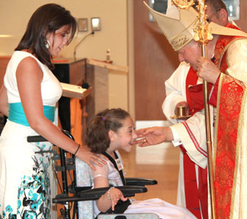
- In Confirmation they choose to become active members of the Church, their lives are given completely to the service of all, as Christ’s was.
- The person who is being confirmed has a sponsor - someone who inspires them in the way they live their faith.
- The gift of the Holy Spirit, signified by the Sign of the Cross made with Chrism, is received as a spiritual sign of becoming more like Christ, so the goodness of Christ should always be seen in the actions and way of life of a confirmed person.
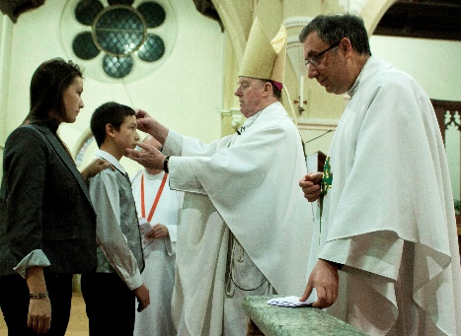
- The person being confirmed is anointed with the Oil of Chrism, a mixture of oil and balsam as a sign of being called and marked out for God’s service.
- The Bishop says, ‘Be sealed with the gift of the Holy Spirit.’ A seal is a sign, a mark or a promise made. The Holy Spirit will always be with the Christian to help and guide him or her.

- Those being Confirmed choose a saint’s name, someone who can be looked up to as an example to follow.

Activities:
- Design a recruitment pamphlet for candidates for Confirmation. Use signs, symbols, and information about Confirmation.

- Write a guide for a candidate for Confirmation to help them know what to expect. Say what symbols, words and actions are used and why.

At the end of all the work you have done on CALLED, say this prayer together:

Holy Spirit fill our hearts with the love of God, provide us with the strength to be and act as followers of God. Come Holy Spirit fill the hearts of the faithful and enkindle in them the fire of thy love.

