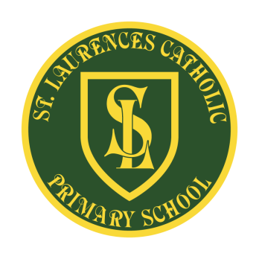
St Laurence’s Catholic Primary School
Holiday Dates 2020 - 2021
Autumn Term
Inset days | - Tuesday 1st September 2020  - Friday 23rd October 2020
Term Starts | Wednesday 2nd September 2020
Half Term | School closes Thursday 22nd October 2020 and re-opens on Monday 2nd November 2020
Autumn Term Ends | Friday 18th December 2020

Spring Term
Inset days | - Monday 4th January 2021
Term Starts | Tuesday 5th January 2021
Half Term | School closes Friday 12th February 2021 and re-opens on Monday 22nd February 2021
Spring Term Ends | 31st March 2021

Summer Term
Inset days | - Wednesday 21st July 2021  - Thursday 22nd July 2021
Bank Holiday | Monday 3rd May 2021
Term Starts | Monday 12th April 2021
Half Term | School closes Friday 21st May 2021 and re-opens on Monday 7th June 2021
Summer Term Ends | Tuesday 20th July 2021

