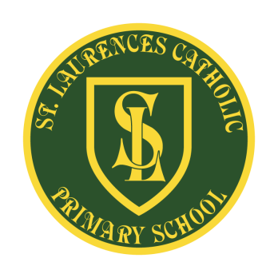
St Laurence’s Catholic Primary School
Leeside Avenue
Southdene
Kirkby
L32 9QX
Telephone: 0151 546 4733
Headteacher: Miss SJ Carroll
Dear Parents/Guardians,
We would like to revise our school’s mission statement.
A mission statement is a public declaration that schools use to describe their purpose and organisational commitments—i.e., what they do and why they do it.
Our current mission statement:
We aim to celebrate our partnership with the families we serve and the community we live in.
We aim to provide an education that enables each child to reach their full potential.
Our aim is the creation of an atmosphere where all are valued, gifts and talents are celebrated and the gospel values of love, respect and justice are at the heart of all we do.
We value your input and would like to invite you to share your ideas of what you believe is important in providing as an educational establishment. Please could you list a maximum of 6 words or phrases below, or on the reverse if this letter, and return to school at your earliest convenience. We will merge everyone’s ideas and come up with a revised mission statement, which will aid in moving our school forward and provide us with a joint vision for St Laurence’s.
Yours sincerely
Miss SJ Carroll
Headteacher

