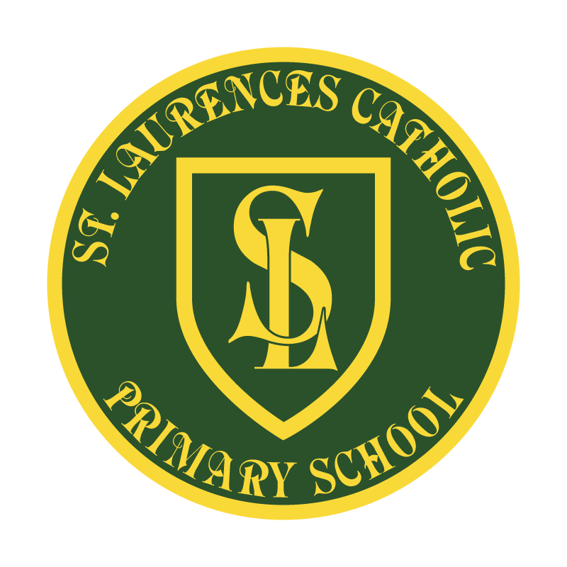

St Laurence’s Catholic Primary School

Policy Statement
for Morality

This policy was reviewed: | January 2018
By name: | Mr John Holmes
Position: | Chair of Governors
Signature: | J. Holmes

ST LAURENCE’S CATHOLIC PRIMARY SCHOOL
OUR MISSION STATEMENT

At St Laurence’s we welcome our partnership with parents and the community.

We aim to provide an education that enables each child to reach their full potential.

We believe this can only be achieved by creating an atmosphere where all are valued, gifts and talents are celebrated and the gospel values of love, respect and justice are at the heart of all we do.

ST. LAURENCE’S CATHOLIC PRIMARY SCHOOL
POLICY FOR MORAL EDUCATION

RATIONALE
Moral education is concerned with developing a child’s ability to distinguish right from wrong, to make appropriate choices and to act upon them from conviction. Personal morality combines the beliefs and values of the individual, those of the social, cultural and religious groups to which he/she belongs and the laws and customs of the wider society.

PURPOSE
To ensure that pupils understand the difference between right and wrong and the importance of striving to do right. This understanding will:

- inform pupils’ thinking and actions and help them exercise their will in
resisting temptation
- prompt the constant attempt to become a better person
- increase fellow feeling and the willingness to make an effort to understand others
- building pupils’ respect for themselves, others, their society and their environment
- enable pupils to engage in effective moral reasoning
- help pupils see that weakness, failure and fault belong to the human condition, but
we should try to overcome them
BROAD GUIDELINES
All adults should have:
- reasonable humility and preparedness to question their own beliefs and actions
- reasonable confidence in themselves
- general goodwill and concern for their pupils
- willingness to review their actual and potential contribution to pupils’ moral development
- a commitment to making that contribution
In order to promote pupils’ moral development, it is essential that the values of St. Laurence’s School are shared with pupils.
Moral Education will be promoted by:
- Fostering positive school values which include –
- Honesty
- Reliability
- Respecting the rights and property of others
- Acting considerably and courteously towards others
- Helping those less fortunate or weaker
- Taking personal responsibility for one’s actions
- Self discipline

REVIEW OF POLICY
The effectiveness of this policy will be reviewed annually by the Senior Leadership Team and every three years by the Governing Body. If changes are made to the policy, the Governing Body will ratify amendments.

This policy was reviewed: January 2018
Signed: J. Holmes
Designation: Chair of Governors
Date: 12.1.18

