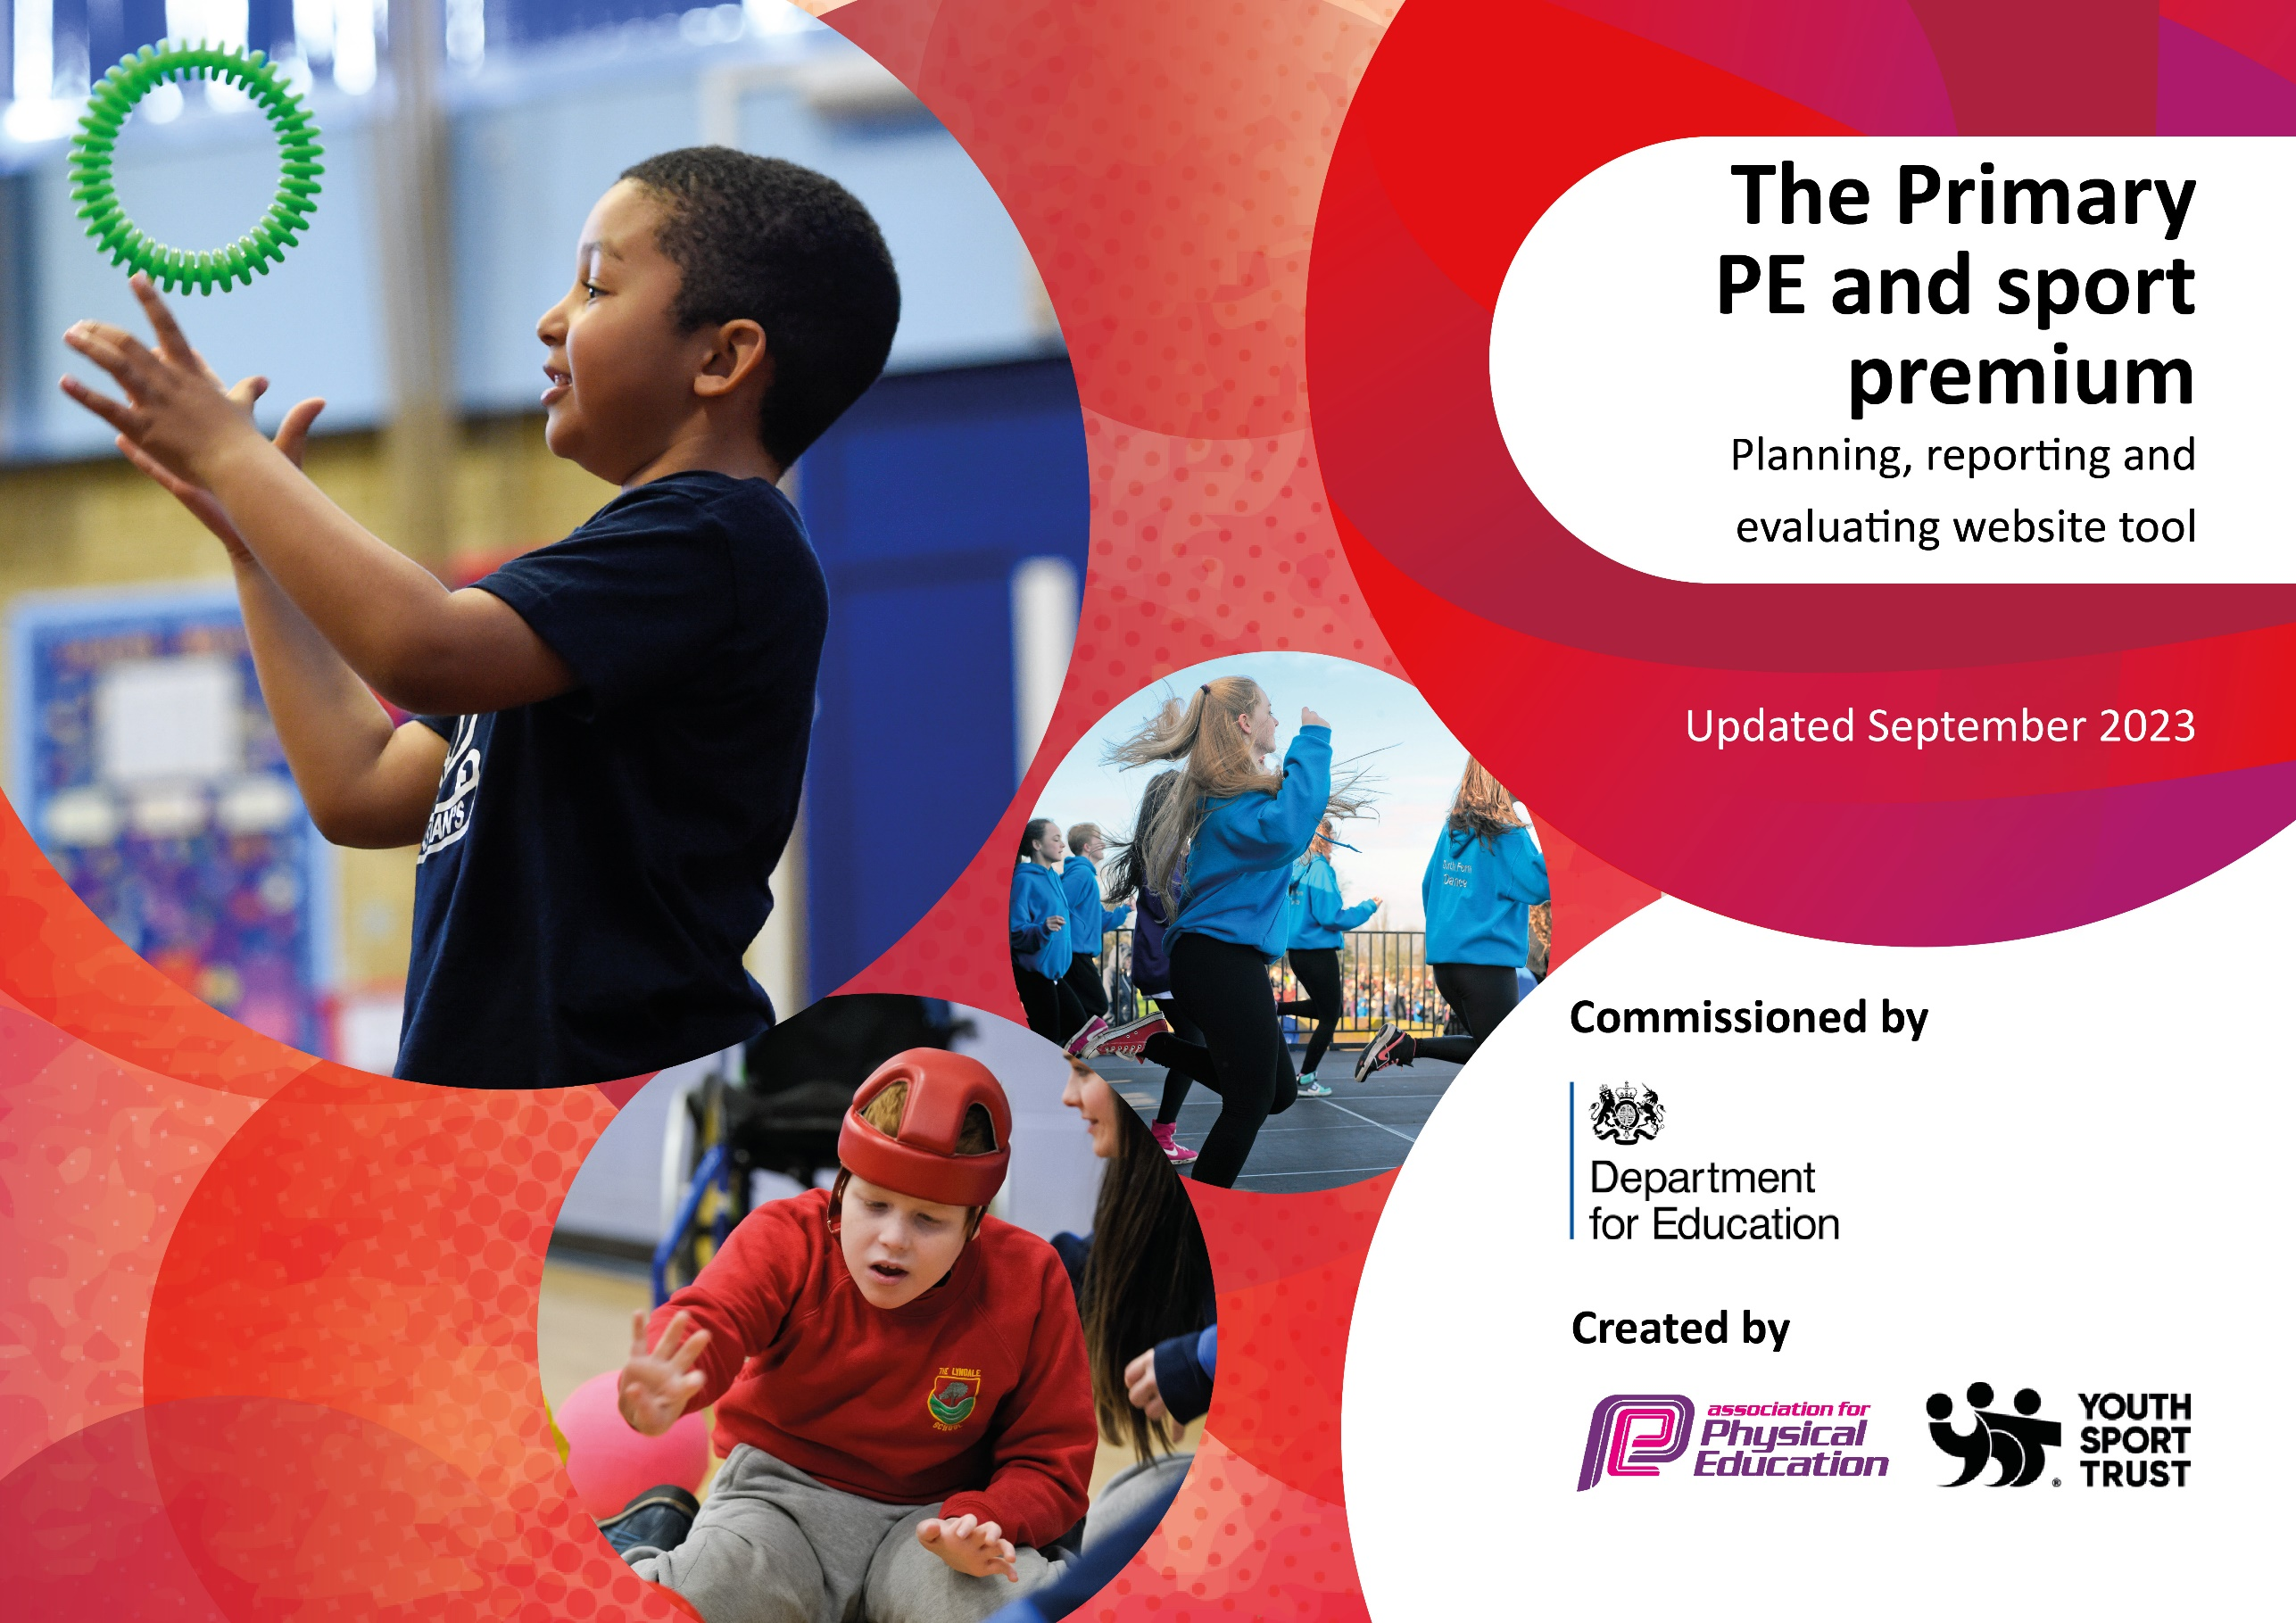
St Laurence Catholic
Primary School
2023-2024

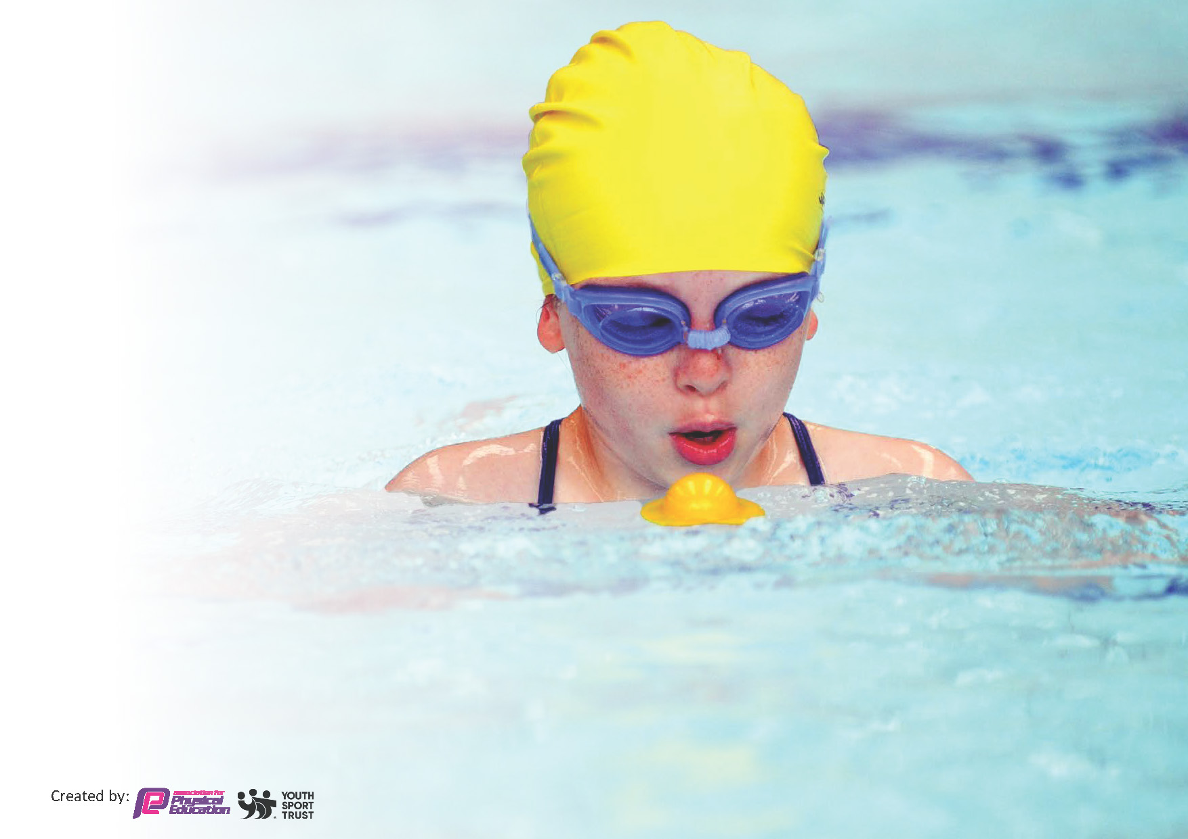
This template can be used for multiple purposes:
by:
- It enables schools to effectively plan their use of the Primary PE and sport premium
- It helps schools to meet the requirements (as set out in guidance) to publish information on their Primary PE and sport premium
- It will be an effective document to support Ofsted inspections enabling schools to evidence progress in Physical Education (PE) and evidence swimming attainment, which forms part of the PE National Curriculum. We would recommend schools consider
the Intent, Implementation and Impact of any spend, as examined within the Education Inspection Framework.

It is important that your grant is used effectively and based on school need.

Schools must use the funding to make additional and sustainable
improvements to the quality of the PE, School Sport and Physical Activity (PESSPA)
they offer. This means that you should use the Primary PE and sport premium to:

- Build capacity and capability within the school to ensure that improvements made now will benefit pupils joining the school in future years
- Develop or add to the PESSPA activities that your school already offers.

The Primary PE and sport premium should not be used to fund capital spend projects; the school’s core budget should fund these. Further detail on capital expenditure can be found in the updated Primary PE and sport premium guidance.

The Primary PE and sport premium guidance, outlines 5 key priorities that funding should be used towards. It is not

necessary that spending has to meet all the key priorities, you should select the priorities that you aim to use any funding towards.

Although completing this template is not a requirement for schools, schools are required to publish details of how they spend this funding. Schools must also outline what the impact this funding has had on pupils’ PE and sport participation and attainment and how any spending will be sustainable in the future. All funding must be spent by 31st July 2024.

The Department for Education has worked closely with the Association for Physical Education (afPE) and the Youth Sport Trust (YST) to develop this template and encourages schools to use it. This template is an effective way of meeting the reporting requirements of the Primary PE and sport premium.
Review of last year’s spend and key achievements (2022/2023)

We recommend you start by reflecting on the impact of current provision and reviewing your previous spend.

Activity/Action | Impact | Comments
Implementation of the Daily Mile at least 3 times a week.  In-school physical activity programme for KS1 and KS2children and parents through Family Fitness twice a week.  Improved quality and variety of PE resources and equipment within school.  All of our extracurricular activities are free and completed by staff.  Separate sports days were organized for KS1 and KS2 pupils, allowing children greater opportunities to participate. Separate sport days also ensures that events are suitable for the participating year groups.  The purchase of the colour run event promoted healthiness and happiness around the school bringing the whole community together to participate in the run.  By using the travel tracker application this has enabled pupils get involved in walk, cycle, or jog activity to school every week instead of driving to school. | This had a massive impact on all who participated. Children were more active around school and therefore creating a healthier lifestyle for all children.  This has a positive impact on both physical and mental well -being of parents and children. In addition to it builds further community link between school and families.  By doing this it enabled the children to complete a wider range of sporting activities within school.  The impact of this suggest extra- curricular activities are important in developing soft (especially social) skills as well as being associated with a range of other positive outcomes (e.g. promotes personal development, improves mental health and well-being, encourages healthy habits, achievement, attendance at school).  Having separate sports days for Key Stage 1 (KS1) and Key Stage 2 (KS2) in schools can have several potential impacts which include: age appropriate events, improved participation, better time management and tailored instruction by the teacher  Children really enjoyed the colour run event and this had a massive impact on all of the children’s well – being and staff members within school and the recommended hour of physical education that week.  Children enjoyed walking to school thus getting pupils more physically active and raising the profile of physical activity within the school. | Try to increase Daily Mile participation to at least 4 times a week in the near future if possible.  As it was a huge success we have been able to offer the family fitness sessions to the parents and children within the community once again this year.  Investing in PE resources not only enhances the physical health and fitness of students but also supports their academic, mental, and social development. It creates a more inclusive and engaging environment, promotes lifelong physical activity, and contributes to the overall wellbeing and success of students.  By separating the sports days it created a more tailored, engaging experience for children in both Key Stages, enhancing participation and enjoyment.  Children really enjoyed this event and we are looking forward to purchasing and completing this event again in the next academic year.  Pupils have stated that they enjoy walking to school and want to continue this which positively impacts their physical and mental well-being.  Staff continue to encourage pupils to walk to school and take up more physical activity to raise the profile of PE.

Key priorities and Planning
This planning template will allow schools to accurately plan their spending.

Action – what are you planning to do | Who does this action impact? | Key indicator to meet | Impacts and how sustainability will be achieved? | Cost linked to the action
To continue to use Everton in the Community (ETIC)  To purchase scoot fit days for children within KS 1 and KS2This will support children with their physical, fine and gross motor skills.  To continue to provide sports clubs that are not part of the curriculum for lower key stage 2, e.g. Quidditch, Indian Dance.  To continue to provide extra- curricular activities for all year groups in several skilled areas.  Subscription to online platform in order to support teachers to deliver a high quality PE curriculum which also focuses on physical literacy in order to develop the whole child.  We as a school celebrate pupil success in PE, sport and physical activity inside and outside of school.  Promote activity through  other areas of the  curriculum | Everton in the community PE coach supported staff and upskilled them in different sports and activities throughout the year. Children are more actively engaged with the EITC coaches in school.  This had an enormous impact on the pupils developing their motor skills.  The impact of this activity contributed towards their recommended hour of physical activity each day, enabling them to keep fit and maintain a healthy lifestyle and to persuade the children to scoot into school rather than come by car increasing active travel.  The children really enjoyed our Quidditch day event which was supplied through ENRICH and also the Dawali dance workshop which was provided by the West End Schools. By providing both workshops to the children had a massive impact on their health and well-being along with meeting the daily exercise needs.  The children have said that they really enjoy the different sessions provided by the staff and have asked if we could be increase the amount of certain sessions per week in a variety of different areas. For example: dance, drama, football, family fitness, boxing, dodgeball cricket and rounders.  PE lead - renew subscription to platform. Teachers - use platform to teach lessons, Pupils - participate in lessons  Teacher/TA celebrate pupil’s achievements in weekly assemblies  Pupils – sense of achievements as participation is celebrated in assemblies, website & Twitter.  PE lead – maintain orienteering trail  Teachers – incorporate orienteering  trail into lessons.  Pupils – take part in physical activities across the curriculum  PE lead – advise parents of active  families section of Getset4pe  Parents & pupils – take part in physical activity at home or via our family fitness sessions.  PE lead – remind teachers of active  blasts in Getset4pe online platform  Teachers – incorporate active blasts in classroom. Pupils – join in with active blasts when required.  PE lead – sign up to ENRICH Education outdoor learning hub  Teachers – use hub to teach outdoor  Activities. Pupils - take part in physical activities outdoors relating to other areas of the curriculum | Key indicator 3: To increase confidence, knowledge and skills of all teaching staff in teaching PE and school sport.  Key indicator 4: Broader experience of a range of sports and activities offered to all pupils  Key indicator 2 and Key indicator 4 -The engagement of all pupils in regular physical activity – the Chief Medical Officer guidelines recommend that all children and young people aged 5 to 18 engage in at least 60 minutes of physical activity per day, of which 30 minutes should be in school.  Key Indicator 4 Broader experience of a range of sports and activities offered to all pupils.  Key Indicator 1 Increased confidence, knowledge and skills of all staff in teaching PE and sport.  Key Indicator 2 Engagement of all pupils in regular physical activity.  Key Indicator 3 The profile of PE and sport is raised across the school as a tool for whole school improvement.  Key Indicator 4 Broader experience of a range of sports and activities offered to all pupils.  KI 3 The profile of PE and sport is raised across the school as a tool for whole school improvement.  Key Indicator 2: Engagement of all pupils in regular physical activity  Key Indicator 3: The profile of PE and sport is raised across the school as a tool for whole school improvement  Key Indicator 4: Broader experience of a range of sports and activities offered to all pupils  Key Indicator 5 Increased participation in competitive sport. | Everton sports coach to continue to work upskilling teachers within years 2/3 this year. This has had a massive impact on the teachers as it will build confidence, knowledge and skill base throughout the year. This will be monitored by PE lead through Planning, observations, assessment and consultation with the EFC coach.  Children again really enjoyed this event as it had a tremendous impact on their motor skills. Therefore we are looking to purchase it again in 24/25.  More pupils meeting their daily physical activity goal, more pupils encouraged to take part in PE and Sport Activities.  By doing this more pupils within the school were meeting their daily physical activity goal.  By purchasing an online PE resource to support teachers can have a positive impact on both the quality of physical education (PE) delivered in schools and the long-term sustainability of PE programs. For example it can help enhance teachers expertise and confidence, provides consistent high quality lessons, improves student engagement and participation and supports inclusive and adaptive PE. | £1100 per term  = £6600  £1500 for both workshops.  Updated equipment =£600  £1650.00  £1200 repurchase of orienteering signs and maps. Children took part in an outdoor learning day provided by enrich education.

PE Lead have access to specialist training through KSSP PE conference.  Resources for PE lessons & playground activities to be updated.  As a school we will continue to encourage all children to participate in competitive sport and any involvement in clubs outside of school is highlighted and celebrated. We have built up a strong relationships with several community based clubs outside of school. (LMSOD, Shissasay Dance school, Quarry Green Football Club and Kirkby Town FC)  Continued involvement with Knowsley Children’s University SLA. (Children will earn University credits for every hour of extra-curricular activity they participate in and they will receive recognition when 30+ hours is reached). | PE Lead attended PE conference.  PE lead to audit resources & replenish  Accordingly. Teachers – use resources to teach lessons. Pupils – use resources with respect to participate in lessons  Our relationship with all of these clubs has become even stronger over the years therefore they will continue to use our school field and sports hall for a number of events throughout the year. Even more children from the school this year are beginning to participate in a wider range of sports outside of school hours which is helping grow confidence and the health and well -being of every child who attends. Pupils from all year groups now compete at a local level with teams progressing to competition finals in all fields mentioned.  Try to increase the numbers of children attending the children’s club and ceremony in summer term for recognition of their achievements in extra-curricular activities by increasing the variety of clubs within the school. | Key Indicator 1: Increased confidence, knowledge and skills of all staff in teaching PE and sport  Key Indicator 1: Increased confidence, knowledge and skills of all staff in teaching PE and sport.  Key Indicator 2: Engagement of all pupils in regular physical activity.  Key Indicator 3: The profile of PE and sport is raised across the school as a tool for whole school improvement.  Key Indicator 4: Broader experience of a range of sports and activities offered to all pupils.  Key indicator 5: Increased participation in competitive sport.  Key Indicator 4 Broader experience of a range of sports and activities offered to all pupils. | Our next steps are to further promote these links with our local clubs and move further afield with other sporting communities.  Children's University is a program that encourages students to engage in learning beyond the classroom, offering a wide range of extra-curricular activities that promote personal development, social engagement, and academic curiosity. Its presence in our school has a profound impact on students, teachers, and the broader school community. It enhances academic achievement, supports personal development and encourages life-long learning. | £180 – one day supply.  £500.  £2,100 plus VAT  (£500 coach for event.)

Key achievements 2023-2024
This template will be completed at the end of the academic year and will showcase the key achievements schools have made with their Primary PE and sport premium spending.

Activity/Action | Impact | Comments
- School have been awarded the School Games ‘Platinum’ Award for Sport for the ninth year in a row.  - Year 5/6 Football winners of Kirkby collaborative league and therefore represented Kirkby at the Knowsley schools football tournament at the Halewood Sports Complex.  - School and children have took part in a variety of different sporting events including, Indoor Athletics, Dodgeball, Football, Cricket, Cross Country and rounders to name but a few.  - Children have completed their swimming sessions weekly in Years 3, 4 and 5.  - Improved Resources for PE lessons & playground | - Children have been part of a variety of sports this year. They have competed in many different competitions both in school and externally.  - The children from Year 5 and 6 were winners and gained a lot of feedback about their enthusiasm, teamwork and respect shown in competition.  - The children have enjoyed being part of many competitions and sports throughout the year – this has made them enjoy extra-curricular activity as well as PE.  - The children have all engaged well in swimming and have gained a lot of confidence in the pool as well as new swimming skills.  - Increased confidence, knowledge and skills of all staff in teaching PE and sport. Engagement of all pupils in regular physical activity. The profile of PE and sport is raised across the school as a tool for whole school improvement. Broader experience of a range of sports and activities offered to all pupils. | - School and children are proud of the achievements for the platinum Sports Mark.  - Children have taken part in a variety of games, competitions and physical activity this year to make sure that we compete for the platinum mark again next year with the option of applying for Platinum Award next year.  - By taking the children swimming it teaches them essential life-saving skills, it improved their physical fitness boosts mental health and well-being and helps with cognitive development. But most of all the children enjoy the experience of going swimming.  - By improving playground resources in schools provides significant benefits to children’s physical, social, emotional, and cognitive development. Well-equipped playgrounds go beyond just offering a place for fun; they serve as important learning environments that contribute to a well-rounded education.

Swimming Data
Meeting National Curriculum requirements for swimming and water safety.
Priority should always be given to ensuring that pupils can perform safe self-rescue even if they do not fully meet the first two requirements of the National Curriculum programme of study

Question | Stats: | Further context  Relative to local challenges
What percentage of your current Year 6 cohort can swim competently, confidently and proficiently over a distance of at least 25 metres? | 72% | Those children who did not achieve returned for further tuition in the summer term.
What percentage of your current Year 6 cohort can use a range of strokes effectively [for example, front crawl, backstroke, and breaststroke]? | 10m front and back only –  90%  25m front and back only –  72%  25m front back and  breaststroke –  72%

What percentage of your current Year 6 cohort are able to perform safe self-rescue in different water-based situations? | 85% | Despite the lower numbers who are able to perform specific strokes it has been pleasing to see the increasing numbers of children who are able to perform self-rescue.
If your schools swimming data is below national expectation, you can choose to use the Primary PE and sport premium to provide additional top-up sessions for those pupils that did not meet National Curriculum requirements after the completion of core lessons. Have you done this? | Yes/No | We will look to send those children who haven’t completed the 25 metre distance using a range of strokes back to the local pool for top up lessons in the summer term 2024.
Have you provided CPD to improve the knowledge and confidence of staff to be able to teach swimming and water safety? | Yes/No | As part of the SLA with the Local Authority a specialist swimming teacher delivers the swimming sessions to all year groups.  Several teachers have now completed online swimming courses last year which has given them confidence in this area when attending our annual swimming lessons at our local leisure centre. We are looking to certificate more staff members within school this year through ASA by using online courses.

Signed off by:

Head Teacher: | Sarah Jane Carroll
Subject Leader or the individual responsible for the Primary PE and sport premium: | Barry Grant PE Co-ordinator
Governor: | John Holmes – Chair of Governors.
Date: | September 2024

