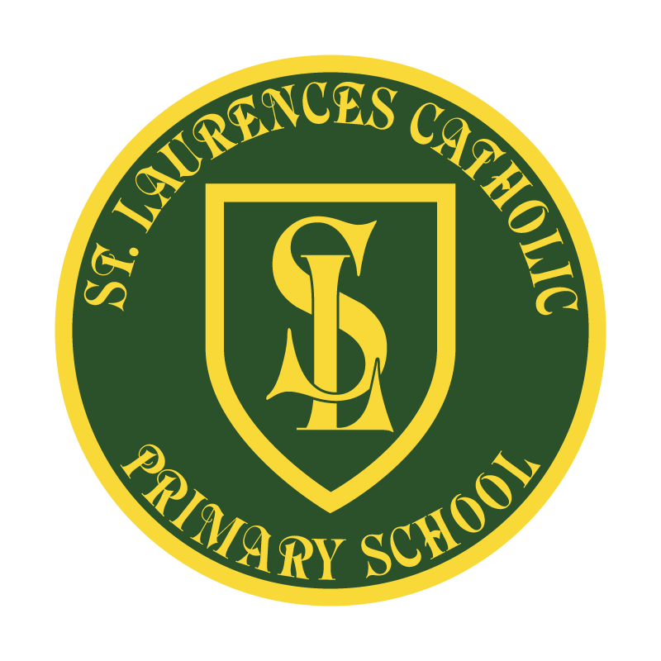

**St Laurence’s Catholic Primary School**

**Policy Statement**

**for**

**Reading for Pleasure**

|  |  |
| --- | --- |
| This policy was reviewed: |  |
| By name: |  |
| Position: |  |
| Signature: |  |

**Our Mission Statement**

**1. We aim to celebrate our partnership with the families we serve and the community we live in.**

**2. We aim to provide an education that enables each child to reach their full potential.**

**3. Our aim is the creation of an atmosphere where all are valued, gifts and talents are celebrated and the gospel values of love, respect and justice are at the heart of all we do.**

**Our Vision**

Everyone feels a sense of belonging,

Has the opportunity to shine,

To enjoy their teaching and learning

But most of all – to dream big!

**Reading for pleasure Policy – St Laurence’s**

**Rationale:**

Reading for pleasure is a vital part of every child’s educational entitlement. Developing a love of reading has huge benefits for children, contributing to pupils’ educational achievement across the curriculum in addition to providing a lifetime of enjoyment. At St Laurence’s Catholic Primary school, we believe in both the importance of developing children’s discrete word-reading skills and comprehension, as well as the need to foster a love of books and reading. “Reading widely and often increases pupils’ vocabulary because they encounter words they would rarely hear or use in everyday speech. Reading also feeds pupils’ imagination and opens up a treasure house of wonder and joy for curious young minds,” (National Curriculum). We recognise that these two elements are intertwined: each relies on the other if children are to become life-long readers. With so much competition for children’s time and attention it is vital that we embed a culture of reading into the core of what we do as a school, helping every child to become a lifelong reader. At St Laurence’s Catholic School we ensure reading is a top priority within all areas of the curriculum. We ensure purposeful books and vocabulary focuses are at the heart of everything we teach to ensure extensive reading and exposure to a wide range of texts make a vital contribution to every child’s educational achievement, regardless of their personal background. This policy works alongside our curriculum statement for reading.

**Provision at St Laurence’s Catholic School**

**Access to reading:**

We aim to ensure that a rich assortment of texts in different formats and genres are available. We believe that access to a wide variety of reading material is extremely important. Texts include:

* Age-related fiction (contemporary and classic)
* Appropriate non-fiction
* Magazines, comics and newspapers
* Internet based texts
* Children’s own work (within books and displays)
* Displays throughout the school
* Online platforms (we subscribe to SATS companion)
* Books that promote diversity and cultures different to our own.

Texts are available in each classroom that accommodate all reading ages within a class. Texts are also available in the school library. We also ensure books are available to support reading ages and match ability.

**Class reading areas and school library:**

* Each classroom has a designated reading area where children have access to a wide variety of texts: fiction, non-fiction, topic related books, newspapers etc. Teachers and pupils ensure these areas reflect the year group and are engaging spaces.
* Library books for KS1 & KS2 are located within classrooms as well as our school library. Children in have access to the school library which also contains books from a variety of genres; by a variety of authors and covers a wide range of interest. We endeavour to ensure that different newly published material is represented and that popular books that succumb to wear and tear are replaced.
* Stories and narrative accounts, e.g. fairy tales, folk tales, and biographies
* Picture books with thought provoking images and examples of artistic talent
* Information books
* As a faith school we proudly provide pupils with examples of reading through scripture and the Bible
* Poetry books
* Joke books
* All pupils have access to reading texts which support early reading phonics, whilst this is found mostly in EYFS and KS1, some pupils continue this support within KS2.

**Pupils are readers:**

* Pupil questionnaires are used to gain an insight into the reading attitudes of the children.
* Older children have opportunities to read with younger year groups through our Year 6 and reception ‘buddy’ system.
* All children are taken on several trips to our local library throughout the year.
* Pupil voice is collected throughout the year to learn about pupils' favourite texts.
* Children are encouraged to celebrate national events such as ‘Shakespeare Week’ or ‘World book day’

**Teachers are readers:**

Teachers at St Laurence’s:

* Read regularly to children. Children can benefit tremendously from being read to aloud. Effective reading aloud time helps to create a positive reading experience which engages students and allows adults to model their enthusiasm for books and reading. This allows whole class interaction, pausing to ask questions about what has been read or discussing the pictures they have been shown. This helps to improve pupil’s comprehension of a story.
* We are a proud ‘Power of Reading school’ all staff have received training to support selecting quality texts.
* Actively encourage a love of reading through discussing books of personal interest, regularly referencing books and promoting different kinds of books.
* Give thought to the choice of class novels to read to and with the children.
* Provide regular time for pupils to read a self-chosen book silently. These slots are built into each class every day to allow every child dedicated time for reading for pleasure.
* Ensure that reading takes place both in and outside of the classroom and in and outside of the school.
* Ensure that engaging displays are visible around the school to encourage children to read for enjoyment.
* Teachers take part in whole school events such as ‘National Poetry Day’
* St Laurence’s staff ensure cross curricular links to reading take place whenever possible and children are exposed to a wealth of STEM and Nonfiction books to increase learning.
* Teachers are observed teaching reading and this is monitored rigorously within class and book scrutinises.
* Employing different elements of the curriculum to develop children as readers: whole class English lessons, guided reading, independent reading, listening to adult reading aloud and reading in curriculum areas other than English, allay an important part of teaching children to enjoy reading.
* Staff new to the school receive support and training from the English Team to ensure power of reading principals are being taught within their classrooms.
* Staff have access to a book club which meets once every half term ; this is lead by the English lead and is open to all staff.
* Staff take ownership of the reading spine to choose high quality texts. This is regularly reflected on to ensure the pupils are having books shared with them that promote diversity and culture capital.

**St Laurence’s English team are readers:**

* At St Laurence’s we are committed to raising the standards of English throughout our school by regular monitoring through our English team. Including: book scrutinises, lesson observations, staff meetings and questioners.
* The English team provides a whole school calendar of reading for pleasure events to complete within the school year. These are then evidenced both within literacy lessons, as well as SMSC links.
* Books are monitored to ensure reading is taking place throughout all areas of the curriculum.
* Book talk is encouraged by staff meetings led by the English team.
* Support for teachers choosing quality texts is completed through support from the English teams
* Within the English team is a school phonics lead, which supports pupils throughout the whole school.
* The English team must give feedback to SLT & governors about all things related to reading at various points within the year.
* All reading practises within school are reflected upon and monitored by the English team to make amendments and changes where necessary.
* Training for to ensure the school is updated on changes to the curriculum is attended by the English lead and fed back to the Head teacher and teaching staff.
* The English team are able to purchase books to replenish reading areas and keep reading current within the curriculum.

**Parents / Carers are readers**

* The school encourages links with parents by ensuring every child has a Home Reading Journal’ that records all reading habits, signed by parents and monitored by class teachers.
* We invite parents to learn about the books we are reading in school through annual coffee mornings.
* Parent volunteers support reading in school for some of our reluctant readers.
* Summer challenges are completed by children within the holidays through pupil and carer participation.
* Families show fantastic support during whole school reading events such as fancy dress costumes on ‘World book day’ or ‘Spooky Spell Day’

**We Celebrate Reading**

* We ensure that reading events are acknowledge and celebrated, such as World Book Day, Roald Dahl Day, Shakespeare Week and National Poetry Day.
* We participate in competitions through our links with Knowsley libraries and national agencies such as the National Literacy Trust and the Reading Agency.
* We use reading in collaboration with other school wide events such as ‘Black History Month’ or ‘National Space Week’ to ensure children have cultural capital through targeted reading.
* English certificates are given out each week for varied reading related achievements.
* Books are bought as prizes throughout the school year.

**Reluctant Readers**

We continue to target reluctant readers in a variety of ways to tackle gaps within learning. ‘Evidence suggests that there is a positive relationship between reading frequency, reading enjoyment and attainment (Clark 2011; Clark and Douglas 2011)’

* Through celebratory events.
* Through competitions.
* Ensuring that children have access to books and resources that they will want to read.
* We are committed to reading daily with our lowest 20% readers 1:1
* Various support and intervention is put into place for non-fluent readers including daily phonics for all pupils up to Year 6.