**English Curriculum Statement**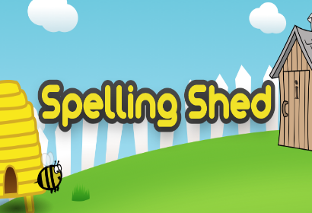

**(Phonics)**

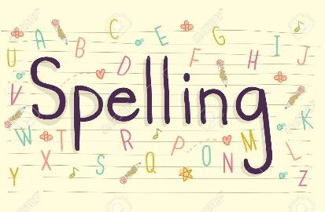

Our phonic and spelling intent, implantation and impact is a culmination of the commitment we have to the written word in all its forms. We believe the work we do in early years reading and phonics is the bedrock to all other success in English our pupils achieve.

**Intent**

At St Laurence’s Catholic Primary School, we want to equip all our pupils with a secure phonic and spelling knowledge that enables them to read and write successfully. We have a commitment to the long-term goal of preparing children for the complexities of language in later key stages, aligning phonics instruction with future spelling and reading challenges. Children will be able to apply their understanding of letters and sounds to decode a range of words which in turn will allow them to read books that are closely matched to their phonic knowledge. When writing, children will be able to make phonically plausible attempts at unfamiliar words, enabling them to write with an appropriate level of independence for their age. They will also be able to use their phonic knowledge to correctly apply a range of spelling rules to words. We believe this is achievable through a combination of strong, high quality, discrete phonics teaching combined with a whole language approach that promotes a ‘Reading for Pleasure’ culture. The teaching of phonics and spelling is of high priority in our school.

**Implementation**

In EYFS and KS1, a systematic and rigorous approach to phonics will be applied through the delivery of the Read, Write Inc. programme. Robust, half-termly assessments will be used to ensure that children are making at least expected progress and are placed in a group that is matched to their ability. Where children are not making expected progress, 1:1 tutoring sessions will be put in place to address this. Staff delivering Read, Write Inc. lessons will have access to quality training materials and attend regular coaching sessions to ensure that teaching is consistent across all groups and always to a high standard. Children will take home familiar and unfamiliar books that are closely matched to their phonic knowledge. When ready, children in KS1 will access the RWI comprehension programme, which will allow them to revisit and apply their phonic knowledge in a range of comprehension activities. In KS2, some children will continue to access RWI lessons until they complete the programme in order to continually support their learning and understanding of more complex reading. These children will continue to take home familiar and unfamiliar books that are closely matched to their phonic knowledge.

In KS2 children are taught spelling through ‘Spelling Shed’. These lessons continue to build on KS1 skills. Children will learn orthography through adult-led discussion and investigation children will become more secure in their knowledge of English orthography based on the frequency and position of the sounds within words. Morphology lessons throughout the scheme that consolidate children’s knowledge of common morphemes such as root formations, prefixes and suffixes. As well as entomology, children will be able to see how the English language has, over time, borrowed and integrated words and spellings from a range of source languages. For example, the latinate verbs which follow Latin prepositions in English words such as: -act (do), -pute (think) or -opt (choose). These lessons take place during English sessions as well as guided read through teacher input and explored through use of spelling lists and games. Pupils are then tested on particular words so the class teacher can keep a record of patterns or word lists which may need further teaching throughout the year. This is further checked and monitored by our English lead and other school stakeholders.

SEND & Disadvantaged provision

At St Laurence’s we use the The Read Write Inc. (RWI) programme as it provides structured and systematic support for all children, including those with Special Educational Needs and Disabilities (SEND), helping them develop strong foundational skills in early reading. For our SEND children, the programme’s carefully sequenced and multi-sensory approach is especially beneficial as it breaks down the complexities of phonics into manageable steps, ensuring that every child can make progress, regardless of their starting point. The systematic synthetic phonics approach, of RWI allows children to learn sounds in a specific, cumulative order. For SEND children, this structured progression is key, as it allows them to build confidence with each new sound before moving on. The small, incremental steps reduce cognitive load, which is particularly important for pupils with learning difficulties or those who process information more slowly. Teachers use quality first teaching to ensure that children revisit previously learned sounds frequently, reinforcing learning and providing SEND pupils with multiple opportunities to consolidate their knowledge.

**Impact**

Children feel confident in using their phonic knowledge and the strategies that they have been taught to read words. This helps them to access a range of material and, in turn, fosters a love of reading. By taking home books that are closely matched to their phonic knowledge, children can celebrate reading success with their parents and carers which will give them the confidence and motivation to read regularly. This will have a positive impact on the progress that they make. Children will be able to make phonically plausibly attempts at spelling words and therefore communicate their ideas in writing across a range of subjects and for a range of purposes both in and out of school. Based on their phonic knowledge, children can make good spelling choices and spell many words correctly. By tracking and monitoring our bottom 20% children within all areas of literacy, class teachers regularly reflect on support and intervention in efforts to ensure all gaps are filled. By using the supporting materials from RWI this is robust and targeted tailored intervention is quickly able to take place, delivered through support staff and class teachers.

In short, we aspire for our pupils to:

• read at an age-appropriate level with fluency which enables them to access the broader curriculum

• develop a life-long love of reading where they read widely and often, with fluency and comprehension.

• Achieve well at EYFS, Key Stage 1 and Key Stage 2 assessment points

• Have the required phonics skills to pass Year 1 phonic screening check on the first attempt