

St Laurence’s Catholic Primary School

Policy Statement
For
Complaints

This policy was reviewed and re-adopted on | 16th September 2021
By name | Mr John Holmes
Position | Chair of Governors
Signature | On behalf of  St Laurence’s Primary School

Our Mission Statement
We aim to celebrate our partnership with the families we serve and the community we live in.
We aim to provide an education that enables each child to reach their full potential.
Our aim is the creation of an atmosphere where all are valued, gifts and talents are celebrated and the gospel values of love, respect and justice are at the heart of all we do.

Our Vision
Everyone feels a sense of belonging,
Has the opportunity to shine,
To enjoy their teaching and learning
But most of all – to dream big!

Contents

Introduction 2
Guidance for Schools – Prevention 3
Linked Documents 4

Guidance for Schools – Good Practice Principles 5
Investigating Complaints 5
Resolving Complaints 6
Anonymous Complaints 6

School Complaints - Model Procedure 7
Informal Stage: 7
Stage 1: 8
Stage 2: 9
Stage 3: 11
Withdrawing a complaint 12

Guidance for Schools – Dealing with unreasonable and unreasonably persistent complaints 12
Examples of unreasonable or unreasonably persistent complaints 12
Things to Consider 13
Guidance for Schools – dealing with abusive, threatening or violent adult visitors 14

Information for Parents and carers on school complaints procedure 15
Informal Stage: 15
Stage 1: 15
Stage 2: 15
Stage 3: 16

Roles and Responsibilities defined 17
The Complainant 17
The Children’s Complaints Officer 17
The Advocate 18
The Ombudsman 18

Recording, reporting and taking action to improve service delivery 19
Useful Contacts 20
Process Maps 0
School Complaints Informal Stage 0
School Complaints Stage 1 1
School Complaints Stage 2 2
School Complaints Stage 3 3
Unreasonable or unreasonably persistent complaints 4

Introduction

This document contains guidance for schools in managing comments and complaints, identifies links to other complaints processes and provides a model policy for adoption. It is the responsibility of individual schools to respond to complaints about the school. Complaints about schools received by the Directorate of Children and Family Services will be referred immediately to the relevant school to deal with under the school complaints procedure. This document is intended to assist Head Teachers and Governors to draw up a policy and procedure that enable them to deal effectively with any concerns raised. Schools may, if they wish, amend the model procedure to meet their own needs.

Since September 2003 governing bodies of all maintained schools and maintained nursery schools in England were required under section 29 of the Education Act 2002 to have in place a procedure to deal with complaints relating to the school and any community facilities or services that the school provides and to publicise the procedure. This can be done by including a summary in the school’s prospectus, displaying posters or leaflets, or by publishing on the school’s website.

Should anyone contact the local authority regarding a school complaint, they will be provided with information on the procedure and encouraged to contact the school directly. The Complaints Officer will also endeavour to inform the Head Teacher of any enquiries to enable them to make an early intervention and address any concerns.

Schools take their responsibility for children seriously. They value the support and partnership of parents and carers. They try very hard to get things right. However, despite everyone’s best efforts, situations may arise which require further attention.

A complaint is defined as:
“An expression of dissatisfaction or disquiet in relation to a school or teacher, which requires a response.”

Pupils, parents or carers can make a complaint to the school about most aspects of its function including:
- Attitude / behaviour of staff
- Teaching and learning
- Application of behaviour management systems
- Bullying
- Provision of extra-curricular activities
- The school environment

The Local Authority retains responsibility for:
- The National Curriculum
- Collective Worship in schools (In the case of denominational schools, concerns relating to worship and spiritual matters may be referred to the relevant Diocese or Archdiocese.)
- Provision of support services such as SEN, school attendance, educational psychology.

Complaints about these matters should be referred to the Directorate of Children and Family Services via the Complaints Manager for progression through the council’s complaints procedure.

Members of the general public may make complaints to the school if the school is directly responsible for the issue being complained about. For example:

- Behaviour of pupils during break-times
- Disturbance to neighbours during school hours
- Health and Safety issues of premises
- Behaviour of staff

Schools are not responsible for the actions or behaviour of pupils outside school hours.

Legal, child protection or disciplinary proceedings take precedence over complaints procedures and timescales.

Guidance for Schools – Prevention
In order to minimise the likelihood of a complaint it is recommended that the following policies and procedures for schools are current, understood by all staff and fully complied with at all times:
- Behaviour Policy
- Anti-Bullying Policy
- Equality and Diversity Policy
- School Complaints Policy
The following training is recommended for all school based staff in respect of preventing and managing complaints:
- Equality and Diversity
- Safeguarding
- Managing Complaints

Linked Documents

This document brings together guidance, policies and procedures relating to school complaints building on national guidance and best practice. This forms part of DCFS wider policy and procedures for complaints covering school complaints, corporate complaints and Children’s Act complaints (Children’s social care). We have also produced:

- A school’s toolkit containing the schools guidance and model procedure (this document), template letters and guidance for schools;
- A parents / carers toolkit with easily accessible guidance and template letters for making a complaint; and
- A young person’s guide to making a complaint

Guidance for Schools – Good Practice Principles

It is important to be clear about the difference between a concern and a complaint. Taking informal concerns seriously at the earliest stage will reduce the numbers that develop into formal complaints.

The underlying principle is that concerns ought to be handled, if at all possible, without the need for formal procedures. The requirement to have a complaints procedure need not in any way undermine efforts to resolve the concern informally. In most cases the class teacher or the individual delivering the service, in the case of extended school provision, will receive the first approach. It would be helpful if staff were able to resolve issues on the spot, including apologising where necessary.

Schools might wish to nominate a member of staff to have responsibility for the operation and management of the school complaints procedure. This role could be termed the school’s ‘Complaints Co-ordinator’. In smaller schools this may often be the Head Teacher.

An effective Complaints Procedure will:

- encourage resolution of problems by informal means wherever possible;
- be easily accessible and publicised;
- be simple to understand and use;
- be impartial;
- be non-adversarial;
- allow swift handling with established time-limits for action and keeping people informed of the progress;
- ensure a full and fair investigation by an independent person where necessary;
- respect people’s desire for confidentiality;
- address all the points at issue and provide an effective response and appropriate redress, where necessary;
- provide information to the school’s senior management team so that services can be improved.

Investigating Complaints

It is suggested that at each stage, the person investigating the complaint makes sure that they:

- establish what has happened so far, and who has been involved;
- clarify the nature of the complaint and what remains unresolved;
- meet with the complainant or contact them (if unsure or further information is necessary);
- clarify what the complainant feels would put things right;
- interview those involved in the matter and/or those complained of, allowing them to be accompanied if they wish;
- conduct the interview with an open mind and be prepared to persist in the questioning;
- keep notes of the interview.

Resolving Complaints

At each stage in the procedure schools will want to keep in mind ways in which a complaint can be resolved. It might be sufficient to acknowledge that the complaint is valid in whole or in part. In addition, it may be appropriate to offer one or more of the following:

- an apology;
- an explanation;
- an admission that the situation could have been handled differently or better;
- an assurance that the event complained of will not recur;
- an explanation of the steps that have been taken to ensure that it will not happen again;
- an undertaking to review school policies in light of the complaint.

It would be useful if complainants were encouraged to state what actions they feel might resolve the problem at any stage. An admission that the school could have handled the situation better is not the same as an admission of negligence.

An effective procedure will identify areas of agreement between the parties. It is also of equal importance to clarify any misunderstandings that might have occurred as this can create a positive atmosphere in which to discuss any outstanding issues.

Anonymous Complaints

Anonymous complaints must be recorded and referred to the Head Teacher in the same way as other complaints.

The Head Teacher should discuss anonymous complaints with the Complaints Manager. If there is sufficient information contained in the complaint it will be investigated in the same way as other complaints.

If there is insufficient information to support an investigation, the complaint will be recorded for service improvement purposes and closed.

SEND Complaints
Please refer to school complaints procedure for any generic SEND complaints. If your complaint is linked to an EHCP appeal please refer to https://www.knowsleyinfo.co.uk/advice-information-local-offer/right-appeal-and-mediation-education-health-care-plans
Which is the Knowsley Offer for SEND and advice for parents.

School Complaints - Model Procedure

Informal Stage:

The vast majority of concerns can be resolved informally. There are many occasions where concerns are resolved straight away by the class teacher, office staff, Head of Year or the Head Teacher, depending on whom the complainant first approaches. It is in everyone’s best interests that complaints are resolved at the earliest possible stage. The experience received at first contact with the school can have a significant impact on the remainder of the process; consider the key principles (outlined on page 4).

Complainants must feel able to raise concerns with members of staff without any formality, either in person, by telephone or in writing. This allows staff to establish whether a person is asking a question, expressing an opinion or making a complaint.

The member of staff first who deals with the initial contact should clarify the nature of the concern and re-assure the complainant that the school wants to hear about it. If the member of staff can resolve the concern immediately they should do so. They should then record the enquiry and any agreements made, and notify the Head Teacher.

It will assist the procedure if the school respects the wish of a complainant who indicates they would have difficulty discussing their concerns with a particular member of staff. Similarly, if a member of staff feels too compromised to deal with a complaint, they should be able to pass the concern to another member of staff.

Where the first approach is made to a governor, the next step would be to refer the complainant to the appropriate person and advise them about the procedure. Governors should not act unilaterally on an individual complaint outside the formal procedure or be involved at the early stages as they may be required to sit on a review panel at a later stage of the procedure.

If the member of staff can’t resolve the concern, they should make a clear note of the date, name, contact address and phone number and a brief note of the nature of the concern. It would also be useful to record what sort of outcome the complainant is looking for. The member of staff should then refer the complaint to the Head Teacher, or designated Deputy. The Head Teacher must decide if the concern is covered by the complaints procedure or should be dealt with under other procedures e.g. child protection or personnel.

If the concern involves an allegation of assault or abuse of a child by a member of staff, the Head Teacher must inform the LADO.

If the concern is about the Head Teacher, the member of staff should provide the complainant with details of how to contact the Chair of the Governing Body.

The staff member dealing with the concern should make sure that the complainant is kept informed of any action taken. The emphasis at this stage should be on resolving the issue quickly and informally for the benefit of staff, pupils and parents.

The complainant should receive a response as soon as possible, and within a maximum of 15 school working days. At this stage the response may be given verbally or in writing. A record should be kept to inform service improvement (contact the Local Authority Complaints Officer). The complainant should be given information on how to proceed if they are not satisfied and where to get independent advice.

Stage 1:

Formal complaints should be made in writing to the Head Teacher. If the complaint is about the Head Teacher they should write to the Chair of the Governing body who should carry out the Stage Two procedure. If the complainant has difficulty expressing themselves in writing, they should be informed where they can get independent assistance. Template letters for making a complaint will be available from the Local Authority.

The Head Teacher should acknowledge the complaint within 3 school working days. The acknowledgement should include a summary of the complaints procedure and a target date for providing a response. This should be within 15 school working days. If this date cannot be met, the complainant should be contacted and given a reason for the delay and a revised target date.

The Head Teacher should provide an opportunity for the complainant to meet him/her to discuss their concerns and find solutions. It should be made clear that the complainant may bring a friend, family member or advocate to the meeting if they wish. Interpreting services should also be made available where necessary. The Head Teacher may find it useful to have another member of staff present to observe and record the meeting and promote staff safety. Care should be taken in these circumstances not to create an intimidating atmosphere for the complainant. Under no circumstances should audio recording equipment be used.

The Head Teacher should make whatever enquiries s/he considers necessary to ascertain the facts and the legitimacy of decisions taken (the head teacher may delegate the task of collating the information to another staff member but not the decision on the action taken). This may include:

- Interviewing staff / pupils
- Reviewing minutes of meetings
- Reviewing school records

Pupils should be interviewed in the presence of another member of staff or learning mentor, or in the case of serious complaints (e.g. where the possibility of criminal investigation exists) in the presence of their parents. Again, care should be taken in these circumstances not to create an intimidating atmosphere.

It is important that the Head Teacher investigates complaints thoroughly and objectively. If s/he feels unable to do this (e.g. if s/he has been directly involved in the decision making process that led to the complaint) s/he should delegate responsibility for investigating the complaint to another member of the management team or the Chair of Governors. It is strongly advised that the Head Teacher should keep a record of interviews, telephone conversations and other documentation.

Once all the relevant facts have been established, the Head Teacher should provide a written response to the complainant. This should include a full explanation of decisions taken and the reasons for them. Where appropriate, it should include details of actions the school will take to resolve the complaint.

It may be useful at this point to offer the complainant a meeting to discuss the response and seek reconciliation. The complainant should be provided with details of how to contact the Governing body if they are not satisfied with the response.

Stage 2:

A letter received by the school notifying that a complainant is dissatisfied with the outcome of a complaint at Stage One must be passed to the Chair of Governors within 3 school working days.

In the case of a written complaint received directly by the governing body, the Chair of Governors should first ensure that:

- The complaint has first been dealt with at Stage One.
- The complaint is covered by the school’s complaints procedure not other procedures e.g. personnel or child protection.

Upon receipt of a letter notifying that the complainant is not satisfied with the outcome of a Stage One investigation the Clerk to the Governors should write acknowledging that the complaint has been received. The letter should explain that the complainant has the right to submit any further documents or information relevant to the complaint. A deadline for submission of these documents should be given.

The Head Teacher should also be invited to submit a written report for the complaints Appeal panel. The Head Teacher may also invite members of staff directly involved in matters raised by the complainant to respond personally or in writing.

The Clerk to the Governors should convene the Complaints Appeal Panel elected from the governing body. The committee should comprise of 3 or 5 Governors who have had no previous involvement with the complaint. The complaint should not be heard by the entire governing body as this could compromise the impartiality of any panel set up for a disciplinary hearing against a member of staff following a serious complaint.

The complaints committee should set a timetable for the investigation and should notify the complainant of this. The review hearing should be heard within 20 school days of receiving the letter.

The Clerk should write to inform the committee, Head Teacher, complainant and any relevant witnesses of the date and time of the hearing, giving a minimum of 5 days notice. All documents submitted should be circulated to the committee, the Head Teacher and the complainant. The complainant will be notified of their right to have a friend, family member, advocate or interpreter present if they wish. The Chair of Governors should ensure that minutes are recorded of the review panel meeting.

The panel should be open-minded and independent. The aim of the meeting should be to resolve the complaint and achieve reconciliation between the school and the complainant. However, it may sometimes only be possible to establish the facts and make recommendations that satisfy the complainant that their concern has been taken seriously.

The hearing should be held in private. Any witnesses (other than the complainant and the Head Teacher) should only attend for the part of the hearing in which they give their evidence.

The committee should remember that the complainants may not be used to formal meetings and may feel inhibited in addressing the committee. It is recommended that the Chair of the committee keep the proceedings as informal as possible. This is particularly important if the complainant is a child.

If either party wishes to introduce new information at the meeting, this should be allowed. The meeting should then be adjourned for a short period to allow other parties to review and respond to this information.

The meeting should allow for:

- The complainant to explain their complaint and the Head Teacher to explain the school’s response.
- Witnesses to be brought by the complainant or the Head Teacher.
- The Head Teacher and the complainant to ask questions of each other and any witnesses.
- The committee to ask questions of the complainant, Head Teacher and any witnesses.
- The complainant and the Head Teacher to summarise their position

The Chair of the Panel should explain to the complainant and the Head Teacher that the committee will consider its decision and respond in writing within 15 school working days. The complainant and the Head Teacher should then leave.

The committee should then consider the complaint and all the evidence presented. They should then decide:
- Whether or not they uphold the complaint, in whole or in part
- What action can be taken to resolve the complaint
- Where appropriate, recommend what action can be taken to prevent similar difficulties on the future.

A written response detailing the decisions, recommendations and the basis on which these have been made should be sent to the complainant within 15 school working days.

The school should retain a copy of all correspondence and records of meetings for seven years.

Stage 3:

The Complainant should be notified of the right to appeal to the Secretary of State for Education or the Local Government Ombudsman if they are unhappy with the way in which procedures have been carried out.

Withdrawing a complaint

Complaints may be withdrawn in writing at any time.

The Head Teacher and Chair of Governors should review the issue of concern and consider whether further investigation is required through other internal management systems.

Guidance for Schools – Dealing with unreasonable and unreasonably persistent complaints

A good complaints procedure can limit the number of complaints that become protracted. However, there may be occasions when despite all stages of the procedure being followed, the complainant remains dissatisfied.

Unreasonable or unreasonably persistent complainants may have reasonable grounds for complaint but pursue them in unreasonable ways. Or they may pursue complaints which have no substance or have previously been investigated. Contact by such complainants with the school or authority may be amicable whilst placing significant demands on resources, or may be emotional and distressing for those involved.

Examples of unreasonable or unreasonably persistent complaints

The Local Government Ombudsman outlines a number of examples of unreasonable or unreasonably persistent complainants and the types of behaviour that may be encountered:
- Refusing to specify the grounds of a complaint, despite offers of assistance with this from staff.
- Refusing to co-operate with the complaints investigation process while still wishing their complaint to be resolved.
- Refusing to accept that issues are not within the remit of a complaints procedure despite having been provided with information about the procedure’s scope.
- Insisting on the complaint being dealt with in ways which are incompatible with the adopted complaints procedure or with good practice.
- Making what appear to be groundless complaints about the staff dealing with the complaints, and seeking to have them replaced.
- Changing the basis of the complaint as the investigation proceeds and/or denying statements he or she made at an earlier stage.
- Introducing trivial or irrelevant new information which the complainant expects to be taken into account and commented on, or raising large numbers of detailed but unimportant questions and insisting they are all fully answered.
- Electronically recording meetings and conversations without the prior knowledge and consent of the other persons involved.
- Adopting a 'scattergun' approach: pursuing a complaint or complaints with the authority and, at the same time, with a Member of Parliament, a local elected member, the authority’s independent auditor, the Standards Board, local police/solicitors/ or the Ombudsman.
- Making unnecessarily excessive demands on the time and resources of staff whilst a complaint is being looked into, by for example excessive telephoning or sending emails to numerous council staff, writing lengthy complex letters every few days and expecting immediate responses.
- Submitting repeat complaints, after complaints processes have been completed, essentially about the same issues, with additions/variations which the complainant insists make these 'new' complaints which should be put through the full complaints procedure.
- Refusing to accept the decision – repeatedly arguing the point and complaining about the decision.
- Combinations of some or all of these.

Things to Consider
In these circumstances, the Head Teacher and / or Chair of Governors should liaise with Legal Services and the appropriate Children and Family Services Manager / Service Director before deciding what action to take. They may also seek advice from the Complaints Manager and Governor Support Service. In order to make use of the unreasonable or unreasonably persistent complaints procedure it should be clear and agreed that:
- the complaint is being or has been investigated properly;
- any decision reached on it is the right one;
- communications with the complainant have been adequate; and
- the complainant is not now providing any significant new information that might affect our view on the complaint.
The presumption should be in favour of not restricting access unless it is absolutely necessary. The Governors may consider:
- Warnings / contract regarding future conduct
- Suspension of the persons access to school premises
- Placing time limits on telephone conversations and personal contacts.
- Restricting the number of telephone calls that will be taken (for example, one call on one specified morning/afternoon of any week).
- Limiting the complainant to one medium of contact (telephone, letter, email etc) and/or requiring the complainant to communicate only with one named member of staff.
- Requiring any personal contacts to take place in the presence of a witness.
- Refusing to register and process further complaints about the same matter.
- Where a decision on the complaint has been made, providing the complainant with acknowledgements only of letters, faxes, or emails, or ultimately informing the complainant that future correspondence will be read and placed on the file but not acknowledged. A designated officer should be identified who will read future correspondence.
The complainant must be written to informing them of:
- the decision that has been taken;
- what it means for his or her contacts with the school;
- how long any restrictions will last; and
- how to contact the Local Government Ombudsman and Secretary of State.
A copy of the Unreasonable Complaints Policy must be enclosed with this letter.

Guidance for Schools – dealing with abusive, threatening or violent adult visitors
Schools should ensure that they have policies covering incidents involving abusive, threatening or violent adult visitors.
As a general rule, schools are orderly, safe places, where relationships between staff and visitors, especially parents, demonstrate mutual respect and recognition of a shared responsibility for pupils’ welfare and educational progress. However, in a minority of schools, the behaviour of a few parents can cause severe disruption or worse, resulting in abusive or aggressive behaviour towards staff. Violence, threatening behaviour and abuse against school staff or other members of the school community will not be tolerated. All members of the school community have a right to expect that their school is a safe place in which to work and learn. There is no place for violence, threatening behaviour or abuse in schools. Where such behaviour does occur, the Directorate of Children and Family Services will play a proactive role in taking all possible action to deal with it, in response to the wishes of the school. If possible, the police should be involved in agreeing a policy for dealing with such incidents and where appropriate, should become involved in particular incidents.
Information for Parents and carers on school complaints procedure

The local authority has developed a leaflet for parents and carers to outline the complaints process in a clear way. The leaflet refers to the detail contained in this document.

Informal Stage:

Many concerns can be resolved quickly with goodwill, often by making early contact with the class teacher or Head of Year. If this is not possible, or the teacher is unable to resolve the concern, the parent, carer or pupil should contact the Head Teacher or Deputy Head Teacher.

The person who receives the complaint should attempt to work with the family to resolve the complaint informally. This may involve

- Mediation and conciliation
- Explaining policies or decisions
- Helping the pupil to express their views to another person
- Review of educational provision
- Review of support services

Stage 1:

If the pupil, parent or carer is not satisfied with the outcome of the informal investigation, they may wish to make a formal complaint. This should be done in writing to the Head Teacher.

If the complaint is about the Head Teacher, or if the problem is not resolved, the matter should be referred to the Chair of Governors of the school.

The school and its Governors have a duty in law to act properly and investigate complaints impartially. Once investigations are complete the person making the complaint should receive a written response from the school.

Stage 2:

Pupils, parents and carers who are not satisfied with the outcome of the investigation and wish to pursue a complaint regarding a school issue can refer the complaint to a review committee of Governors, known as the complaints panel.

This can be done by writing to the Clerk to the Governing Body. The aim of the panel is to establish any areas of agreement and identify actions that can be taken to resolve the complaint.

Stage 3:

If all other attempts to resolve the complaint have been unsuccessful the pupil, parent or carer may refer their complaint to the Local Government Ombudsman or Secretary of State for Education.

Roles and Responsibilities defined

The Complainant

The complainant is the person who makes the complaint.

The complainant will receive more effective responses to the complaint if s/he:

- co-operates with the local authority in seeking a solution to the complaint;
- expresses the complaint in full as early as possible;
- responds promptly to requests for information or meetings or in agreeing the details of the complaint;
- asks the Complaints Manager for assistance as needed; and
- treats all those involved in the complaint with respect.

The Children’s Complaints Officer

The Children’s Complaints Officer in Knowsley is the Business Partner (Information, Risk and Compliance). This role is the Designated Complaints Manager for Knowsley’s Directorate of Children & Family Services. The primary function is to co-ordinate all aspects of complaints by users of the Directorate’s services, including children’s social care, education, early years and youth services.

The Complaints Officer will be available as an initial point of contact for people wishing to make a comment, compliment or complaint. The service will provide information, advice and support to service users regarding the complaints procedures, and support staff to respond to and resolve issues. This may include providing mediation or conciliation if the Service Manager or Head Teacher and the Complaints Officer agree that this would be appropriate and beneficial.

The Complaints Officer has responsibility for promoting the accessibility of the complaints service to all Knowsley children and young people and their families, regardless of age, disability or ethnicity. This includes providing access to advocacy services for children and young people.

The Complaints Officer has responsibility for maintaining a detailed record of all complaints made and their outcomes and producing reports on the operation of the complaints service.

The Complaints Officer will also provide training, support and advice to staff, managers and partners to ensure an effective response to all representations and complaints.

The Advocate

The advocate should provide independent and confidential information, advice, representation and support to the child or young person making the complaint. The role of the advocate in the complaints procedure is:

- to empower the child or young person by enabling him to express his views, wishes or feelings, or by speaking on his behalf;
- to seek the resolution of any problems or concerns identified by the child or young person by working in partnership with the child or young person and only with his agreement;
- to support the child or young person pursuing a complaint through every stage of the complaints procedure and to provide him with information about his rights and options, helping him clarify the complaint and the outcomes he is seeking; and
- to speak for or represent the child or young person at any stage of the complaints process, including at the informal stage or at any formal hearing or interviews.

The Ombudsman

- To investigate whether there has been any maladministration on the part of the local authority
- To make recommendations on action to be taken if maladministration is found.
- To report publicly on any cases where maladministration is found.

Recording, reporting and taking action to improve service delivery

The Complaints Officer will keep a record of all complaints received by DCFS, what action was taken to resolve them, the outcome and compliance with timescales. In order to identify trends and issues schools should keep the Complaints Officer updated with progress and outcomes of complaints.

To assist in this, staff should notify the Complaints Officer of all complaints received in line with the specified procedures.

The information will be recorded in the Children and Family Services Complaints Database. Access to the database is limited to named individuals within the Support Team and Extended Leadership Team.

An annual report on all complaints information will be produced and submitted to the Extended Leadership Team and Cabinet Member.

A young people’s version of the report will be made available. The purpose of this is to enable children and young people to see that their concerns and suggestions are taken seriously and to identify any patterns, trends or areas for service improvement.

Where patterns or weaknesses in service delivery are identified, these will be discussed with the relevant team or management group to agree ways to improve overall service delivery.

In addition to the annual report, summary reports will be produced throughout the year to highlight good practice and significant issues particular to certain service areas. This will encourage service development as an ongoing response to issues raised in complaints.

Useful Contacts

Children’s Complaints Officer | 443 3231
Parent Partnership Service | 443 3283
Citizen’s Advice Bureau | www.citizensadvice.org.uk/
Local Government Ombudsman | 0845 602 1983
Secretary of State for Education | 0870 000 2288
Department for Children, Schools and Families | www.dcsf.gov.uk
Children’s Commissioner | www.childrenscommissioner.org
Children’s Rights Director | www.rights4me.org
OfSTED | www.ofsted.gov.uk

Complaint/Concern form

If you are not satisfied or feel that you have been unfairly treated, we would like you to indicate the problem.

It is important that you attempt to resolve any difficulties informally in the first instance by discussing your concerns/complaint with a member of staff at the school.

If you have tried this and are still not satisfied with the response, please fill in all the sections of this form and return to the Headteacher or Chair of Governors (this would be need to be sent c/o Clerk to Governors at the school address).

a) Your name:

b) Your address:

c) Your tel no: | Day: | Evening:

d) Child’s name and D.O.B: | Your relationship to the child:

e) Name of school:

f) Please give a brief description or your concern/complaint:

g) Have you complained about this before? Yes/No

h) If you answered yes to (g) when did you report the problem to the school:

If you answered yes to (g) to whom at the school did you report the problem:

What was the response:

If you have answered yes to (g) above please indicate what steps do feel should have been taken by the school to resolve the matter:

What steps do you feel should now be taken by the school to resolve the matter: (please also complete this section if this is your first contact)

This information may be shared with other persons as appropriate to investigate your complaint. Please sign below to give approval for this data to be shared as mentioned.

I do/do not* wish my details to be shared as detailed (* please delete as appropriate)

Signature of parent/guardian …………………………………………………………………………

Date ………………………………………………………………………………………………………

FOR OFFICE USE ONLY

Date form sent to parent/carer |  | Date returned:
Parent/carer’s name

Address:

Tel no: | Day: |  | Evening:

Child’s name and D.O.B: | Relationship to the child:

Name of school:

Nature of complaint:

Complaint referred to:

Date:

Process Maps

School Complaints Informal Stage

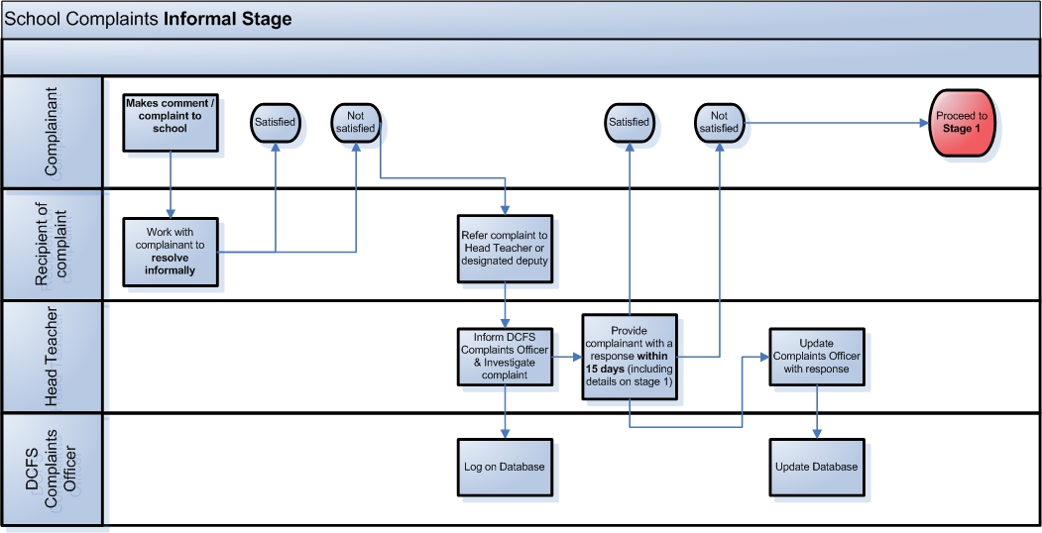

School Complaints Stage 1

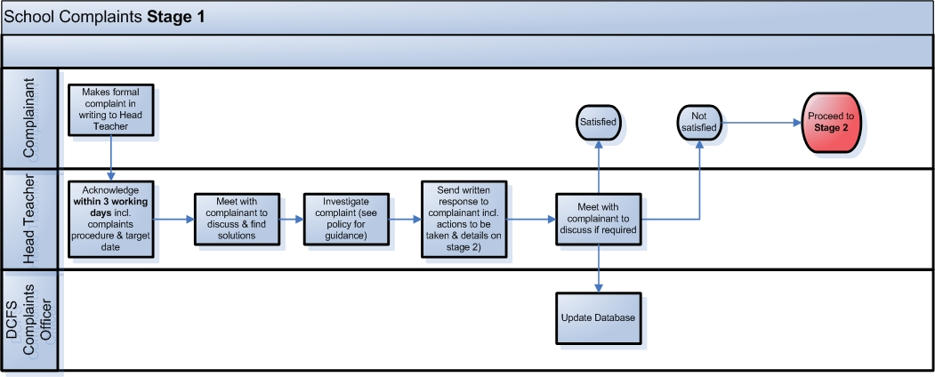

School Complaints Stage 2
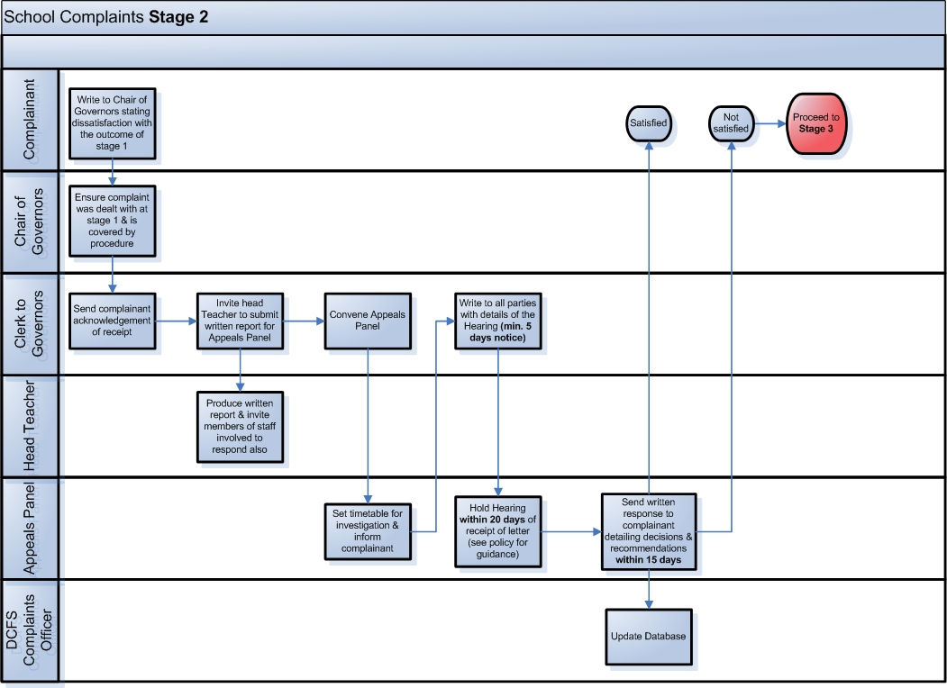

School Complaints Stage 3

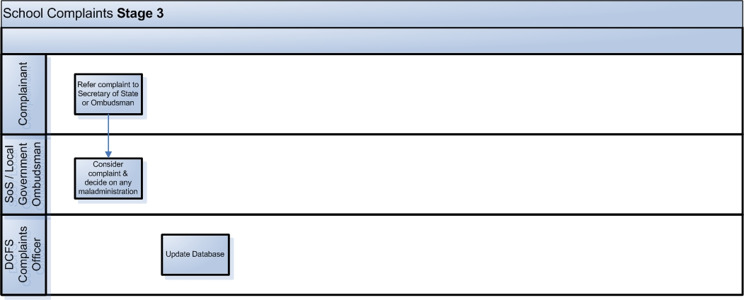

Unreasonable or unreasonably persistent complaints

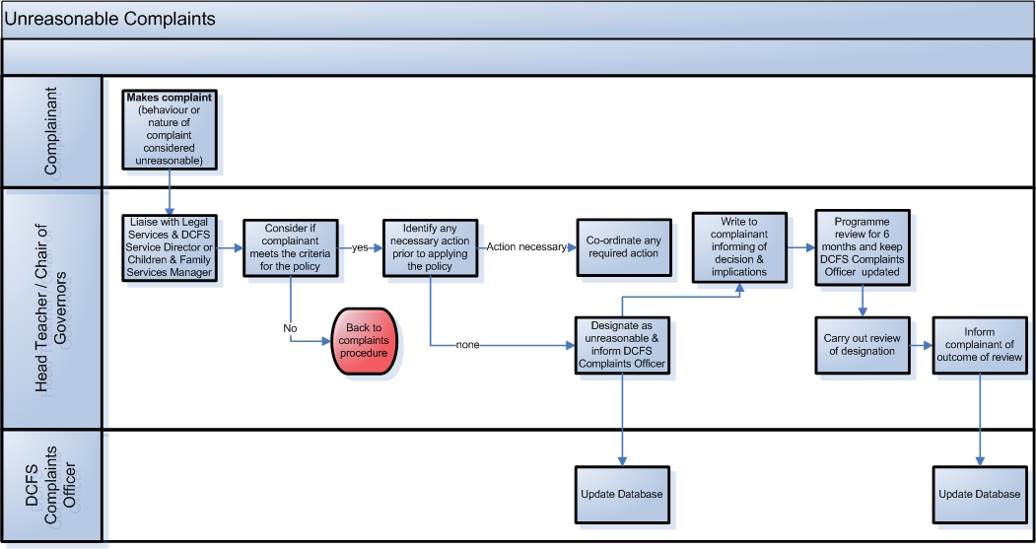

REVIEW OF POLICY
The effectiveness of this policy will be reviewed annually by the Senior Leadership Team and every three years by the Governing Body. If changes are made to the policy, the Governing Body will ratify amendments.

This policy was reviewed by the governing body: 27th September 2019
Signed: Mr John Holmes

Designation: Chair of Governors

Reviewed by SLT - Date: 15th September 2022

