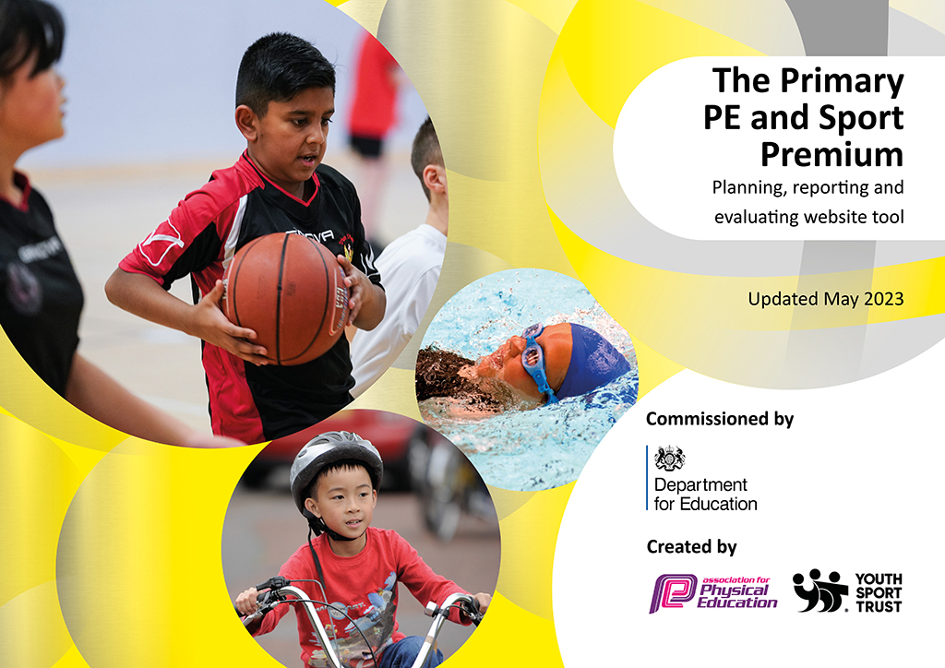
St Laurence’s Catholic Primary School
2022-2023
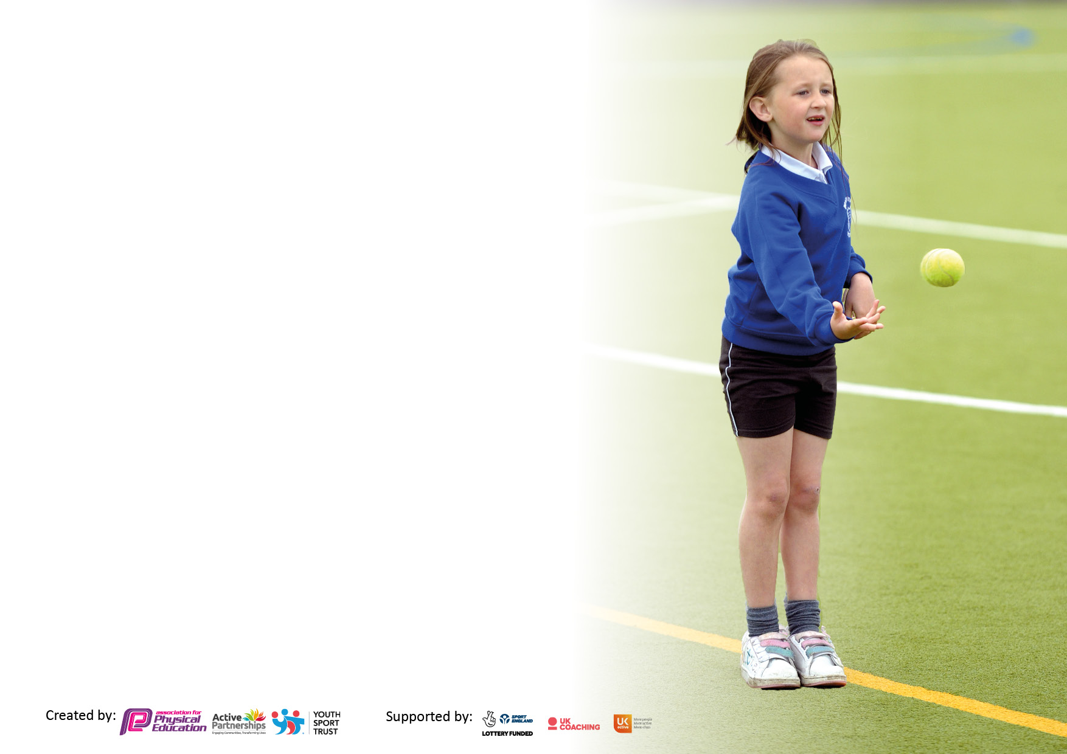

It is important that your grant is used effectively and based on school need. The Education Inspection Framework makes clear there will be a focus on ‘whether leaders and those responsible for governors all understand their respective roles and perform these in a way that enhances the effectiveness of the school’.

Under the Quality of Education Ofsted inspectors consider:
Intent - Curriculum design, coverage and appropriateness
Implementation - Curriculum delivery, Teaching (pedagogy) and Assessment
Impact - Attainment and progress

To assist schools with common transferable language this template has been developed to utilise the same three headings which should make your plans easily transferable between working documents.

Schools must use the funding to make additional and sustainable improvements to the quality of Physical Education, School Sport and Physical Activity (PESSPA) they offer. This means that you should use the Primary PE and sport premium to:

- Develop or add to the PESSPA activities that your school already offer
- Build capacity and capability within the school to ensure that improvements made now will benefit pupils joining the school in future years
- The Primary PE and sport premium should not be used to fund capital spend projects; the school’s budget should fund these.

Please visit gov.uk for the revised DfE guidance including the5keyindicatorsacrosswhichschoolsshoulddemonstrate an improvement. This document will helpyoutoreviewyourprovisionandtoreportyourspend.DfEencouragesschools to use this template as an effective way of meeting the reporting requirements of the Primary PE and Sport Premium.

We recommend you start by reflecting on the impact of current provision and reviewing the previous spend.

Schools are required to publish details of how they spend this funding, including any under-spend from 2021/2022, as well as on the impact it has on pupils’ PE and sport participation and attainment. The funding should be spent by 31st July but the DfE has stated that there will be no clawback of any unspent money so this can be carried forward into 2023/24.

We recommend regularly updating the table and publishing it on your website throughout the year. This evidences your ongoing self-evaluation of how you are using the funding to secure maximum, sustainable impact. Final copy must be posted on your website by the end of the academic year and no later than the 31st July 2023. To see an example of how to complete the table please click HERE.

Details with regard to funding
Please complete the table below.

Total amount carried over from 2021/22 | £
Total amount allocated for 2021/22 | £
How much (if any) do you intend to carry over from this total fund into 2022/23? | £
Total amount allocated for 2022/23 | £18964
Total amount of funding for 2022/23. Ideally should be spent and reported on by 31st July 2023. | £18964
Swimming Data
Please report on your Swimming Data below.

Meeting national curriculum requirements for swimming and water safety.

N.B. Complete this section to your best ability. For example you might have practised safe self-rescue techniques on dry land which you can then transfer to the pool when school swimming restarts.
Due to exceptional circumstances priority should be given to ensuring that pupils can perform safe self rescue even if they do not fully meet the first two requirements of the NC programme of study
What percentage of your current Year 6 cohort swim competently, confidently and proficiently over a distance of at least 25 metres?  N.B. Even though your pupils may swim in another year please report on their attainment on leaving primary school at the end of the summer term 2023.  Please see note above | 78%
What percentage of your current Year 6 cohort use a range of strokes effectively [for example, front crawl, backstroke and breaststroke]?  Please see note above | 70%
What percentage of your current Year 6 cohort perform safe self-rescue in different water-based situations? | 70%
Schools can choose to use the Primary PE and sport premium to provide additional provision for swimming but this must be for activity over and above the national curriculum requirements. Have you used it in this way? | Yes/No

Action Plan and Budget Tracking
Capture your intended annual spend against the 5 key indicators. Clarify the success criteria and evidence of impact that you intend to measure to evaluate for pupils today and for the future.

Academic Year: 2022/23 | Total fund allocated:£18,964 | Date Updated: JULY 23
Key indicator 1: The engagement of all pupils in regular physical activity – Chief Medical Officers guidelines recommend that primary school pupils undertake at least 30 minutes of physical activity a day in school |  |  |  | Percentage of total allocation:
 |  |  |  | 30%
Intent | Implementation |  | Impact
Your school focus should be clear what you want the pupils to know and be able to do and about  what they need to learn and to  consolidate through practice: | Make sure your actions to achieve are linked to your intentions: | Funding allocated: | Evidence of impact: what do pupils now know and what can they now do? What has changed?: | Sustainability and suggested next steps:
To encourage all pupils to partake in regular exercise, also ensuring PE kits are always in school and encourage healthy eating and lifestyles.  To continue to improve Playground improvements e.g. Court/pitch/ Daily markings, and also accessibility to adventure trail. To aid active break/lunchtimes and promote healthier lifestyles in addition to being utilised for curricular and extra-curricular activities.  To target less active pupils to encourage engagement in more physical activity.  To continue to provide activities which ensure children have access to developing their own motor skills through climbing, balancing and strengthening their core. | All classes have two hour timetabled PE sessions along with the timetabled Daily mile sessions during curriculum time and be able to access lunch time and after school clubs.  Ensure all children participate within school curriculum PE lessons. Each class within school are provided with 6 extra PE kits so that all the children can participate.  Teachers will provide extra-curricular sports before and after school.  Ensure the promotion of the Health for Schools Initiatives and try to achieve an award once again.  Update lunchtime PE equipment to encourage more challenge during physical activity during breaks and dinner.  We purchased a colour run event to promote healthiness and happiness by bringing the whole school community together to participate in the run.  To purchase scoot fit days for children within KS 1 and KS2This will support children with their physical, fine and gross motor skills. | £1,500  £384.00  £908  £1496  £1,100 | School Games Platinum certificate was presented to the PE lead in relation to PE Tasks completed whilst in school and completion of a KSSP competitions calendar for the eighth year in a row.  This enabled all children to participate within PE Lessons impacting on their well-being and learning new skills.  Teachers were able to provide extra- curricular activities with the children which was a huge success with all the children. The impact of this suggest extra- curricular activities are important in developing soft (especially social) skills as well as being associated with a range of other positive outcomes (e.g. achievement, attendance at school).  Twice a week (Mon/Wed) Family Fitness Sessions with children and parents was completed by Mr Cushion. This has a positive impact on both physical and mental well -being of parents and children. In addition to it builds further community link between school and families.  Children were able to participate in a variety of different activities on the playground which included: daily mile, PE Lessons, Orienteering which they all thoroughly enjoyed.  To continue lunchtime and after school clubs were created which allowed less active pupils to take part which included: cross country, indoor athletics and table tennis. PE resources were purchased and this had a massive impact on these pupils in relation to their fitness which impacted on their health and wellbeing.  Children really enjoyed this event and this had a massive impact well – being and recommended hour of physical education that week.  This had an enormous impact on the pupils developing their motor skills.  The impact of this activity contributed towards their recommended hour of physical activity each day, enabling them to keep fit and maintain a healthy lifestyle and to persuade the children to scoot into school rather than come by car increasing active travel. | Continue to refresh and review of lunchtime provision including:  The replacement of play equipment and introduce new activities to the children.  Teachers to continue to support extra-curricular activities in 2023/2024.  As it was a huge success we have been able to offer the family fitness sessions to the parents and children within the community once again this year.  Children really enjoyed this event and are looking forward to completing again in the next academic year.  We will look to repurchase the event once again next year. Sept/Oct 23-24.
Key indicator 2: The profile of PESSPA being raised across the school as a tool for whole school improvement |  |  |  | Percentage of total allocation:
 |  |  |  | 20%
Intent | Implementation |  | Impact
Your school focus should be clear what you want the pupils to know and be able to do and about  what they need to learn and to  consolidate through practice: | Make sure your actions to achieve are linked to your intentions: | Funding allocated: | Evidence of impact: what do pupils now know and what can they now do? What has changed?: | Sustainability and suggested next steps:
Continued involvement with Knowsley Children’s University SLA. (Children will earn University credits for every hour of extra-curricular activity they participate in and they will receive recognition when 30+ hours is reached). | Try to increase the numbers of children attending the children’s club and ceremony in summer term for recognition of their achievements in extra-curricular activities by increasing the variety of clubs within the school. | £2,000  (£400 coach for event.) | The repurchase of several schemes relating to PE has had a massive impact on the students and teachers. Teachers especially as this up skilled teachers to deliver high quality PE lessons. | We will buy into the scheme once again next year, however moving forward we may look at officiating our own ceremony in the future in relation to attendance of extra-curricular clubs.

Key indicator 3: Increased confidence, knowledge and skills of all staff in teaching PE and sport |  |  |  | Percentage of total allocation:
 |  |  |  | 30%
Intent | Implementation |  | Impact
Your school focus should be clear | Make sure your actions to | Funding | Evidence of impact: what do | Sustainability and suggested
what you want the pupils to know | achieve are linked to your | allocated: | pupils now know and what | next steps:
and be able to do and about | intentions: |  | can they now do? What has
what they need to learn and to |  |  | changed?:
consolidate through practice:
To continue to provide high quality, focused continuous professional development for staff to support the delivery of high quality physical education and school sport.  To continue to use Everton in the Community (ETIC)  Ensure that new staff responsible for teaching swimming attend appropriate course and gain qualifications in order to teach swimming effectively. | To continue to identify the teaching strengths in PE within our own staff and continue to ‘buddy’ teachers up to develop each other skill sets. EITC.  To up skill staff to deliver high quality PE lessons to ensure sustainability of a High Quality PE & School Sport Programme. Try to encourage several members of staff complete a Level 5/6 PE qualification.  To improve staff knowledge and understanding of Physical Education by the use of key vocabulary within lessons and keeping abreast of new initiatives within it.  As above – by being supported by Everton within school this will also help up-skill our teachers and children and help us maintain and sustain a high quality PE programme across the whole of the school.  To continue to access online appropriate swimming courses from KSSP for all new staff. (JB, RB, JK) | £650  £6,000 per year  £1000 per term  £150.00 | The Everton in the community PE coach supported staff throughout the school year and upskilled them in different sports and activities. The children were actively engaged with both teacher and coach listening and participating well in all lessons. Primary teachers more confident to deliver effective PE supporting pupils to undertake extra activities inside and outside of school, including teaching water safety and swimming and as a result improved % of pupil’s attainment in PE.  PE qualification which has enabled staff to bring new ideas into school and pass this knowledge onto fellow teachers which has improved their knowledge and understanding of the subject.  Everton in the community PE coach supported staff and upskilled them in different sports and activities throughout the year. Children are more actively engaged with the EITC coaches in school.  Teachers have now completed online swimming courses which has given them confidence in this area and when attending our annual swimming lessons at our local leisure centre. (see certification and Photographic evidence in big book). | (See below)  Moving forward we are looking to send several staff members on subject specific courses next year which will include: dance, gymnastics and basketball.  Everton sports coach to continue to work upskilling teachers within years 2/3 throughout 2023/24. This will be monitored by PE lead through Planning, observations, assessment and consultation with the EFC coach.  We are looking to certificate more staff members this year through ASA by using online courses.
Key indicator 4: Broader experience of a range of sports and activities offered to all pupils |  |  |  | Percentage of total allocation:
 |  |  |  | 10%
Intent | Implementation |  | Impact
Your school focus should be clear | Make sure your actions to | Funding | Evidence of impact: what do | Sustainability and suggested
what you want the pupils to know | achieve are linked to your | allocated: | pupils now know and what | next steps:
and be able to do and about | intentions: |  | can they now do? What has
what they need to learn and to |  |  | changed?:
consolidate through practice:
To continue to provide after school sports clubs that are not part of the curriculum for lower key stage 2, e.g. Boxing and Badminton.  To continue to provide extra- curricular activities for all year groups in one skilled area. | Key Stage 1 and 2 children to take part in Quidditch tournament over two days. KS1 and KS2 children took part in a Diwali dance workshop provided by West End in schools  Dance for EYFS, KS1 and KS2 after school. (Tammy) | £1314.00  £560.00 | The children enjoyed our Quidditch and Diwali Dance day events which was supplied through ENRICH and West End In Schools. The children have expressed an interest in doing both events again next year as it had a positive effect on the children’s health and well-being.  The children have said that they really enjoy the dances sessions and have asked if we could be increase the amount of sessions per week. | PE lead to book another Quidditch, Dance and OL event for 2023/24 as it was a huge success.

Key indicator 5: Increased participation in competitive sport |  |  |  | Percentage of total allocation:
 |  |  |  | 0%
Intent | Implementation |  | Impact
Your school focus should be clear | Make sure your actions to | Funding | Evidence of impact: what do | Sustainability and suggested
what you want the pupils to know | achieve are linked to your | allocated: | pupils now know and what | next steps:
and be able to do and about | intentions: |  | can they now do? What has
what they need to learn and to |  |  | changed?:
consolidate through practice:
• To continue to encourage all children to participate in competitive sport and any involvement in clubs outside of school is highlighted and celebrated. | To continue build up a strong relationships with several community based clubs outside of school. (LMSOD, Shissasay Dance school, Quarry Green Football Club and Kirkby Town FC) |  | Our relationship with these clubs has become even stronger this year therefore they will continue to use our school field for a number of events throughout the year. Children from the school now participate in a wide range of sports outside of school hours which is helping grow confidence and the health and well -being of every child who attends. Pupils from all year groups compete at a local level with teams progressing to competition finals. Academy achievements celebrated and recognised. | Our next steps are to further promote other sports and links with other local sporting communities such as:  - Kirkby Milers cross country club  - Performance Dance studios.

Signed off by
Head Teacher: | Sarah-Jane Carroll
Date: | October 2022
Subject Leader: | Barry Grant
Date: | 30th July 2023
Governor: | John Holmes
Date: | November 2022

