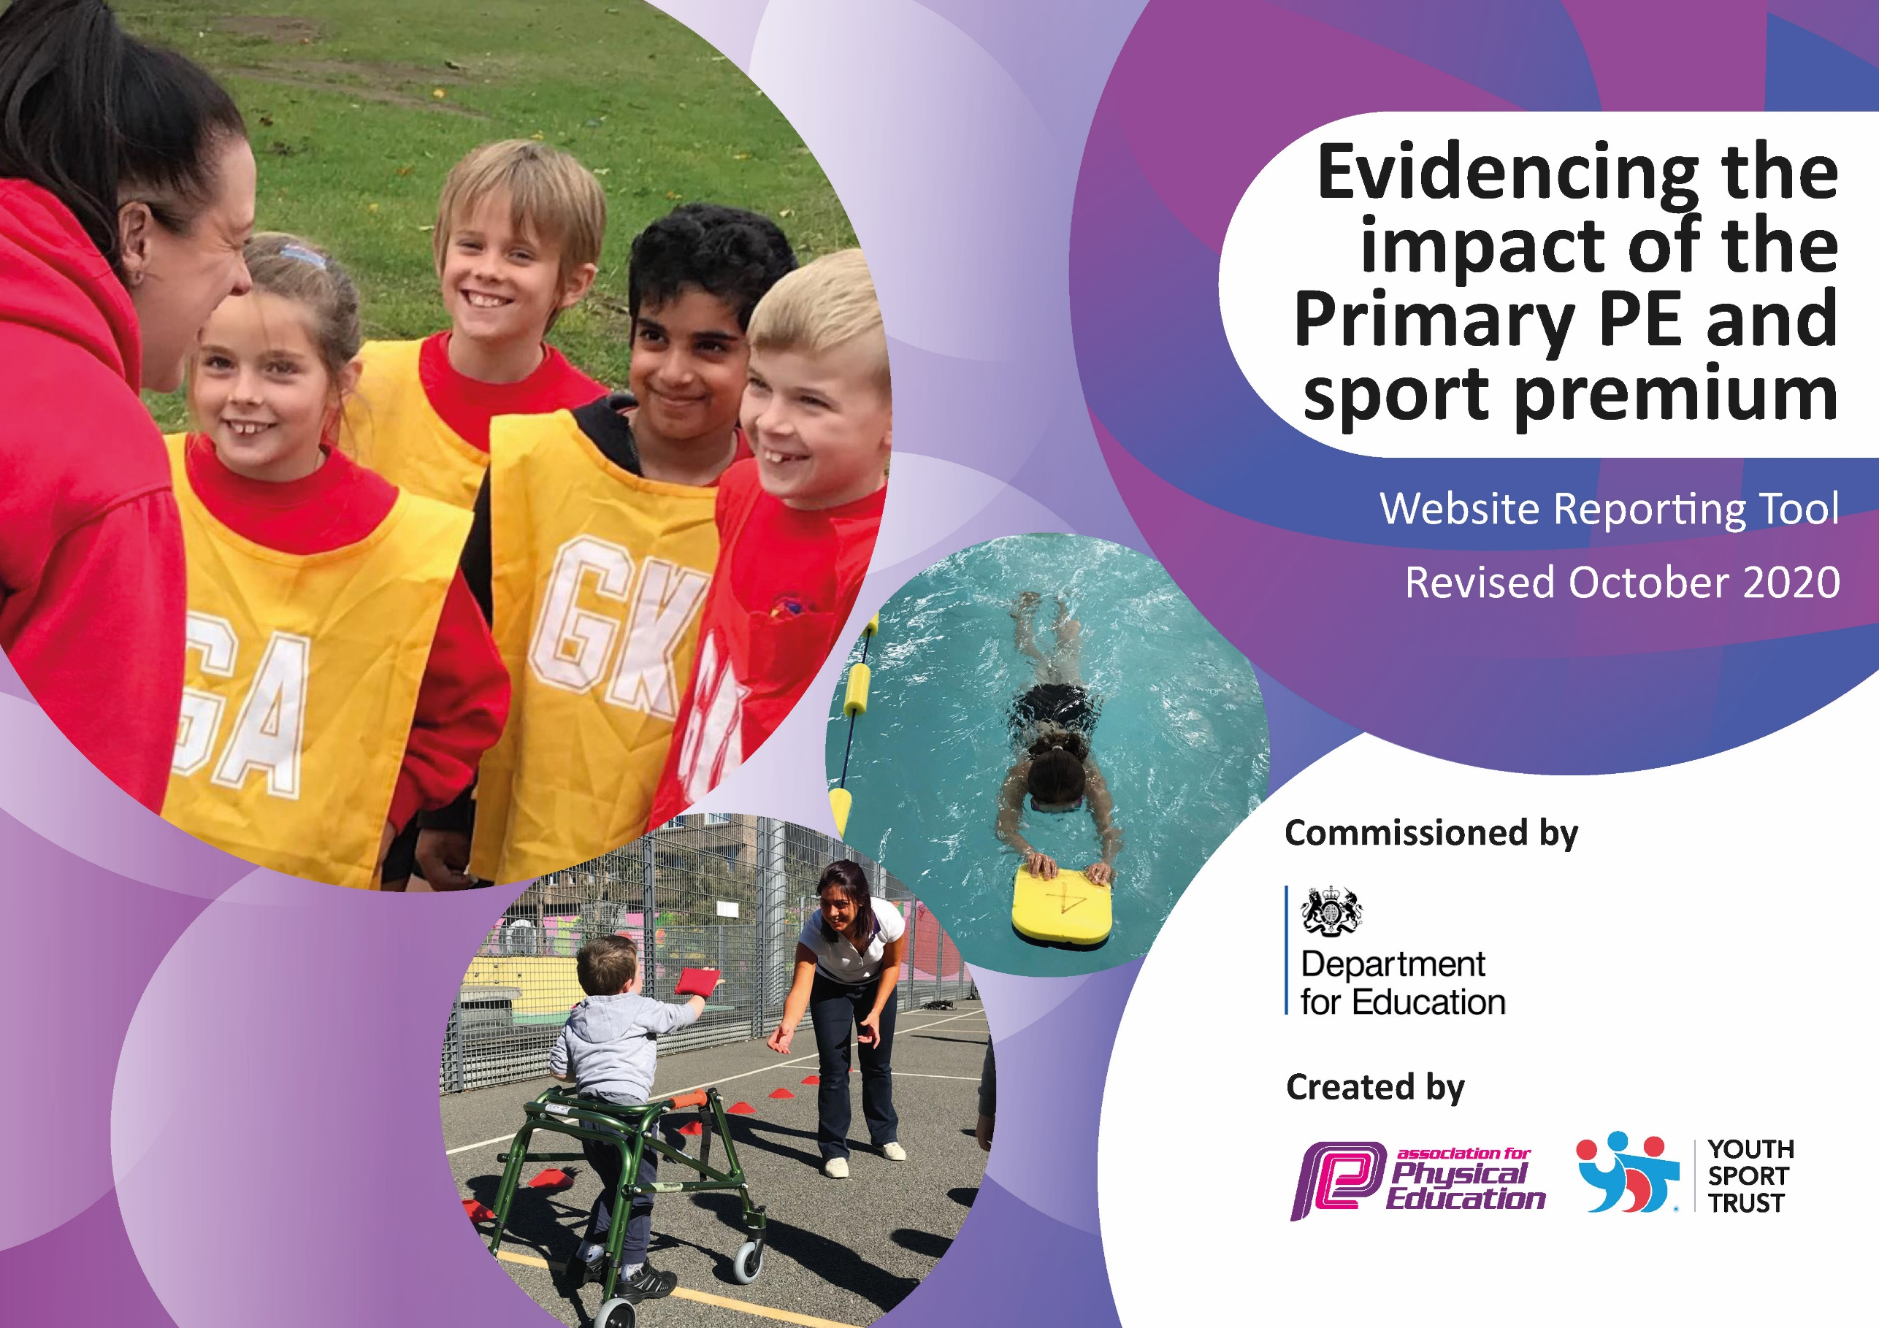
St Laurence’s Catholic Primary School 2020 - 2021
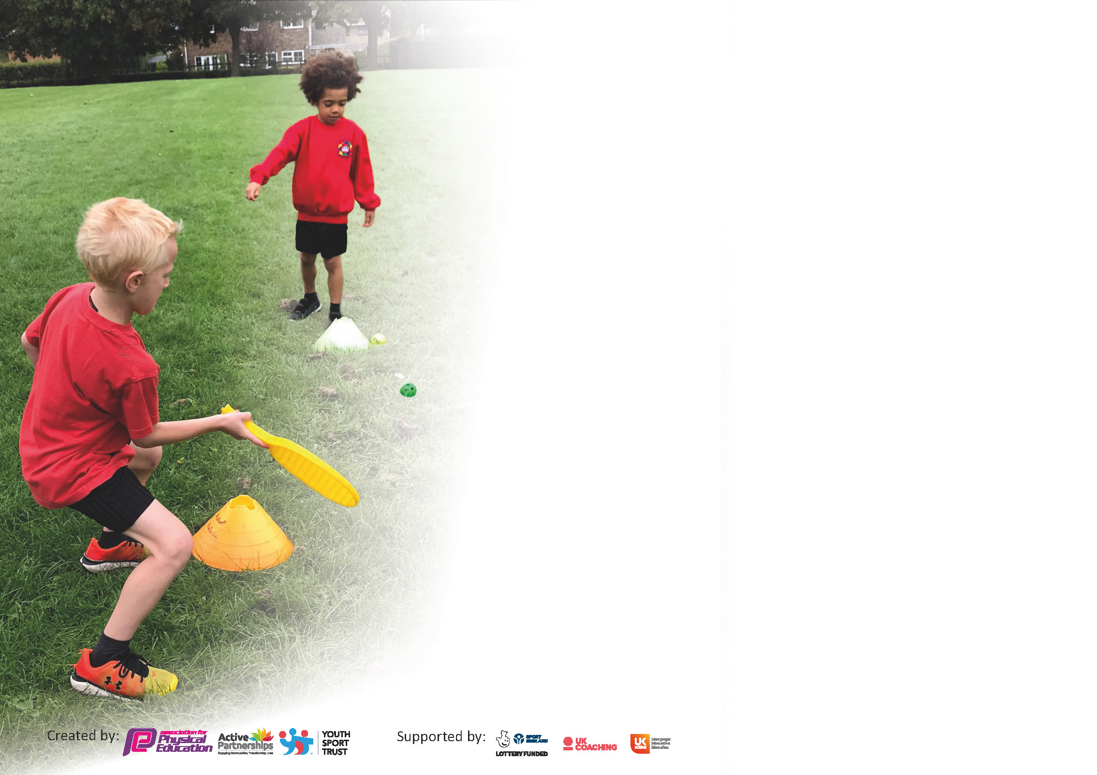

It is important that your grant is used effectively and based on school need. The Education Inspection Framework (Ofsted 2019 p64) makes clear there will be a focus on ‘whether leaders and those responsible for governors all understand their respective roles and perform these in a way that enhances the effectiveness of the school’.

Under the Quality of Education criteria (p41) inspectors consider the extent to which schools can articulate their curriculum (INTENT), construct their curriculum (IMPLEMENTATION) and demonstrate the outcomes which result (IMPACT).

To assist schools with common transferable language this template has been developed to utilise the same three headings which should make your plans easily transferable between working documents.

Schools must use the funding to make additional and sustainable improvements to the quality of Physical Education, School Sport and Physical Activity (PESSPA) they offer. This means that you should use
the Primary PE and sport premium to:

- Develop or add to the PESSPA activities that your school already offer
- Build capacity and capability within the school to ensure that improvements made now will benefit pupils joining the school in future years

Please visit gov.uk for the revised DfE guidance including the 5 key indicators across which schools should demonstrate an improvement. This document will help you to review your
provision and to report your spend. DfE encourages schools to use this template as an effective way of meeting the reporting requirements of the Primary PE and sport premium.

We recommend you start by reflecting on the impact of current provision and reviewing the previous spend.

Schools are required to publish details of how they spend this funding as well as on the impact it has on pupils’ PE and sport participation and attainment by the end of the summer term or by 31st July 2021 at the latest.

** In the case of any under-spend from 2019/20 which has been carried over this must be used and published by 31st March 2021.

We recommend regularly updating the table and publishing it on your website throughout the year. This evidences your ongoing self-evaluation of how you are using the funding to secure maximum, sustainable impact. Final copy must
be posted on your website by the end of the academic year and no later than the 31st July 2021. To see an example of how to complete the table please click HERE.
Created by: Supported by:

Please note: Although there has been considerable disruption in 2020 it is important that you publish details on your website of how you spend the funding - this is a legal requirement.
Support for review and reflection - considering the 5 key indicators from DfE, what development needs are a priority for your setting and your pupils now and why? Use the space below to reflect on previous spend and key achievements and areas for development.

N.B. In this section you should refer to any adjustments you might have made due to Covid-19 and how these will influence further improvement.
Key achievements to date until July 2020: | Areas for further improvement and baseline evidence of need:
*Continuation of CPD for staff across the school in their chosen areas of development.  *Improved quality and variety of PE resources and equipment.  * Playground improvements which included the marking of a daily mile course and Outside Gym.  *We have increased Daily Mile participation to at least 4 times a week.  *PE wall Display to include photos, certificates and awards.  *In school competitions including Speed Bounce and Skipping and Hula Hoop etc.  *All pupils have a 2 hour timetabled session of PE each week. There are further opportunities for PE at lunch times, through a range of clubs.  *To continue to provide extracurricular activities that are free and completed by staff within school except for Dance, Judo and Fencing.  * To continue to provide a separate sports days which are organised for KS1 and KS2 pupils, allowing children greater opportunities to participate. | *Ensure SEN pupils are being selected for competitions.  *PE wall display to include certificates and awards.  *Continue staff CPD in areas of weakness.  *Encourage more KS1 children to attend clubs.  *Complete PE survey to see what clubs the children would like to see.  *Re-introduction of Play Leaders for KS1 – think about dinner times for KS2 and implications. (In consultation with KSSP Coronavirus Pandemic has hindered progress).  Further Subject Leader training provided by KSSP to ensure that the PE curriculum intent and implementation has the desired impact that pupil’s knowledge and skills develop to meet or exceed expectations in all classes.  * To continue to organise and run sports competitions with other local schools when safe to do so. E.g. Deb Mottram Foster Trophy.  *Re-introduce daily wake up shake up sessions, possibly as a morning activity and at end of weekly assembly.  * Increase the range of sports during extra-curricular time to include Badminton, Table Tennis, Hockey and Tri- Golf.  *To achieve School Games Mark Platinum again for the fourth year in recognition of the high quality provision for school sport.

Did you carry forward an underspend from 2019-20 academic year into the current academic year? YES/NO * Delete as applicable

If YES you must complete the following section
If NO, the following section is not applicable to you

If any funding from the academic year 2019/20 has been carried over you MUST complete the following section. Any carried over funding MUST be spent by 31 March 2021.
Academic Year: September 2020 to March 2021 | Total fund carried over: £ | Date Updated:  Autumn 20
What Key indicator(s) are you going to focus on? |  |  |  | Total Carry Over Funding:
 |  |  |  | £
Intent | Implementation |  | Impact
Your school focus should be clear how you want to impact on your pupils. | Make sure your actions to achieve are linked to your intentions: | Carry over funding allocated: | Evidence of impact: How can you measure the impact on your pupils; you may have focussed on the difference that PE, SS & PA have made to pupils re-engagement with school. What has changed?: | Sustainability and suggested next steps and how does this link with the key indicators on which you are focussing this academic year?:

Meeting national curriculum requirements for swimming and water safety.

N.B Complete this section to your best ability. For example you might have practised safe self-rescue techniques on dry land.
What percentage of your current Year 6 cohort swim competently, confidently and proficiently over a distance of at least 25 metres?
N.B. Even though your pupils may swim in another year please report on their attainment on leaving primary school at the end of the summer term 2020.
What percentage of your current Year 6 cohort use a range of strokes effectively [for example, front crawl, backstroke and breaststroke]?
What percentage of your current Year 6 cohort perform safe self-rescue in different water-based situations?
Schools can choose to use the Primary PE and sport premium to provide additional provision for swimming but this must be for activity over and above the national curriculum requirements. Have you used it in this way?

Action Plan and Budget Tracking
Capture your intended annual spend against the 5 key indicators. Clarify the success criteria and evidence of impact that you intend to measure to evaluate for pupils today and for the future.

Academic Year: 2020/21 | Total fund allocated: £18,730 | Date Updated: Autumn 20
Key indicator 1: The engagement of all pupils in regular physical activity – Chief Medical Officers guidelines recommend that primary school pupils undertake at least 30 minutes of physical activity a day in school |  |  |  | Percentage of total allocation:
 |  |  |  | %
Intent | Implementation |  | Impact
- To encourage all pupils to partake in regular exercise, also ensuring PE kits are always in school and encourage healthy eating and lifestyles. | All classes have two hour timetabled PE sessions along with the timetabled Daily mile sessions during curriculum time and be able to access lunch time and after school clubs.  Ensure all children (within their bubbles) participate within school curriculum PE lessons.  Teachers will provide extra-curricular sports before and after school when it’s safe to do so.  Ensure the promotion of the Health for Schools Initiatives and try to achieve an award once again.
- To continue to improve Playground improvements e.g. Court/pitch/ Daily markings, and also accessibility to adventure trail. To aid active break/lunchtimes and promote healthier lifestyles in addition to being utilised for curricular and extra-curricular activities.  - To target less active pupils to encourage engagement in more physical activity.  - To continue to provide activities which ensure children have access to developing their own motor skills through climbing, balancing and strengthening their core. | To ensure that access to the yard and other areas for all activities are completed by Summer 2021. Restrictions may apply  To continue to update PE resources and kit to enhance (sustainability) provision in lessons and extra-curricular activity.  To upgrade playground equipment to ensure sustainability. Outside Gym  Update lunchtime PE equipment to encourage more physical activity during breaks and dinner.  Improve permanent resources for PE and sport including:  *Access and fencing to a wooded area for orienteering and Forest School (FS) activities.  To continue to encourage parents to join KS1 Family Fitness sessions every Friday morning. (Purchase of healthy fruit will help to promote healthy eating) Summer terms. | £
Key indicator 2: The profile of PESSPA being raised across the school as a tool for whole school improvement |  |  |  | Percentage of total allocation:
 |  |  |  | %
Intent | Implementation |  | Impact
- Physical education prepares all children to be physically and mentally active, fit and healthy...for life. This is an important aspect of our school ethos. | To continue to celebrate our successes and participation in sports clubs outside of school which can be highlighted and celebrated during whole school assemblies. (Regularly recognise and reward sporting achievement through the presentation of awards throughout the year and at prize giving at the end of the summer term).
- Use of PE across the curriculum, linking with other subjects (Active Maths).  - Continued involvement with Knowsley Children’s University SLA. (Children will earn University credits for every hour of extra-curricular activity they participate in and they will receive recognition when 30+ hours is reached).  - Continued implementation of mindfulness sessions with the children. | The re-purchase and continue to implement of Active Maths across the school (by doing this it will help with children’s physical fitness after lockdown).  Try to increase the numbers of children attending the children’s club and ceremony in summer term (this will be done through year group bubbles within the school) for recognition of their achievements in extracurricular activities by increasing the variety of clubs within the school. Summer terms  This will improve the children’s physical and mental awareness that is needed to promote healthier lifestyles after lockdown. Restriction may apply, try to complete in the summer term. | £1575  £2000

Key indicator 3: Increased confidence, knowledge and skills of all staff in teaching PE and sport |  |  |  | Percentage of total allocation:
 |  |  |  | %
Intent | Implementation |  | Impact
- To continue to provide high quality, focused continuous professional development for staff to support the delivery of high quality physical education and school sport.  - To continue to use Everton in the Community (ETIC) | To continue to identify the teaching strengths in PE within our own staff and continue to ‘buddy’ teachers up to develop each other skill sets. (Summer Terms)  To up skill staff to deliver high quality PE lessons to ensure sustainability of a High Quality PE & School Sport Programme. Try to encourage several members of staff complete a Level 5/6 PE qualification.  To improve staff knowledge and understanding of Physical Education by the use of key vocabulary and keeping abreast of new initiatives within it.  As above – by being supported by Everton within school this will also help up-skill our teachers and children and help us maintain and sustain a high quality PE programme across the whole of the school. Restrictions may apply. | £3500 | -
- Ensure that new staff responsible for teaching swimming attend appropriate course and gain qualifications in order to teach swimming effectively. | To continue to access online appropriate swimming courses from KSSP for all new staff.
Key indicator 4: Broader experience of a range of sports and activities offered to all pupils |  |  |  | Percentage of total allocation:
 |  |  |  | %
Intent | Implementation |  | Impact
- To continue to use Knowsley School Sports Partnership (KSSP) which provides the co-ordination and delivery of regular high quality school and borough wide competitions in a wide and diverse range of sports, ensuring that the players/teams have the opportunity to link into county, regional and national competitions in line with national governing bodies of sport and the national School Games programme. The SLA also aims to increase the number of young people participating in competitive opportunities and the depth of competitions offered.  - To continue to provide after school sports clubs that are not part of the curriculum for lower key stage 2, e.g. judo and fencing.  - Try to complete a sport that enthuses the children which has been attempted before and that they enjoyed which is not on the current PE curriculum.  - To continue to provide extra- curricular activities for all year groups in one skilled area. | To continue to develop a range of extra-curricular activities which will help the children achieve, we currently offer a range of sports clubs across the school. Football occurs on a weekly basis across several year groups, whereas other clubs will change term by term dependent on upcoming events and seasonal changes (for example cross country club changes to indoor/ outdoor athletics club in the winter summer terms). (Evidence collated to submit application for the Virtual Games Award during  Lockdown). By doing this the children will be recognised for their participation through gaining Children’s University credits.  Try to set up assembly for Year 3 and Year 4 children and create a new club for both year groups with outside agent. (Restrictions may apply)  Key Stage 1 and 2 children to take part in Quidditch tournament over two days.  Dance for EYFS, KS1 and KS2 after school. | £1300  £1160
Additional achievements:

Key indicator 5: Increased participation in competitive sport |  |  |  | Percentage of total allocation:
 |  |  |  | %
Intent | Implementation |  | Impact
- To continue to encourage all children to participate in competitive sport and any involvement in clubs outside of school is highlighted and celebrated.  - There has been a lot of research about the use of Sports Coaching in the UK commissioned a report that interview 10,000 people within primary schools: The top five benefits were: Improved fitness (72%) Enhanced Fun (68%) learning something new(47%) improved performance (41%) Develop sporting skills (38%).  - To continue to provide high quality PE at St Laurence’s we will continue to need teachers that are enthused about the subject and have a passion for it. ? | To build up a strong relationships with several community based clubs outside of school. (Quarry Green Football Club,  To continue to sustain high level of participation (when applicable) within all clubs and also to engage with our School games organiser on a regular basis. Ensure that staff lead teams for all competitions in the future. To complete training session before all children’s competitions. To also continue our approach to team selection – trials based approach and the participation of those pupils not usually selected for sports in which they could excel for example Boccia, New age curling etc.

Signed off by
Head Teacher:
Date:
Subject Leader:
Date:
Governor:
Date:

