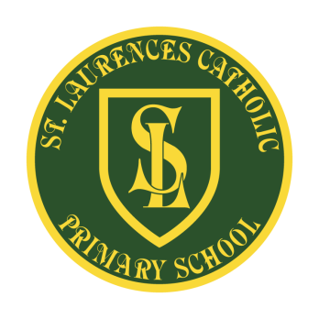
St Laurence’s Catholic Primary School
Holiday Dates 2021 - 2022
Autumn Term
Inset days | - Wednesday 1st September 2021  - Friday 22nd October 2021
Term Starts | Thursday 2nd September 2021
Half Term | School closes Thursday 21st October 2021 and re-opens on Monday 1st November 2021
Autumn Term Ends | Friday 17th December 2021

Spring Term
Inset days | - Tuesday 4th January 2022
Term Starts | Wednesday 5th January 2022
Half Term | School closes Friday 11th February 2022 and re-opens on Monday 21st February 2022
Spring Term Ends | Wednesday 6th April 2022

Summer Term
Inset days | Monday 25th July 2022  Tuesday 26th July 2022
Bank Holiday | Monday 2nd May 2022  Monday 18th April 2022  Thursday 2nd June 2022  Friday 3rd June 2022 (Queen’s Jubilee)
Term Starts | Wednesday 20th April 2022
Half Term | School closes Friday 20th May 2022 and re-opens on Monday 6th June 2022
Summer Term Ends | Friday 22nd July 2022

