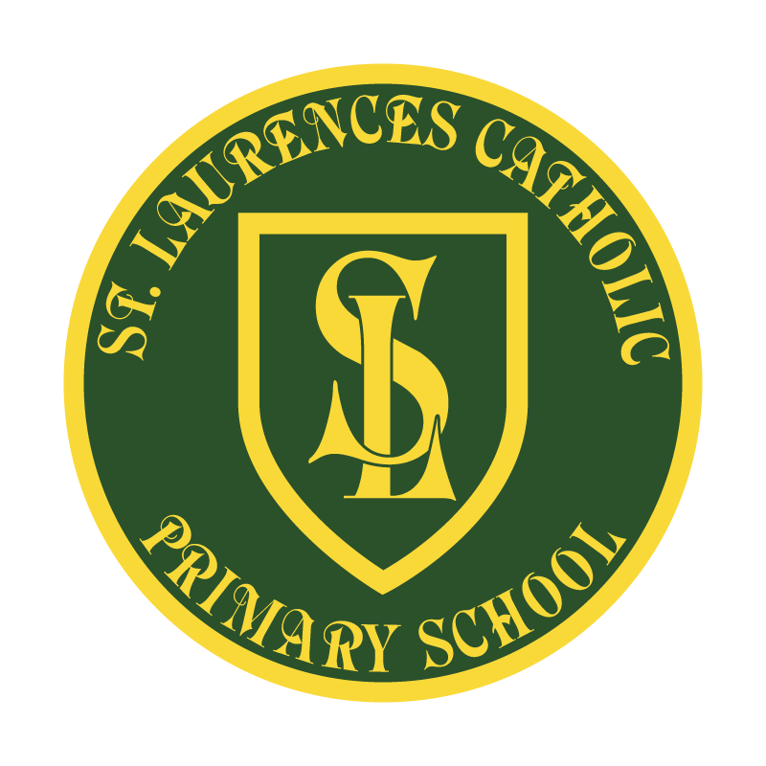

St Laurence’s Catholic Primary School

Policy Statement
For

MUSIC

This policy was adopted:
By name:
Position:
Signature:

Our Mission Statement
We aim to celebrate our partnership with the families we serve and the community we live in.
We aim to provide an education that enables each child to reach their full potential.
Our aim is the creation of an atmosphere where all are valued, gifts and talents are celebrated and the gospel values of love, respect and justice are at the heart of all we do.

Our Vision
Everyone feels a sense of belonging,
Has the opportunity to shine,
To enjoy their teaching and learning
But most of all – to dream big!


St. Laurence’s R.C Primary School

MUSIC POLICY

Philosophy

At St. Laurence’s we believe that music has a very important role in the life of our school.

‘Music is a universal language that embodies one of the highest forms of creativity. A high quality music education should engage and inspire pupils to develop a love of music and their talent as musicians, and so increase their self-confidence, creativity and sense of achievement. As pupils progress, they should develop a critical engagement with music, allowing them to compose, and to listen with discrimination to the best in the musical canon.’ –National Curriculum Music (2014).

We will therefore aim to commit ourselves to following this policy and encourage children to develop these important life skills through music.

Aims and Objectives

- To make music a highly valued part of the life of the school.

- To offer each child in our school the greatest possible opportunity for participation in music at all stages of their development.

- To provide opportunities for children to experience instrumental playing.

- To introduce children to a wide range of music and composers and therefore enable children to appreciate the importance of music in society and the history of music

- To make music an enjoyable activity and foster a lifelong enjoyment of music.

- To relate, where relevant, music with other areas of the curriculum.

Objectives and Entitlement
All children will be taught music as outlined in the National Curriculum document produced by DfE 2014. Updated 2021.

Purpose of study
Music is a universal language that embodies one of the highest forms of creativity. A high quality music education should engage and inspire pupils to develop a love of music and their talent as musicians, and so increase their self-confidence, creativity and sense of achievement. As pupils progress, they should develop a critical engagement with music, allowing them to compose, and to listen with discrimination to the best in the musical canon.

Aims:
The national curriculum for music aims to ensure that all pupils:

- Perform, listen to, review and evaluate music across a range of historical periods, genres, styles and traditions, including the works of the great composers and musicians.

- Learn to sing and to use their voices, to create and compose music on their own and with others, have the opportunity to learn a musical instrument, use technology appropriately and have the opportunity to progress to the next level of musical excellence.

- Understand and explore how music is created, produced and communicated, including through the inter-related dimensions: pitch, duration, dynamics, tempo, timbre, texture, structure and appropriate musical notations.

Attainment Targets:
By the end of each key stage, pupils are expected to know, apply and understand the matters, skills and processes specified in the relevant programmes of study.

Subject Content:
Early Years:
Pupils should be taught to:
3-4 year olds
*Listen with increased attention to sounds.
*Respond to what they have heard, expressing their thoughts and feelings. •
*Remember and sing entire songs.
*Sing the pitch of a tone sung by another person (‘pitch match’).
*Sing the melodic shape (moving melody, such as up and down, down and up) of familiar songs.
*Create their own songs, or improvise a song around one they know.
*Play instruments with increasing control to express their feelings and ideas.

In Reception
*Listen attentively, move to and talk about music, expressing their feelings and responses.
*Watch and talk about dance and performance art, expressing their feelings and responses.
*Sing in a group or on their own, increasingly matching the pitch and following the melody.
*Explore and engage in music making and dance, performing solo or in groups

ELG
*Sing a range of well-known nursery rhymes and songs.
*Perform songs, rhymes, poems and stories with others, and (when appropriate) try to move in time with music.

Key Stage One:
Pupils should be taught to:
*Use their voices expressively and creatively by singing songs and speaking chants and rhymes.
*Play unturned and tuned instruments musically
*Listen with concentration and understanding to a range of high-quality live and recorded music.
*Experiment with, create, select and combine sounds using the inter-related dimensions of music.

Key Stage 2:
Pupils should be taught to:
*Sing and play musically with increasing confidence and control.
*They should develop an understanding of musical composition, organising and manipulating ideas within musical structures and reproducing sounds from aural memory.
*Play and perform in solo and ensemble contexts, using their voices and playing musical instruments with increasing accuracy, fluency, control and expression.
*Improvise and compose music for a range of purposes using the inter-related dimensions of music.
*Listen with attention to detail and recall sounds with increasing aural memory.
*Use and understand staff and other musical notations.
*Appreciate and understand a wide range of highly-quality live and recorded music drawn from different traditions.
*Develop an understanding of the history of music.

Implementation of Music across the school
Music is to be undertaken by all teachers with their own classes. To assist teachers deliver the aims and objectives, the following are used:
Nursery –Charanga
Reception – Charanga
Key Stage 1 –Charanga
Key Stage 2 –Charanga

A hymn /singing practice takes place for Key Stages 1 and 2 in preparation for specific events throughout the school year.

Two peripatetic instrumental teachers, from the Knowsley Music and Performing Arts Service, visit the school once a week to deliver tuition to groups of Key Stage 2 pupils in the areas below:

Woodwind
Strings
Keyboard

When appropriate, ABRSM Music examinations are undertaken by the children (Music Medals, Grade examinations).

One Year Group (3) has Wider Opportunities lessons for a full year, alternating weekly between the two year 3 classes. These lessons are taught by a music specialist from the Music and Performing Arts Service. The class is a KS2 class and the instrument is the Recorder.

Musicians and singers are strongly encouraged to perform at various musical events throughout the school year. These events include:
School and Family Masses;
Christmas and Easter performances;
Various assemblies;
Awards Assembly;
Music Concerts;
Fundraising events;
Choir;
Out-of-school organised events

Musicians and Musical Agencies visit the school to perform and run workshops / support external events wherever possible and appropriate.

Expectations and Assessment

End of Key Stage Expectations-KS1.
- Pupils recognise and explore how sounds can be made and changed.
- They use their voices in different ways such as speaking, singing and chanting, and perform with awareness of others.
- They repeat short rhythmic and melodic patterns and create and choose sounds in response to given starting points.
- They respond to different moods in music and recognise well-defined changes in sounds, identify simple repeated patterns and take account of musical instructions.
- Pupils recognise and explore how sounds can be organised.
- They sing with a sense of the shape of the melody, and perform simple patterns and accompaniments keeping to a steady pulse.
- They choose carefully and order sounds within simple structures such as beginning, middle, end, and in response to given starting points.
- They represent sounds with symbols and recognise how the musical elements can be used to create different moods and effects.
- They improve their own work.
- Pupils recognise and explore the ways sounds can be combined and used expressively.
- They sing in tune with expression and perform rhythmically simple parts that use a limited range of notes.
- They improvise repeated patterns and combine several layers of sound with awareness of the combined effect.
- They recognise how the different musical elements are combined and used expressively and make improvements to their own work, commenting on the intended effect.

End of Key Stage Expectations-KS2
- Pupils identify and explore the relationship between sounds and how music reflects different intentions.
- While performing by ear and from simple notations they maintain their own part with awareness of how the different parts fit together and the need to achieve an overall effect.
- They improvise melodic and rhythmic phrases as part of a group performance and compose by developing ideas within musical structures.
- They describe, compare and evaluate different kinds of music using an appropriate musical vocabulary.
- They suggest improvements to their own and others' work, commenting on how intentions have been achieved.
- Pupils identify and explore musical devices and how music reflects time and place.
- They perform significant parts from memory and from notations with awareness of their own contribution such as leading others, taking a solo part and/or providing rhythmic support.
- They improvise melodic and rhythmic material within given structures, use a variety of notations and compose music for different occasions using appropriate musical devices such as melody, rhythms, chords and structures.
- They analyse and compare musical features.
- They evaluate how venue, occasion and purpose affects the way music is created, performed and heard.
- They refine and improve their work.

Assessment in Music will take a variety of forms:

*Teacher Assessment – through observations, practical activities and discussion
*Assessment against learning objectives during lessons and inputted on termly assessment trackers
*Assessment using the descriptors appropriate for the pupils age and stage of development.
*SEN
*Working towards
*Expected

*At the end of each academic year, a report is sent to parents.

*Children receiving instrumental music tuition are given a written report at the end of each academic year, written by their specialist music teacher.

*All pupils receiving Wider Opportunities lessons are given a written report at the end of the academic year, written by the specialist teacher.

Cross Curricular Links

Music provides excellent opportunities for cross-curricular links and development of key skills and concepts:

R.E/RSHE – Children are encouraged, through music, to work together, respect each other and to celebrate each others gifts and talents. Children learn and sing songs of worship together and for various events throughout the school year. Children listen to and appreciate music from other cultures, religions and traditions.

Language and Literacy – Using voices by singing songs and rhymes; singing songs with clear diction and a sense of phrase; perform with an audience in mind; explore feelings about music through the use of expressive language; to listen attentively

Mathematics– Rhythmic songs and games; multiplication songs, etc

Physical Education – Explore and express feelings about music through dance and movements

I.T – Using recording equipment and software

Science – Exploration about the range of different sounds and pitch, and how sounds can be made.

History / Geography – Singing songs related to the topic in order to enhance learning and understanding of the topic content. Through the history topics children can listen to and explore the history of music and different types of music through the ages and look at famous composers both past and present.

Spiritual, Moral, Social and Cultural Development
Spiritual Development:
Children are able to develop and deepen their own spirituality and religious beliefs through listening to music and singing songs of worship.

Moral Development:
Through listening to and singing lyrics children can explore and have a better understanding of moral issues and develop their own morality

Social Development

Music creates opportunities for children to work together, build up relationships and express themselves socially.

Cultural Development
Children are able to develop cultural awareness and respect through listening to and discussing music from other religions, cultures and traditions.

Policies related to Music
Specific curriculum policies (see above)
RE, SEND, Behaviour, PSHE, EYFS, Equality

Special Educational Needs
This policy is written within the context of the school’s policy for those with special educational needs. Teachers should ensure that music lessons are accessible to every child and provide appropriate opportunities for all levels of ability.

Equal Opportunities

This policy is written within the context of the school’s policy for equal opportunities in that the school seeks to give equality of opportunity regardless of race, religion, gender, social circumstances or first language.

Music, through the breadth of study, provides opportunities for children to listen to, and perform, a range of music from other cultures.

Role of the Music Lead
The role of the Music Lead is to:
- Develop policies and introduce schemes of work.
- Keep up-to-date with developments in the music curriculum.
- Offer advice and support to staff.
- Ensure that teachers are following the scheme of work and support them with monitoring.
- Monitor and manage resources.
- Oversee the organisation of music tuition.
- Lead music clubs.
- Organise, or assist with the preparation of, specific music events throughout the year.
- Liase with other musical agencies/musicians where appropriate.

Resources
Two Music Trollies-Key Stage One/ Two.
Class musical instrument sets.

Situated in the Music Cupboard:
A range of tuned musical instruments.
A range of untuned musical instruments.
Music stands

Charanga.........login
60345
knowsley

Appendices

Long term plan for Music
 | Autumn 1 | Autumn 2 | Spring 1 | Spring 2 |  | Summer 1 | Summer 2
Reception | Me | My Stories | Everyone |  | My World | Big Bear Funk |  | Reflect, Rewind and Replay
Vocabulary | Rhythm, rhyme, song, tune, music |  | Chorus, verse, pitch, play, percussion instruments |  |  | Perform, compose, musical instruments, singers, audience
Trips or Visitors | Harvest/Christmas Celebrations |  | Collective Worships /Masses/Assemblies |  |  | Whole School Celebrations
Year 1 | Hey You | Rhythm in the Way We Walk and Banana Rap | In The Groove | Round and Round |  | Your Imagination |  | Reflect, Rewind and Replay
Vocabulary | Pulse, rhythm, pitch, rap, improvise, compose, melody, bass guitar, drums decks, perform, singers, keyboard, percussion,  trumpets, saxophones, Blues, Baroque, Latin, Irish Folk Funk, pulse, rhythm, pitch, groove, audience, imagination.
Trips or Visitors | Harvest/Christmas Celebrations |  | Collective Worships Masses/Assemblies |  |  | Whole School Celebrations
Year 2 | Hands, Feet Heart | Ho Ho Ho | I Wanna Play in A Band | Zootime |  | Friendship Song |  | Reflect, Rewind and Replay
Vocabulary | Keyboard, drums, bass, electric guitar, saxophone, trumpet, pulse, rhythm, pitch, improvise, compose, audience, question and answer, melody, dynamics, tempo, perform/performance, audience, rap, Reggae, glockenspiel.
Trips or Visitors | Harvest/Christmas Celebrations |  | Collective Worships Masses/Assemblies |  |  | Whole School Celebrations
Year 3 | Let Your Spirit Fly/Recorders | Glockenspiel Stage 1/Recorders | Three Little Birds | The Dragon Song |  | Bringing Us Together |  | Reflect, Rewind and Replay
Vocabulary | Structure, intro/introduction, verse, chorus, improvise, compose, pulse, rhythm, pitch, tempo, dynamics, bass, drums, guitar, keyboard, synthesizer, hook, melody, texture, structure, electric guitar, organ, backing vocals, hook, riff, melody, Reggae, pentatonic scale, imagination, Disco
Trips or Visitors | Harvest/Christmas Celebrations |  | Collective Worships Masses/Assemblies |  |  | Whole School Celebrations
Year 4 | Mamma Mia | Glockenspiel Stage 2 | Stop | Lean On Me |  | Blackbird |  | Reflect, Rewind and Replay
Vocabulary | Keyboard, electric guitar, bass, drums, improvise, compose, melody, pulse, rhythm, pitch, tempo, dynamics, texture, structure, compose, improvise, hook, riff, melody, solo, pentatonic scale, unison, rhythm patterns, musical style, rapping, lyrics, choreography, digital/electronic sounds, turntables, synthesizers, by ear, notation, backing vocal, piano, organ, acoustic guitar, percussion, birdsong, civil rights, racism, equality.
Trips or Visitors | Harvest/Christmas Celebrations |  | Collective Worships Masses/Assemblies |  |  | Whole School Celebrations
Year 5 | Livin On A Prayer | Classroom Jazz 1 | Make Me Feel Your Love | The Fresh Prince Of Bel Air |  | Dancing In The Street |  | Reflect, Rewind and Replay
Vocabulary | Rock, bridge, backbeat, amplifier, chorus, bridge, riff, hook, improvise, compose, appraising, Bossa Nova, syncopation, structure, Swing, tune/head, note values, note names, Big bands, pulse, rhythm, solo, ballad, verse, interlude, tag ending, strings, piano, guitar, bass, drums, melody, cover, Old-school Hip Hop, Rap, riff, synthesizer, deck, backing loops, Funk, scratching, unison, melody, cover, pitch, tempo, dynamics, timbre, texture, Soul, groove, riff, bass line, brass section, harmony, melody.
Trips or Visitors
Year 6 | Happy | Classroom Jazz 2 | A New Year Carol | Youv’e Got A Friend |  | Music and Me |  | Reflect, Rewind and Replay
Vocabulary | style indicators, melody, compose, improvise, cover, pulse, rhythm, pitch, tempo, dynamics, timbre, texture, structure, dimensions of music, Neo Soul, producer, groove, Motown, hook, riff, solo, Blues, Jazz, improvise/improvisation, by ear, melody, riff, solo, ostinato, phrases, unison, Urban Gospel, civil rights, gender equality, unison, harmony
Trips or Visitors | Harvest/Christmas Celebrations |  | Collective Worships Masses/Assemblies |  |  | Whole School Celebrations
Our objectives at St Laurences are to develop a curiosity for the subject, as well as an understanding and acceptance of the validity and importance of all types of music. We are committed to ensuring children understand the value and importance of music in the wider community, and are able to use their musical skills, knowledge, and experiences to involve themselves in music in a variety of different contexts..
Reading is at the heart of our school curriculum. Having access to a variety of texts enables our children to experience a wealth of vocabulary. Through music, children are able to read and follow lyrics, learning how a song/ music is organised. Through music children learn a range of musical vocabulary, terms and elements.
The music lead is constantly monitoring and evaluating our curriculum offer ensuring that all our children have the best possible start to their music education. We believe that our music curriculum is ambitious and all children will be given the chance to succeed in life, making the best start at Primary School level

Implementation: 
This is implemented through highly effective teaching. We support this teaching through a collaborative CPD programme for all staff enabling them to develop their own knowledge and skills of music transferring this back into the classroom and onto our children.

Our curriculum is monitored by the music lead each term through observations, scrutinies, learning walks and questionnaires. Evaluations and changes are made when necessary. All evaluations are shared with our SLT and governing body to ensure that all stakeholders have an understanding of our music curriculum offer.

The music curriculum at St Laurence’s is designed and taught using strategies to enable children to embed their learning in their long-term memories. Clear and well thought out sequences of learning and ongoing assessments ensure that new knowledge and skills build on prior learning.

Music lessons will engage and inspire pupils to develop a love of music and develop their talent as musicians, and in turn increase their self-confidence, creativity and sense of achievement. Music lessons allow children to develop new music skills, concepts, knowledge and vocabulary whilst also revisiting and embedding established musical skills and concepts.

Our teaching focuses on developing the children’s ability to understand rhythm and follow a beat. Through singing songs, children learn about the structure and organisation of music. We teach them to listen and to appreciate different forms of music. Children develop descriptive language skills in music lessons when learning about how music can represent different feelings, emotions and narratives. We also teach technical vocabulary such as volume, pitch, beat and rhythm and encourage children to discuss music using these terms.

Music teaching at St Laurences will deliver the requirements of the National Curriculum through half termly topics and teachers plan lessons based on our knowledge and skills document and the Charanga scheme of work ensuring consistency and progression throughout the school

The Charanga scheme of work is used from Year R - 6 to ensure a wide exposure to different genres of music, with lots of practical opportunities to explore and develop as musicians and singers.

Each unit of work has an on-going musical learning focus and a unit specific focus to enable previous musical skills to be embedded. Music lessons usually follow a specific learning sequence:
- Listen and Appraise
- Musical Activities (including pulse and rhythm)
- Singing and Voice
- Playing instruments
- Composition
- Perform and Share

Lessons typically involve a combination of the following; games, songs, challenges, listening to music and discussing music, playing a range of musical instruments, performing back, finding the pulse and composing music using notation sheets.

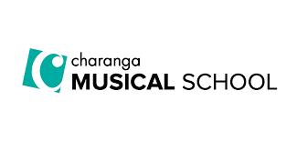

The school also offers a wider opps to all year 3 pupils who are currently learning to play the recorder on a weekly basis. From years 4 to 6 children have the opportunity to receive a weekly music lesson with a peripatetic music teacher playing either the keyboard, the flute, the clarinet or the violin.
Additional opportunities are offered in music, such as the key stage 2 choir which performs regularly in school and at events in the local community.

We also perform at Christmas and at Masses throughout the year, as well as class masses and hymn practices.

The progress of all children, including those with SEND and disadvantaged children is closely monitored and the curriculum is designed to ensure that any gaps are closed

Impact:

Our music curriculum is monitored regularly by the Senior Leadership Team and Subject Leads to ensure that all learners, including disadvantaged and pupils with SEND have:
- A depth of coverage of music
- Knowledge and skills are ongoing throughout each year group
- Consistent standards
- Engaged, creative independent learning
- Accurate assessment for learning
- Feedback moving the learning forward
- can confidently recall key knowledge from current and previous areas of learning
- are confident in using and applying vocabulary
The music curriculum is planned to demonstrate progression and building on and embedding musical skills,
Music assessments are completed at the end of each term with each child being assessed as SEN, WT and Expected. Music is monitored throughout the year using a variety of strategies such as lesson observations, scrutinies, photos and work in the music big book, along with pupil voice.

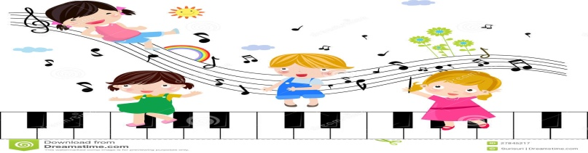

Expectations of teaching Music at St Laurence’s Catholic Primary

INCLUDEPICTURE "http://officeimg.vo.msecnd.net/en-us/images/MB900329305.jpg" \* MERGEFORMATINET INCLUDEPICTURE "http://officeimg.vo.msecnd.net/en-us/images/MB900329305.jpg" \* MERGEFORMATINET
Music lessons are to be taught over consecutive days or weeks, depending on timetables, using the online resource Charanga.
♪
Musical vocabulary and terms are to be used within lessons. These must be re-visited regularly and built upon over the year
♪
Children should learn to sing and to use their voices, to create and compose music on their own and with others, have the opportunity to learn a musical instrument, and have the opportunity to perform and share with others.
♪
Children should understand and explore how music is created, produced and communicated, including through the inter-related dimensions: pitch, duration, dynamics, tempo, timbre, texture, structure and appropriate musical notations.

INCLUDEPICTURE "http://officeimg.vo.msecnd.net/en-us/images/MB900329305.jpg" \* MERGEFORMATINET INCLUDEPICTURE "http://officeimg.vo.msecnd.net/en-us/images/MB900329305.jpg" \* MERGEFORMATINET

