MFL – Modern Foreign Languages Policy

Introduction
Learning a foreign language is part of the primary National Curriculum and is a requirement for all children within key stage 2 (KS2). St Laurence’s Catholic Primary School has adopted a whole school approach to the teaching of Spanish to all KS2 pupils. The implementation of this policy is the responsibility of all teaching staff.

Our Aims
Our aim is to develop the confidence and competence of each child in the foreign language they are learning. Our goal is for them to be passionate, curious and confident about their own foreign language learning abilities when they finish the primary school phase of their education.

We will help them develop and demonstrate substantial progress in the 5 key language skills necessary for learning Spanish:

- Speaking
- Listening
- Reading
- Writing
- Grammar

We aim to ensure that pupils of all abilities develop solid foundations in these key language learning skills - properly preparing them for the next stage of their language learning journey. These skills will develop children’s ability to understand what they hear and read and enable them to express themselves in speech and writing. We will extend their knowledge of how language works and explore the similarities and differences between the foreign language they are learning and English. We will also help strengthen their sense of identity through learning about culture in other countries and comparing it with their own.

Teaching and Learning Overview
Our whole school approach to language teaching and learning is in line with the recommendations of the National Curriculum and the requirements outlined in the Department for Education Languages Programme of Study for Key Stage 2.

The National Curriculum for languages aims to ensure that all pupils:

- Understand and respond to spoken and written language from a variety of authentic sources.
- Speak with increasing confidence, fluency and spontaneity, finding ways of communicating what they want to say, including through discussion and asking questions, and continually improving the accuracy of their pronunciation and intonation.
- Can write at varying length, for different purposes and audiences, using the variety of grammatical structures that they have learnt.
- Discover and develop an appreciation of a range of authentic writing in the language studied.
Through our implementation (see Appendix) we aim that by the end of key stage 2, pupils should be able to:

- Listen attentively to spoken language and show understanding by joining in and responding.
- Explore the patterns and sounds of language through songs and rhymes and link the spelling, sound and meaning of words.
- Engage in conversations; ask and answer questions; express opinions and respond to those of others; seek clarification and help.
- Speak in sentences, using familiar vocabulary, phrases and basic language structures.
- Develop accurate pronunciation and intonation so that others understand when they are reading aloud or using familiar words and phrases.
- Present ideas and information orally to a range of audiences.
- Read carefully and show understanding of words, phrases and simple writing.
- Appreciate stories, songs, poems and rhymes in the language.
- Broaden their vocabulary and develop their ability to understand new words that are introduced into familiar written material, including through using a dictionary.
- Write phrases from memory, and adapt these to create new sentences, to express ideas clearly.
- Describe people, places, things and actions orally and in writing.
- Understand basic grammar appropriate to the language being studied, including (where relevant): feminine, masculine and neuter forms and the conjugation of high-frequency verbs; key features and patterns of the language; how to apply these, for instance, to build sentences; and how these differ from or are similar to English.

Displays of the topics being taught in Spanish will be displayed around individual classrooms and updated regularly showcasing the children’s work.

Organisation & Delivery
Spanish is taught in a whole-class setting by the class teacher. Teachers plan their lessons using the Language Angels scheme of work and can supplement this with their own ideas and experience.

The lessons are designed to motivate, captivate and interest children from the first moment. They have clear, achievable objectives and incorporate different learning styles. SEN children have access to the curriculum through variation of task, grouping or support from an adult.

Each class has a timetabled lesson of at least thirty minutes per week. Spanish can also be revisited in short sessions throughout the week to consolidate knowledge and ensure new language is retained.
Spanish lessons include:
- PowerPoint’s and interactive whiteboard materials.
- Interactive games (which pupils can access from home to consolidate their learning).
- Spanish songs.
- Differentiated desk-based consolidation activities.
- Worksheets are provided for each lesson throughout each teaching unit.
- Writing activities which focus on key vocabulary and grammar taught.

Each lesson will focus on a combination of the 5 key language learning skills (speaking, listening, reading, writing and grammar).

Below is an outline of the units we cover throughout KS2:
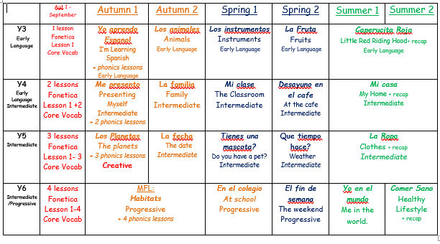

Resources
The Language Angels scheme is a fully online resource enabling all teachers, in all classes, to have instant and continuous access to all the resources they need to teach whichever lesson they choose. Key Vocabulary from each unit will be at the heart of each lesson and teachers will use knowledge organisers, core vocabulary sheets and display materials to embed and deepen children’s understanding.

Evidence of Teaching & Learning
Worksheets or activities completed by the children will be evidenced in their books which are passed through the years and become a portfolio of their learning. Each half term, teachers will use end of unit assessments and teacher judgement to track the children’s progression of learning which will inform their future planning and allows teachers to recognise those children who may need extra support or intervention if progress is not being made.
Assessment of Pupil Learning & Progression
Two forms of assessment are available at the end of each Language Angels unit:
- Peer and self-assessment ‘I can do…’ grids. This is a quick and easy way for all pupils in the class to record which units they have completed and the progress they are making.
- More detailed skills based assessments using bespoke skills assessment worksheets. This form of assessment enables teachers to determine the learning and progression of all pupils in the key language learning skills, as well as monitoring their progress against the 12 attainment targets stipulated in the DfE Languages Programme of Study for Key Stage
The Subject Leader and class teacher monitor the learning and progression made by pupils across the key stage through these half term assessments which inform future lessons and planning.
Monitoring and evaluation
The Subject Leader monitors the effectiveness of the language teaching provided throughout the school via Subject Development Days where the lead can look at a selection of children’s exercise books; observe any lessons, speak to children to about their MFL experiences and gather evidence to update MFL ‘big book’ for each term to show progression throughout KS2. They support teachers in their teaching and delivery of MFL, by keeping them informed of any developments from Language Angels.

The Subject Leader will encourage wider exposure to Spanish in the form of greetings/instructions used outside of the Spanish Lessons. In September each class teacher receives a poster containing everyday phrases in Spanish. Teachers are encouraged to use these with the children so they become familiar with the phrases as they move throughout the school.

The subject leader will take responsibility of organising a Spanish Day each academic year so the children are immersed in the Spanish culture by completing various activities and workshops. This will deepen the children’s understanding and curiosity of the language they are learning.

