St Laurence’s Patron Saints
2022-2023
Year Group | Saint Studied | Short background
Nursery | 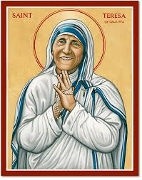 | Mother Teresa is the Patron Saint of World Youth Day.
Reception | 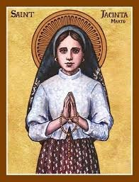 | A child Saint, canonised in 2017, Saint Jacinta is the youngest Saint who was not canonised as a martyr. Saint Jacinta is the Patron Saint of sick people.
Year One | 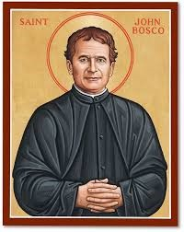 | A priest who set up schools for the poor, Saint John Bosco is Patron Saint of school children.
Year Two | 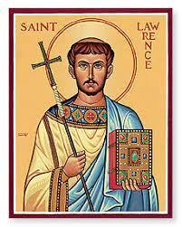 | Saint Lawrence is the Patron Saint of school children, poor people, cooks and comedians.
Year Three | 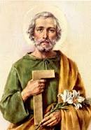 | St Joseph the Worker is the Patron Saint of the Universal Church.
Year Four | 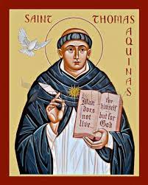 | Saint Thomas Aquinas is the Patron Saint of Scholars.
Year Five | 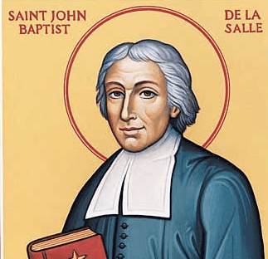 | St John Baptist De La Salle is the Patron Saint of Teachers.
Year Six | 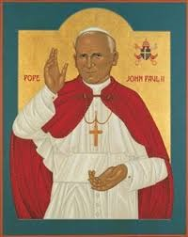 | Pope John Paul II is the Patron Saint of World Youth Day.

