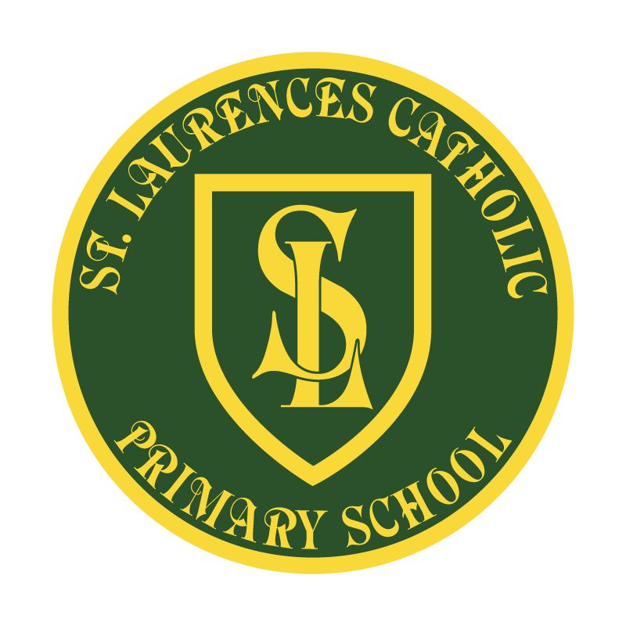

St Laurence’s Catholic Primary School

Parents/Visitors
Code of Conduct on school site
This policy was reviewed: | November 2022
By name: | Mr John Holmes
Position: | Chair of Governors
Signature: | J Holmes

Our Mission Statement

1. We aim to celebrate our partnership with the families we serve and the community we live in.

2. We aim to provide an education that enables each child to reach their full potential.

3. Our aim is the creation of an atmosphere where all are valued, gifts and talents are celebrated and the gospel values of love, respect and justice are at the heart of all we do.

Our Vision
Everyone feels a sense of belonging,
Has the opportunity to shine,
To enjoy their teaching and learning
But most of all – to dream big!

Parent/Visitor Code of Conduct

RATIONALE
At St Laurence’s Catholic Primary School we are very fortunate to have supportive and friendly parents.
Our parents recognise that educating children is a process that involves partnership between the home and school and understand the importance of a good working relationship to equip children with the necessary skills for adulthood.
For these reasons we welcome and encourage parents/guardians/visitors to participate fully in the life of our school.
The purpose of this policy is to provide a reminder to all parents/guardians and visitors to our school about expected conduct so that we can work together to ensure a safe and positive school environment for our children.

This Code of Conduct is an unsigned agreement between the Parent, Guardian, Visitor and
St Laurence’s Catholic Primary School.

RESPECT AND CONCERN FOR OTHERS AND THEIR RIGHTS:
We expect parents/guardians/visitors to show respect and concern for others by:-
- supporting the respectful ethos of our school by setting a good example in their own speech and behaviour towards all members of the school community;
- working together with teachers for the benefit of children. This includes approaching the school to resolve any issues of concern and to discuss and clarify specific events in order to bring about a positive solution;
- respecting the school environment, including keeping the school tidy by not littering and returning equipment that has been borrowed.
- delivering and collecting children in an orderly manner

In order to support a peaceful and safe school environment, the school will not tolerate:-
- disruptive behaviour which interferes with the operation of a classroom, the office area, the outside learning environment or any other part of the school grounds;
- using loud and/or offensive language or displaying temper;
- threatening harm or the use of physical aggression towards another adult or child, including your own
- abusive or threatening emails, phone or social network messages;
- smoking and consumption of alcohol or other drugs or accessing the school site whilst intoxicated.
- Dogs being brought on to the school premises. (other than guide dogs)

If any of the above points are repeatedly persistent and do not cease we will take matters up with the police, which could result in prosecution and a fine.

ISSUES OF CONDUCT WITH THE USE OF SCOIAL MEDIA
Most people take part in online activities and social media. It’s fun, interesting and keeps us connected.

‘Think before you post’
We ask that social media, whether public or private, should not be used to fuel campaigns and voice complaints against the school, school staff, other parents or children in our school community.

We take very seriously inappropriate use of social media by a parent to publicly humiliate or criticise another parent, member of staff or child.

If parents have any concerns about their child in relation to the school as we have said above they should:

- Initially contact the class teacher
- If the concern remains, they should contact the Headteacher
- If still unresolved, the school governors through the complaints procedure

They should not use social media as a medium to air any concerns or grievances.

Online activity which we consider inappropriate:
- Identifying or posting images/videos of children
- Abusive or personal comments about staff, governors, children or other parents
- Bringing the school in disrepute
- Posting defamatory or libellous comments
- Emails circulated or sent directly with abusive or personal comments about staff or children
- Using social media to publicly challenge school policies or discuss issues about individual children or members of staff
- Threatening behaviour, such as verbally intimidating staff, or using bad language
- Breaching school security procedures

The above behaviours on school premises or social media will be reported to the appropriate authorities and Governors may prohibit any offending adult from entering the school grounds to safeguard our school community.

We trust that parents/guardians and visitors will assist our school with the implementation of this policy and thank you for your continuing support.

