St Laurence’s Catholic Primary School
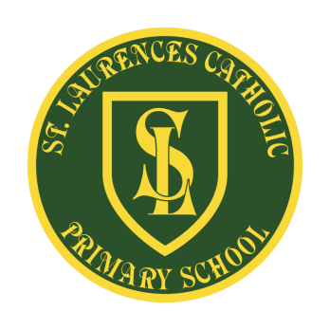
E Mail: stlaurence@knowsley.gov.uk
Website: www.stlaurences.co.uk
Twitter: @slaurences
Leeside Avenue
Southdene
Kirkby
L32 9QX
Telephone: 0151 546 4733
Headteacher: Mrs SJ Carroll-McKevitt
Date: 7th November 2022
RE: Behaviour of parents on our school site

Dear Parent/Guardian,
At St Laurence’s Catholic Primary School, your child’s education and welfare is our number one priority. All of the staff here are passionate about every single child achieving their very best potential. That’s why we believe every new day presents endless possibilities.
We know that parents and guardians are passionate about their children too. For this reason, we have an open-door policy. We are here to help and are happy to discuss any concerns with you, so that they can be quickly resolved. We expect that you will raise any concerns in a calm, considered and caring way. Fortunately, the overwhelming majority of you do, however recently not all parents/guardians have been.
Our staff have every right to be treated with respect and courtesy, at all times.
We will not tolerate ANY member of staff being subjected to aggressive, intimidating or violent behaviour, which causes them to feel threatened. This particularly relates to physical behaviour, but can also include comments made on social media or on the school grounds. Any instances of aggressive, intimidating or violent behaviour, whether they be physical, verbal or through social media, will be reported by staff to the Headteacher and Governing Body, and appropriate action will be taken.
Following some recent specific instances of staff being verbally shouted at the Governing Body has reluctantly found it necessary to adopt a new policy for dealing with abusive parents or carers.
The policy can be found on our website at http://stlaurences.co.uk - named parent code of conduct. This sets out the forms of behaviour that are considered unacceptable and threatening in nature. The policy allows for the school to provide the ultimate sanction of banning an abusive parent or guardian from the school’s premises and reporting the matter to the police, if necessary. Where the police become involved, the matter could result in a prosecution and fine.
We respect the right of our staff to feel safe and secure in their professional working environment and therefore hope all of our parents will think about their behaviour when speaking to any staff member.
We sincerely hope you will continue to work with us to ensure it will never become necessary to apply this policy to any parent or carer of children at St. Laurence’s.

Attached to this letter is also a copy and reminder of our Kirkby Collaborative of Schools Safeguarding and Behaviour promise, which is in place across all Kirkby schools.

Kind regards

Mr J Holmes
Chair of Governors

