St Laurence’s Catholic Primary School
Leeside Avenue
Southdene
Kirkby
L32 9QX
Telephone: 0151 546 4733
Headteacher: Mrs SJ Carroll-McKevitt
9th September 2022
Dear Parent/Guardian
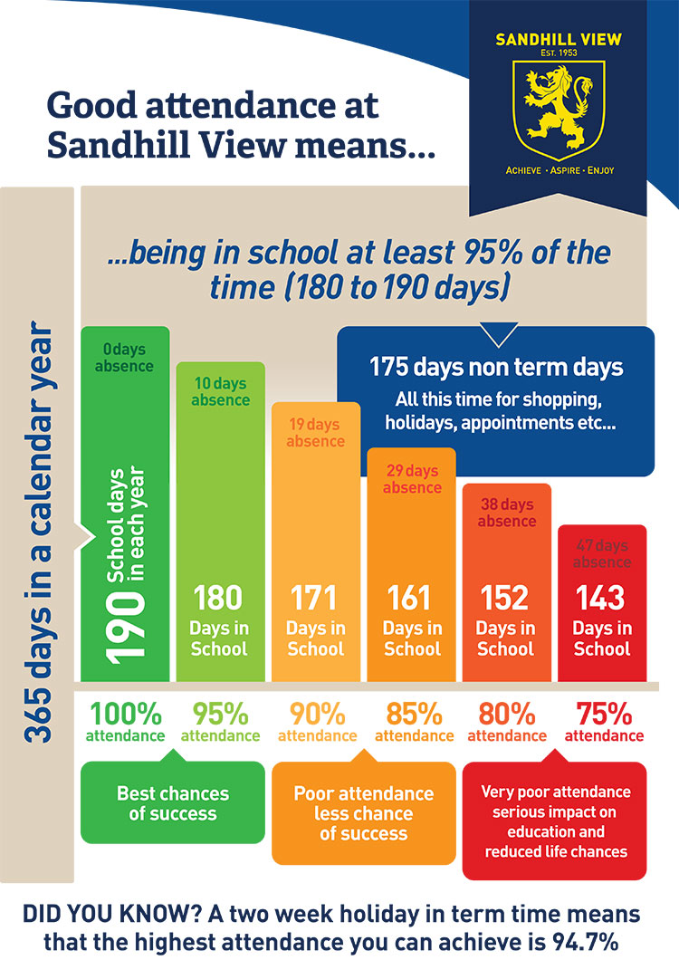
As a school we pride ourselves on having a good attendance throughout the year. This year we have set an attendance target of 96.5% - which we want all of our children to achieve. All classes have been given a class target to strive to achieve. We can only achieve this with your help in sending your child into school, ON TIME – EVERY DAY. Pupils are expected to arrive at school between 8.40am and 8.55am. The gates will close at 8.55am. This is now more important than ever, after they have been absent due to COVID and lockdown for so long.
We want all of our children to achieve their best but they can only do this if they are in school EVERY DAY.
I am therefore asking that all competitions, days out and holidays be attended outside of school hours. Failure to do so will mean your child recieves an unauthorised absence.
Please see the following national research information that shows the impact of absence and punctuality on a child’s achievements.
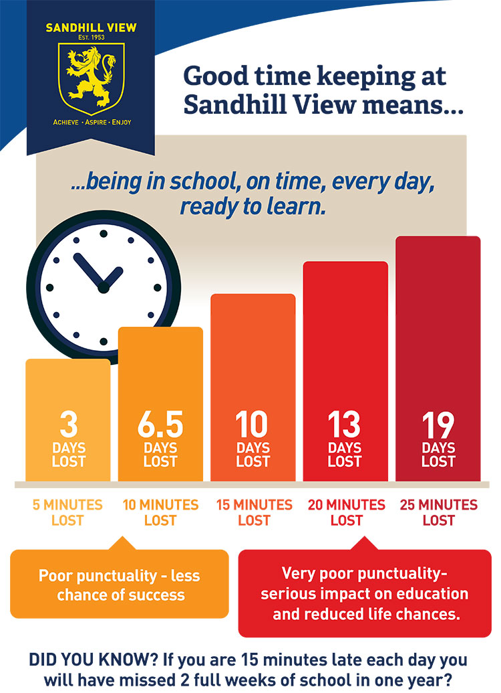
Your support with our target is always appreciated. We can all make a difference in the lives of our children if they are given the right tools to work and learn. This can only happen if they’re in school. The information tables in this letter show how detrimental absence and lateness can be.
This year we will be offering the following incentives for our good attenders:
Family Rewards – Each term children with 100% will be entered into a draw to win a day out for their family.
Pizza Party – we will hold a pizza party for 100% attendance winners every term, instead of at the end of the year.
Attendance Cup – We will hold a competition each term, between each of our classes – the winning class will receive our Attendance Cup and a prize for their class.
Class Rewards – The class with the best attendance each week will be rewarded with £10 to spend on whatever they choose.
We believe that these incentives are a fantastic way to increase our overall school attendance and we welcome your support in trying to achieve our school target of 96.5%.
If you have any questions about any of the information given in this letter, please don’t hesitate in coming into school to speak to myself, Mr Cushion or a member of staff.
Yours sincerely,
Mrs Carroll-McKevitt

