St Laurence’s Catholic Primary School
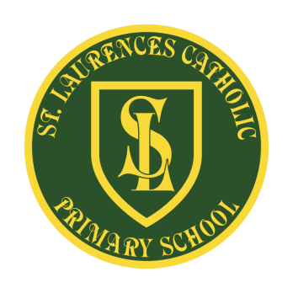
E Mail: stlaurence@knowsley.gov.uk
Website: www.stlaurences.co.uk
Twitter: @slaurences
Leeside Avenue
Southdene
Kirkby
L32 9QX
Telephone: 0151 546 4733

Headteacher: Mrs SJ Carroll-McKevitt
Date: 25th October 2022

School Spider, Seesaw and Tapestry

Dear Parent/Guardian,

Thank you to all of you who have registered for either your child’s Seesaw or Tapestry notifications from their class teacher/school.

Our staff have sent out letters with QR codes and log in details on a number of occasions this half term. If you have still not logged on, please see your child’s class teacher for details, when we return to school.

The above apps are one of our ways of communicating with you. Staff may put up examples of work completed by your child/children in class or they will share announcements/messages with you on Seesaw/Tapestry. We also communicate through our website app – School Spider, which can be downloaded from the App store.

We ask that parents reply to or send messages on these apps at sensible times and are understanding if staff do not respond back, especially during the school teaching day and at times out of school hours.

Staff will not communicate with you after 5pm, at weekends or during school holidays. We politely ask that you respect their well being and down time and do not send messages during these periods.

Your support with the above is greatly appreciated.

Kind regards
Mrs Carroll-McKevitt

