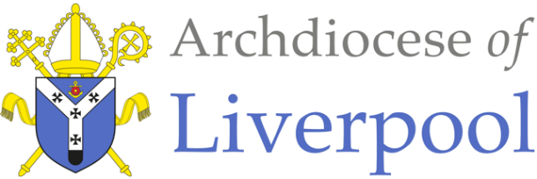

**Belonging – A Sacramental Topic**

**\*Note to parents**.

This work comes from the *Come and See* Religious Education programme which is taught in all Catholic schools in the Archdiocese of Liverpool. We have given a general guide to the learning opportunities that your child may have come across in school and have only suggested and selected a small amount of the programme. The activities aim to keep Religious Education practical and fun. They are in Year groups however, there is no harm in completing other lower year group work as well as this will help your child to remember and strengthen their learning***.***

The first part of learning is called – **EXPLORE**. This shares your child’s everyday experiences and helps them to see how the Catholic faith is lived in their everyday lives as the theme progresses. The second part, called – **REVEAL** shares bible stories, religious teachings, lives of saints etc. that can relate to their everyday life. There are suggested activities for each section. Choose those you wish to do and record them as best as you can sending any work undertaken to school.

This theme is a Sacramental theme and focuses on the Sacraments of Baptism (and Confirmation, Marriage and Holy Orders). We understand that not every child or parent will have been baptised, so alongside this document are notes about the Sacrament of Baptism that you may find useful. All the other information you will need is here.

**YEAR 5 -** **LIFE CHOICES - EXPLORE**

Showing care and commitment

* Children may be able to **make links** to show how their feelings and beliefs affect their own and others’ quality of care and commitment towards each other and the way they behave towards each other.
* Friendships are important in life. When you make friends, you have to think about the other person and show some care and loyalty towards them. Friendship usually means commitment to the other person’s needs as well as your own. This is true in families. In families where there is care, compassion and loyalty to each other everyone will feel better.
* Talk about what it means to be a caring member of your family and what sacrifices you all make to show care and compassion to each other.
* Discuss how you feel when one of the family hurts another or when you fall out with one of your friends. Describe what responsibilities friends and family have towards one another.
* Talk about a time when you celebrated a special time with a) your family b) with your friends.

**Activities:**

* What ‘ingredients’ do you need to be a loyal friend? Write a recipe for a good and faithful friend.
* Write an article for a magazine giving advice about how to maintain a friendship, include ideas about commitment, responsibility and fidelity.
* Make a paper chain of your friends or family. On it write all the ways you can show fidelity and commitment to each other.



**YEAR 5 - LIFE CHOICES - REVEAL**

The call to life and love within the community; marriage

* Children may be able to **give reasons** for the religious actions and symbols used in the Sacrament of Marriage and for the love and service shown by Christians.
* Children may be able **to show some understanding** of the marriage liturgy, the promises made and of how religious belief shapes the lives of married people.
* Through the Sacrament of Baptism, all Christians are called to share the mission of Jesus and they carry this out in many different ways. God calls each of us to a particular vocation (calling) in life. Everyone has an important, but different role in the mission of the church. Some people’s vocation is to marriage, to the single life or to the religious life. Some people’s vocation is to ordination as a deacon, priest or bishop.
* **The Sacrament of Marriage:**

For some people the living out of the commitment to love and service will be through marriage.

Marriage is a sacrament of commitment to love and support of each other. It celebrates the gift of love, life and friendship with God and one another. The husband and wife, if blessed with children, will provide a loving family for the children to grow up in.

Before a couple get married, they must take part in a marriage preparation course which usually takes place in the parish or Deanery. The purpose of this is to make sure the couple really understand what they are undertaking as this is a life-long commitment of service.

A man and a woman choose to be married in church because Jesus is important in their lives and they want God’s blessing. This is their response to God’s call to live a life filled with love for one another. The family gather to celebrate the sacrament with them at their wedding. Sometimes the celebration takes place during Mass and other times it is a different liturgy.

The ceremony goes as follows:

* Entrance of the bride – everyone stands to welcome her and joyful music is played
* 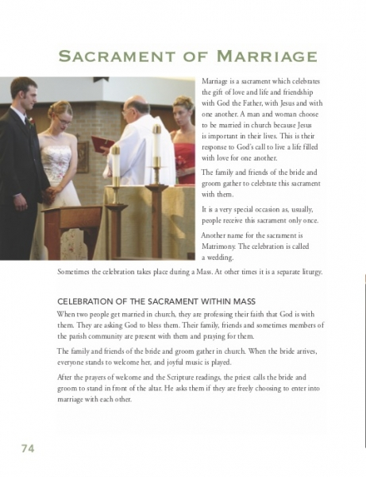Prayers of welcome
* Scripture Readings
* Bride and Groom are asked by the priest if they are freely choosing to enter into a marriage with each other.
* After each has said they are, they join hands and make their promises. They each, in turn, say, “I call upon these persons here present to witness that I (name) do take thee (name) to be my lawful wedded wife/husband to have and to hold, from this day forward, for better, for worse, for richer, for poorer, in sickness and in health, to love and to cherish till death do us part.”
* Rings, which are a sign of love and fidelity, are blessed by the priest and exchanged. The bride and groom say to one another, (name), take this ring as a sign of my love and fidelity. In the name of the Father and of the Son and of the Holy Spirit”. (Think about the shape of a ring, that it has no beginning or end and is usually made of gold or a precious metal.)
* The bride and groom and their witnesses sign the register of marriage. This is an official legal document.
* Everyone then joins in with the Our Father, which ends with a blessing in which the priest prays that the couple will be faithful to each other, be an example of Christian life.
* The priest asks that they will be blessed with children and be good parents and, that at the end of their lives they will have everlasting life in Heaven with all the saints.
* The couple leave the church followed by family and friends and celebrations usually follow.
* Talk together about
* how a married couple can show their love, service and fidelity to each other
* why the promises they make are important
* whether the promises are hard to keep and what they commit the bride and groom to
* what the rings symbolise

**Activities:**

* Design a wedding card using appropriate symbols. Create a prayer for married people, asking God for his strength and guidance to help the couple show their love and service to each other. Incorporate the prayer into the wedding card.
* Make a booklet of the marriage liturgy, explaining what is happening and why, include a choice of appropriate hymns and scripture readings and give reasons for your choices.
* Read the Promises. In your own words say what you think they might mean in terms of thoughts and actions within daily life. Match simplified promises to the actual promises of the sacrament of marriage and give an example of how this might be lived out in married life.

|  |  |  |
| --- | --- | --- |
| **Simplified Promise…** | **Actual Promise…** | **How this is might be lived in daily life…** |
| Not to let illness  break us up | In sickness and in health | Looking after one another |
| To share all I have equally with you |  |  |
| To live with you for ever until one of us dies |  |  |
| Not to let poverty  come between us |  |  |
| To be faithful to  you alone |  |  |
| To love you and look after you tenderly |  |  |
| To begin a new  family with you |  |  |
| To put you first in  my life |  |  |

At the end of all the work you have done about **LIFE CHOICES**,say together the prayer you have written. Remember to say thank you to the people who show love and service to you!