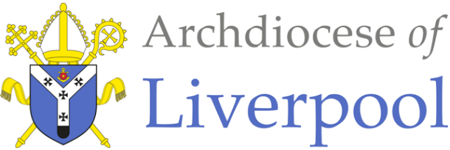
Belonging – A Sacramental Topic
*Note to parents.
This work comes from the Come and See Religious Education programme which is taught in all Catholic schools in the Archdiocese of Liverpool. We have given a general guide to the learning opportunities that your child may have come across in school and have only suggested and selected a small amount of the programme. The activities aim to keep Religious Education practical and fun. They are in Year groups however, there is no harm in completing other lower year group work as well as this will help your child to remember and strengthen their learning.
The first part of learning is called – EXPLORE. This shares your child’s everyday experiences and helps them to see how the Catholic faith is lived in their everyday lives as the theme progresses. The second part, called – REVEAL shares bible stories, religious teachings, lives of saints etc. that can relate to their everyday life. There are suggested activities for each section. Choose those you wish to do and record them as best as you can sending any work undertaken to school.
This theme is a Sacramental theme and focuses on the Sacraments of Baptism (and Confirmation, Marriage and Holy Orders). We understand that not every child or parent will have been baptised, so alongside this document are notes about the Sacrament of Baptism that you may find useful. All the other information you will need is here.

YEAR 2 - SIGNS & SYMBOLS - EXPLORE
The love and care shown in the family

- Children may be able to talk about and describe their experiences and feelings about signs which help them and others in daily life and say what symbols are important to them and why.
- Children may be able to say what they wonder about the meaning and importance of some symbols in their life and ask others which ones are important to them.

- Talk about signs and symbols, how a sign tells us something we need to know (for example, McDonald’s, road signs, numbers), and a symbol means something really important (for example, hugs, kisses, tears).

- Read this story together and encourage your child to point out the signs and symbols as you go along.
(Symbols and their meanings used in the story:
welcome: glad to see them hugs and kisses: love, friendship
food: caring and sharing a toast: good wishes, celebration
singing: joy, happiness
engagement ring: love, belonging, commitment, promise
party: celebration
tears: joy, happiness, memories)
This Photo by Unknown Author is licensed under CC BY-NC

Cousin Liz’s engagement party

“Liz told us to look out for McDonald’s along this road,” said Dad.
“Then we’ve got to turn into Princess Road, opposite the park gates,” added Mum who was holding a piece of paper with directions and a map.
“There’s McDonald’s,” shouted Jason. They drove along and there was Princess Road. “Right, Dad!” said Jason.
“Now look out for No. 36,” said Mum. “I bet Liz is feeling like a princess.”
“Will I have to kiss everyone?” asked Jason. “I’ll hate it.”
Dad grinned, and Mum said, “Just remember to behave yourself and don’t get too excited with your cousins, like you did last time.”
“There’s 36,” shouted Jason, glad to change the subject. “There’s the yellow burglar alarm they told us to watch out for.”
Dad tooted the horn and Liz came out to welcome them. Jason was glad to see that David was there as well. “I think that must be Liz’s fiancée, Derek,” said Mum, “Isn’t he tall!”
There were hugs and kisses at the front door. Jason tried to escape before Auntie Terry could kiss him, but he failed! David took Jason into the dining room. “Come and see all this food. I can’t wait to get started,” said David.
“Amazing!” said Jason, at the sight of the sandwiches, salads, trifles and gateaux, crisps, sausages on sticks and pieces of cheese and pineapple. In the middle was a cake with ‘Liz and Derek’ iced on it.

Activities:
- Make a list of all the signs and symbols in the story and what they mean.

- Take the children for a walk in the local area noticing signs and symbols along the way. Discuss why they are used.

- Describe and draw some of the signs and symbols that have been used recently.

YEAR 2 - SIGNS & SYMBOLS - REVEAL
God’s love and care for every family

- Children may be able to recognise the signs and symbols used in Baptism.
- Children may use some religious words and phrases and describe some actions and symbols used in the Sacrament of Baptism.
- Children may be able to recognise that and describe how Christians act in a particular way because they are members of the Church family and followers of Christ.

- (See Baptism Notes for Parents – Signs & Symbols)
Look at the pictures below. Describe the signs and symbols of Baptism you can see and talk about what they mean.
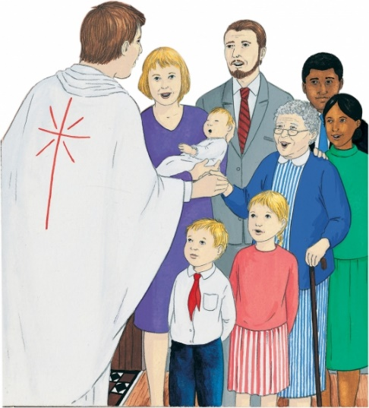

Activities: (choose whichever you would like to do)

- Design an invitation card to a Baptism using some of the symbols you have talked about. Inside the card write down what the symbols mean.

- Make a Baptism candle with a name and symbols of Baptism on it. Write on it the words the priest uses as he pours the water.

- Write a prayer for a newly baptised baby including the characteristics of oil and the Holy Spirit.

At the end of all the work you have done on SIGNS &SYMBOLS, say this prayer or the prayer that you have written:
Thank you, God for the signs and symbols around us that keep us safe and show us that you are always with us. Help all Christians to follow the light of Jesus. Amen!

