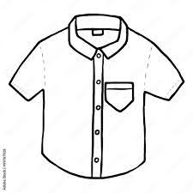
Pre-loved uniform

St Laurence’s Catholic Primary School

Looking for a FREE uniform?
Come along to our uniform exchange on
Wednesday 31st August 10am – 11am,
Thursday 1st September 2.30pm – 3.30pm
Friday 2nd September 2.30pm – 3.30pm

to collect any needed items!

Items we have:
Jumpers Cardigan
Skirts Trousers
Ties Shirts
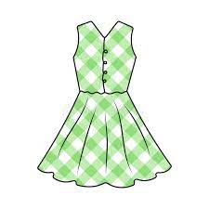
Pinafores Shorts
Summer Dresses

All of the schools in Kirkby are working together to ensure that old, unwanted and pre-loved uniforms are not going to waste! If you have any unwanted or unneeded uniforms, which are in good condition, they could be used to help another family within our community.

Thank you for supporting this wonderful project.

