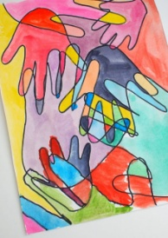  Family Handprints  Draw around all of your families hands so they are overlapping. Then use a different colour pencil to colour in each of the sections. | Share a story  Choose one of your favourite books and read it to a family member or friend. You might want to record yourself reading the story and send it to someone if you don’t live with them. Ask what they liked about the story. | Create a card  Design and make a card for someone you care about. It could be for their birthday, a special occasion or to tell them you are thinking of them.  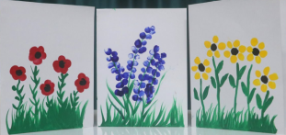 | Write a poem  Take the word SUMMER and write an acrostic poem. An acrostic poem is when the first letter of each line spells out the word. Here is an example:  Sun shining brightly in the sky.  Up in the sky the birds fly high.  Not a cloud in sight.
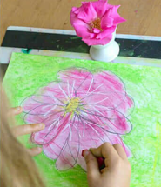  Observational Draw  Take an object of your choice, a piece of paper and pencil. Carefully sketch your object. Remember to look closely at the object and try to include as much detail as possible in your drawing. | 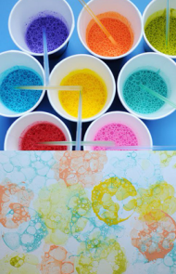  Bubble Art  1. Add 3 tablespoons of bubble solution (washing up liquid) and some paint to a dish or cup.  2. Mix the solution together.  3. Take a piece of paper and put on a table or outside.  4. Use a bubble wand or straw and dip it in the bubble solution and then blow onto the paper. | 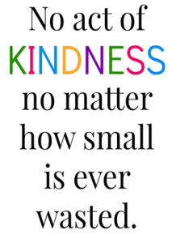  Act of kindness  Spread some happiness and positivity by doing something kind for the people you live with. You could make them a drink, help to wash the dishes or give them a hug when they least expect it. See how many acts of kindness you can complete in a week. | Exercise  - Get some exercise by playing your favourite sport outside.  - Ride your bike or scooter.  - Learn to skip with a skipping rope.  - Set up an obstacle course to complete.  - Complete a home work out.  - Complete a cosmic kids yoga video on YouTube.  - Go for a walk with your family.
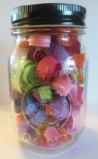  Hopes for the Future  Take some strips of paper and a jar. On the pieces of paper write down things you are looking forward to doing in the future. This might be going to the zoo or learning something new. Place strips of paper in the jar. | Movie Night  Choose one your favourite films and have a movie night with your family. Get some of your favourite snacks to enjoy whilst watching the film.  You could even create your own den to get comfy in while you watch the film! | Prayer Handprint  1. Take a piece of card and draw around your hand.  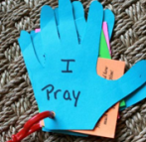  2. Carefully cut out your handprint.  3. In the middle of the handprint write ‘I pray for’ and then on each finger choose someone you pray for. This could be family, friends or teachers. | Bake a treat  With an adult make one of your favourite treats. You might bake a cake, biscuits or brownie.  Or cook one of your favourite meals.

