St Laurence’s Catholic Primary School
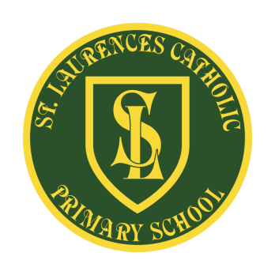
E Mail: stlaurence@knowsley.gov.uk
Website: www.stlaurences.co.uk
Twitter: @slaurences
Leeside Avenue
Southdene
Kirkby
L32 9QX
Telephone: 0151 546 4733
Headteacher: Miss SJ Carroll
Date: 1st September 2021
Dear Parent/Guardian,
We hope you find the information below useful.
Our Breakfast Club opens at 7.45am daily until 8.40am and our After School Club from 3.15pm until 5.15pm. The charge for each is as follows:
Breakfast Club - £4.00 After School Club £6.50
Having completed risk assessments and thorough cleaning we will be in a position to open our doors for up to 20 children in each session. This will be frequently monitored and evaluated.
Please note the following information that must be adhered to, if wanting a place for your child/children:
- Pre booking a place is required. No children will be allowed to drop in without prior booking.
- All payments must be made via ParentPay – we cannot accept cash.
- Parents will be asked to give their name to the staff member on the door who will then sign your child into the club.
- A contract must be completed by parents before a child is allowed to start (these can be collected from the school office)
- All accounts must be up to date and no debts owing for a place to be given.
- Monies must be paid up front and on time. Any monies not received for two weeks will mean the loss of your child’s place.
We expect all children who attend the club to follow the social distancing rules that have been put into place within school. Any pupil who does not follow these will be asked to leave the club.
Children will be given breakfast or a snack when they are in the club – depending on what club they attend.
We will expect the children to follow sanitizing rules, similar to those used in school.
If you have any questions or would like further information, please telephone school and ask to speak to Mrs Simpson or Miss Carroll.

Kind regards
Miss Carroll

