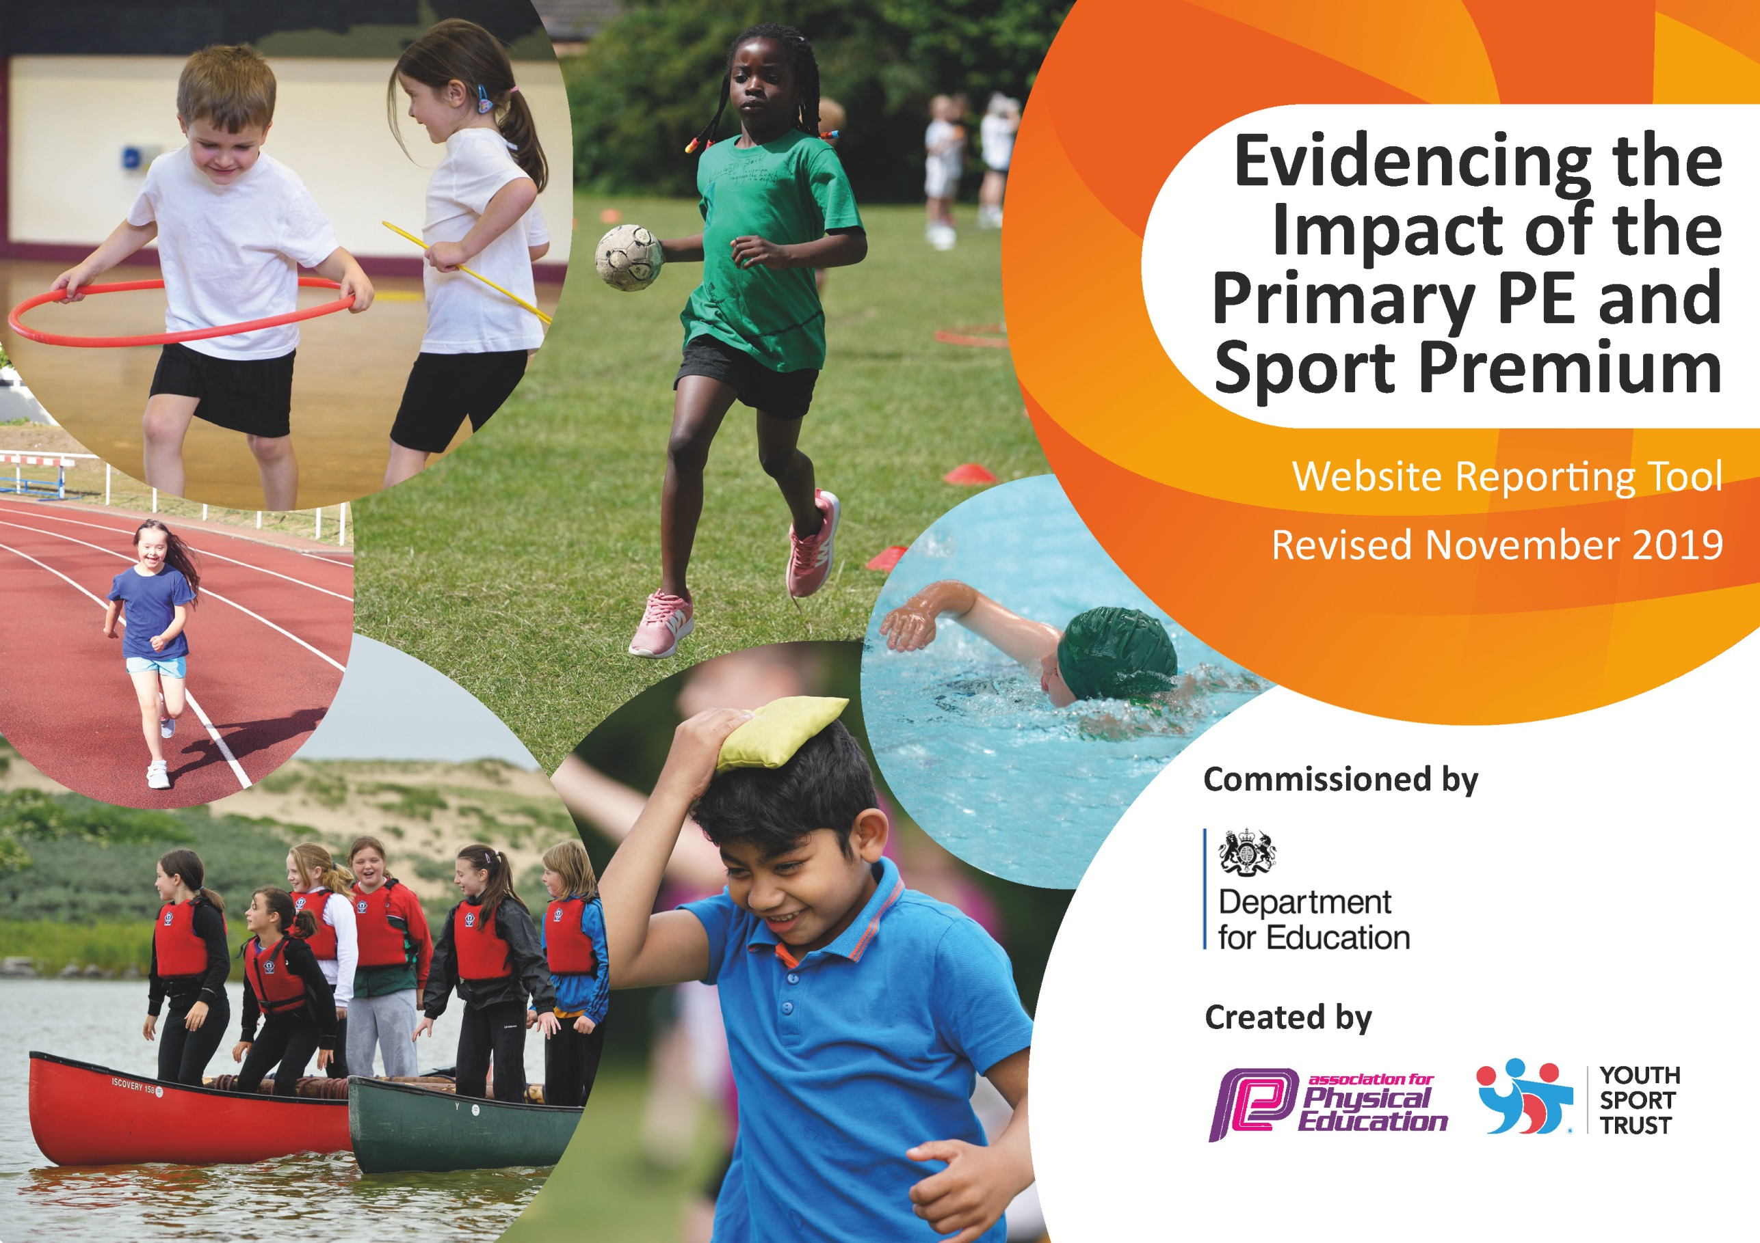
33
St Laurence’s Catholic Primary School
2019 -2020
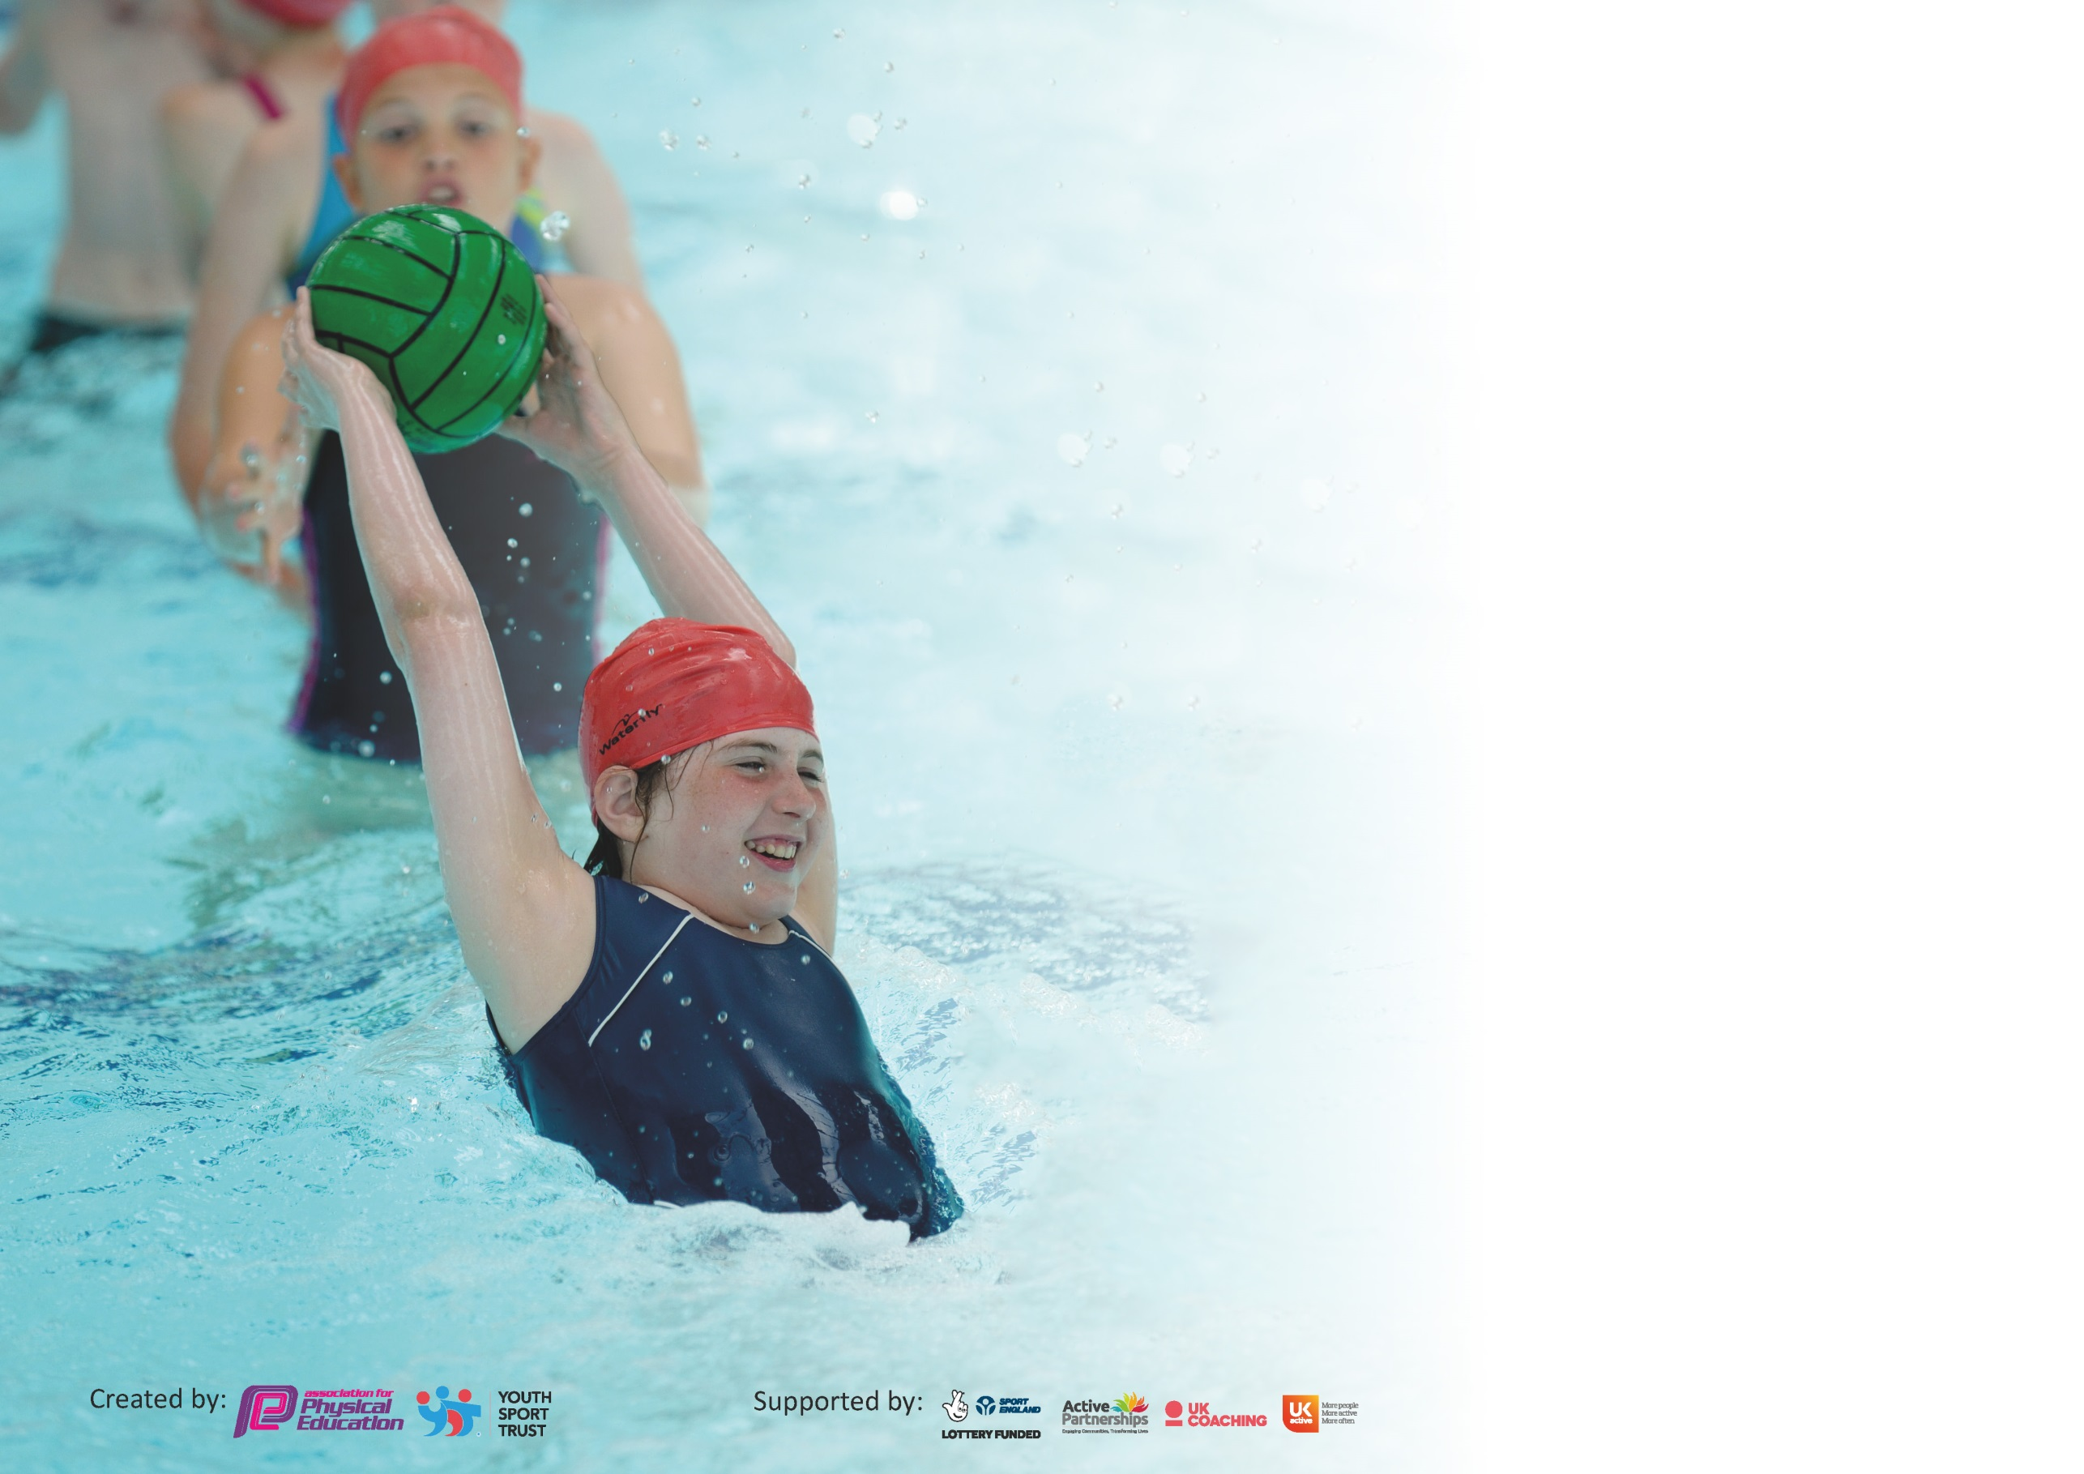

It is important that your grant is used effectively and based on school need. The Education Inspection Framework (Ofsted 2019 p64) makes clear there will be a focus on ‘whether leaders and those responsible for governors all understand their respective roles and perform these in a way that enhances the effectiveness of the school’.

Under the Quality of Education criteria (p41) inspectors consider the extent to which schools can articulate their curriculum (INTENT), construct their curriculum (IMPLEMENTATION) and demonstrate the outcomes which result (IMPACT).

To assist schools with common transferable language this template has been developed to utilise the same three headings which should make your plans easily transferable between working documents.

Schools must use the funding to make additional and sustainable improvements to the quality of Physical Education, School Sport and Physical Activity (PESSPA) they offer. This means that you should
use the Primary PE and Sport Premium to:

- Develop or add to the PESSPA activities that your school already offer
- Build capacity and capability within the school to ensure that improvements made now will benefit pupils joining the school in future years

Please visit gov.uk for the revised DfE guidance including the 5 key indicators across which schools should demonstrate an improvement. This document will help you to review your provision and to report your spend. DfE encourages schools to use this template as an effective way of meeting the reporting requirements of the Primary PE and Sport Premium.

We recommend you start by reflecting on the impact of current provision and reviewing the previous spend.

Schools are required to publish details of how they spend this funding as well as on the impact it has on pupils’ PE and sport participation and attainment by the end of the summer term or by 31st July 2020 at the latest.

We recommend regularly updating the table and publishing it on your website throughout the year. This evidences your ongoing self-evaluation of how you are using the funding to secure maximum, sustainable impact. Final copy must be posted on your website by the end of the academic year and no later than the 31st July 2020. To see an example of how to complete the table please click HERE.

Support for review and reflection - considering the 5 key indicators from DfE, what development needs are a priority for your setting and your pupils now and why? Use the space below to reflect on previous spend and key achievements and areas for development.

Key achievements to date until July 2019: | Areas for further improvement and baseline evidence of need:
*Continuation of CPD for staff across the school in their chosen areas of development.  *Attendance at the YST conference.  *Implementation of the Daily Mile at least 3 times a week.  *Promotion of active, healthy lifestyles for all children.  *In-school physical activity programme for Key Stage 1 children and parents through Family Fitness  *We offer a range of sports during curricular and extra-curricular time, including athletics, football, high fives and gymnastics.  *Extra-curricular activities are popular and there are a good proportion of pupils eligible for free school meals who take part in each of the activities from Key Stage 2.  *Improved quality and variety of PE resources and equipment.  *All pupils are engaged in PE during curricular time (this is supported by our specialist advisor from Knowsley Schools Sports Partnership)  *We have maintained participation in intra-schools competitions, with our school having won Kirkby Indoor Athletics Championships twelve years in a row and our football teams doing consistently well in the Kirkby and Knowsley leagues and competitions.  *In school competitions including Speed Bounce and Skipping and Hula Hoop. Virtual Competitions.  *All of our extracurricular activities are free and completed by staff within school except for Dance, Judo and Fencing. Postponed Due to Co-vid.  All pupils have a 2 hour timetabled session of PE each week. There are further opportunities for PE at lunch times, through a range of clubs.  *School achieved the School Games Award Platinum (judged by KSSP) in recognition of participation and quality provision in sport.  *Separate sports days are organised for KS1 and KS2 pupils, allowing children greater opportunities to participate.  *Separate sport days also ensures that events are suitable for the participating year groups. Postponed Due to Co-vid.  *Entered events to gain access to out of school companies such as the Everton FC Primary Premier League Tournaments. (All year Groups) | *Ensure SEN pupils are being selected for competitions.  *PE wall display to include certificates and awards.  *Continue staff CPD in areas of weakness.  *Encourage more KS1 children to attend clubs.  *Complete PE survey to see what clubs the children would like to see.  *Re-introduction of Play Leaders for KS1 – think about dinner times for KS2 and implications.  Subject leader training provided by KSSP to ensure that the PE curriculum intent and implementation has the desired impact that pupils knowledge and skills develop to meet or exceed expectations in all classes.  *Send dinner time staff on CPD for encouraging positive play at lunch time.  Review of Sports Day. Consider how the flow of events can be improved and also add variation to events.  *Increase Daily Mile participation to at least 4 times a week.  * To continue to organise and run sports competitions with other local schools. E.g. Deb Mottram Foster Trophy.  *Re-introduce daily wake up shake up sessions, possibly as a morning activity and at end of weekly assembly.  * Increase the range of sports during extra-curricular time to include Badminton, table tennis, Hockey and Tri golf.  * PE wall Display to include photos, certificates and awards.  Achieve School Games Mark Platinum again for the fourth year in recognition of the high quality provision for school sport.

Meeting national curriculum requirements for swimming and water safety.
What percentage of your current Year 6 cohort swim competently, confidently and proficiently over a distance of at least 25 metres?  N.B. Even though your pupils may swim in another year please report on their attainment on leaving  primary school at the end of the summer term 2020. | 80%
What percentage of your current Year 6 cohort use a range of strokes effectively [for example, front crawl, backstroke and breaststroke]? | 80%
What percentage of your current Year 6 cohort perform safe self-rescue in different water-based situations? | 80%
Schools can choose to use the Primary PE and Sport Premium to provide additional provision for swimming but this must be for activity over and above the national curriculum requirements. Have you used it in this way? | Yes 10/50 = 20% need further support during the summer term  Due to the pandemic this couldn’t happen.

Action Plan and Budget Tracking
Capture your intended annual spend against the 5 key indicators. Clarify the success criteria and evidence of impact that you intend to measure to evaluate for pupils today and for the future.

Academic Year: 2019/20 | Total fund allocated: £18,730 | Date Updated: July 2020
Key indicator 1: The engagement of all pupils in regular physical activity – Chief Medical Officer guidelines recommend that primary school pupils undertake at least 30 minutes of physical activity a day in school |  |  |  | Percentage of total allocation:
 |  |  |  | 30% £5502.65
Intent | Implementation |  | Impact | Sustainability and suggested next steps:
- To encourage all pupils to partake in regular exercise, also ensuring PE kits are always in school and encourage healthy eating and lifestyles. | All classes have timetabled PE sessions during curriculum time and access to lunch time clubs.  Provide a wide range of sports and activities that will encourage and engage all children to participate fully in all sporting activities.  Ensure all children participate within school curriculum PE lessons. Teachers provide extra-curricular sports before and after school. | £1000 Approx | School Games Award Evidence. PE subject Leader’s file.  Playground leaders to support children in the delivery of activities at break and lunchtimes.  Unfortunately, due to the early and swift end to the 19/20 academic year, we were unable to complete a percentage analysis. | Permanent PE Subject Leader Development of PE Teaching in lessons through watching other PE teaching in school.  PE lead to help support teachers in their delivery of the P.E curriculum schemes of work will be studied and explored.
- Playground improvements e.g. Court/pitch/ Daily Mile markings, and also accessibility to adventure trail. To aid active break/lunchtimes and promote healthier lifestyles in addition to being utilised for curricular and extra-curricular activities.  - To target less active pupils to encourage engagement in more physical activity | Ensure that access to the yard and areas for activities are completed by march 2020  Update PE equipment to enhance provision in lessons and extra-curricular activity. Update lunch time equipment to encourage more physical activity.  Improve permanent resources for PE and sport including:  *Access and fencing to a wooded area for orienteering and Forest School (FS) activities.  To continue to encourage parents to join KS1 Family Fitness sessions. (purchase of healthy fruit etc to promote healthy eating) | £1595  £1902.65  £2000 approx  £100 approx | Children have the opportunity to develop their social, communication and organisation skills through engaging in orienteering, outdoor PE and FS activities. Unfortunately, due to the early and swift end to the 19/20 academic year, we were unable to complete several of our improvements which were timetabled.  The participation in regular activity has increased due to the fact that the Daily Mile track has now been installed which encouraged a more active break times, lunchtimes and overall lifestyle with the children. However this was cut short due the restrictions imposed in March 20.  The children did take part in more structured activities that required social interaction with others. (For example: orienteering program).  However this was cut short due to the pandemic in March. The Family Fitness Sessions had to be postponed due to the restrictions. However there was an increase in participation before the above happened. | To develop a walking bus to and from school.  PE lead to continue to develop partnership with Knowsley Schools 4 Health initiative and look into further programmes and awards. (Postponed)  Outdoor areas (Field/yard) require maintaining throughout the year.
Key indicator 2: The profile of PESSPA being raised across the school as a tool for whole school improvement |  |  |  | Percentage of total allocation:
 |  |  |  | 23% £4151.41
Intent | Implementation |  | Impact | Sustainability and suggested next steps:
Physical education prepares all children to be physically and mentally active, fit and healthy...for life. This is an important aspect of our school ethos. | Successes / participation of children in sports clubs outside of school to be highlighted and celebrated during assemblies. (Regularly recognise and reward sporting achievement through the presentation of awards throughout the year and at prize giving at the end of the summer term). | £280.08 prizes and trophies | The participation of children playing in organised activities during lunch time in KS2 was be more structured which decreased incidents of poor behaviour and low levels of activity from the children. | To inspire all children to participate in a range of extra - curricular clubs and promote clubs outside of school.
Use of PE across the curriculum, linking with other subjects (Active Maths). | Purchase and continued implementation of Active Maths | £1700 for three years (Active Maths) | Children wanting to learn in other subjects due to learning through PE activities. This has had a massive impact on the children’s mathematical learning and there health and well-being. However again cut short in March. | Renew next year and buy in for 3 years.
Continued involvement with Knowsley Children’s University SLA. (Children will earn University credits for every hour of extra-curricular activity they participate in and they will receive recognition when 30+ hours is reached). | Increased numbers of children attending ceremony in summer for recognition of their achievements in extracurricular activity. | £2000 Children’s University SLA  £185 transport costs | More children within the school did start to attend the Children’s University and would of went onto receive a bronze, silver or gold award at the ceremony. So participation in clubs has increased by another 10% due to this. However due to the pandemic the ceremony and clubs had to be postponed WC 15th March 20.
We have also implemented mindfulness sessions with the children. | This will improve the children’s physical and mental awareness that is needed to promote healthier lifestyles | £1100 | Children are now again taking part in more structured activities that require social interaction with others. These sessions have had a massive impact on the children mental and physical awareness increasing participation in healthier activities by about 20%.

Key indicator 3: Increased confidence, knowledge and skills of all staff in teaching PE and sport |  |  |  | Percentage of total allocation:
 |  |  |  | 20% £3760
Intent | Implementation |  | Impact | Sustainability and suggested next steps:
Provide high quality, focused continuous professional development for staff to support the delivery of high quality physical education and school sport.  Everton in the Community (ETIC) | Identify teaching strengths within our own staff and ‘buddy’ teachers up to develop each other.  To up skill staff to deliver high quality PE lessons to ensure sustainability of a High Quality PE & School Sport Programme.  To improve staff knowledge and understanding of Physical Education.  To develop staff confidence.  To keep abreast of new initiatives.  As above – by being supported by Everton within school. This will also help up-skill teachers and children and help us maintain and sustain a high quality PE programme across the school. | £1000 (supply cover included)  £3500 | Watching quality teaching within the school (also observing others from collaborative schools). By doing this it has increased the confidence of the staff in this field.  Monitoring and observations.  Review by Knowsley, School Sports Partnership.  PE leader confident that PE provision is on the way to be outstanding once again and has the means to support teaching and learning to bring about this aim.  Enhanced quality of teaching  higher standards of physical literacy.  By the teachers promoting high quality PE lessons throughout the school this has improved pupils’ attitude towards the subject.  Positive attitude to health and wellbeing.  This was cut short due to the restrictions imposed by the government due to the pandemic. | PE lead to continue observing lessons of good quality and practice and sharing these with staff across the school.  CPD training for new Staff within school.
Purchase a scheme of work to enable teachers to become more confident in teaching elements of PE to pupils. | Staff to use I-moves planning resources in dance and gymnastics within their PE lessons to demonstrate skills of children, therefore enhancing their own teaching and the children’s learning experiences. | £995 | The teacher’s knowledge, understanding and confidence in delivering aspects of PE that are unfamiliar or weak has improved due to the purchase of I-moves. e.g. Dance, Gymnastics. | Next steps: purchase a scheme of work that will up skill all teachers in relation to PE. Getset4PE
Greater range of resources available to staff to help them teach and prepare lessons. | New PE lead to develop his leadership skills through regular CPD courses. | £1000 approx | PE teacher feels more confident in delivering PE lessons because of the range of resources and Schemes of work purchased.  PE leader confident that PE provision is on the way to being outstanding again and has the means to support teaching and learning to bring about this aim. | .
Ensure staff responsible for teaching swimming attend appropriate course and gain qualifications in order to teach swimming effectively. | Access appropriate swimming course from KSSP | £2000 to fund course and pay for supply costs(possibly less). | This has raised the number of children achieving expected standard for swimming at the end of primary school. | Staff to attend relevant training in preparation for their class attending swimming lessons. On line swimming training resource available to all staff new and old where necessary.
Key indicator 4: Broader experience of a range of sports and activities offered to all pupils |  |  |  | Percentage of total allocation:
 |  |  |  | 27% £4940
Intent | Implementation |  | Impact | Sustainability and suggested  next steps:
Knowsley School Sports Partnership provides the co-ordination and delivery of regular high quality school and borough wide competitions in a wide and diverse range of sports, ensuring that the players/teams have the opportunity to link into county, regional and national competitions in line with national governing bodies of sport and the national School Games programme. The SLA also aims to increase the number of young people participating in competitive opportunities and the depth of competitions offered. | Continued development of extra-curricular activities, we currently offer a range of sports. Football occurs on a weekly basis, whereas other clubs will change term by term dependent on upcoming events and seasonal changes (for example cross country club changes to athletics club in the summer term).  Children will be recognised for their participation through gaining Children’s University credits | £1300 (SLA) | Monitoring and observations.  *Increased pupil participation  *Extra-curricular sports enhanced, extended and inclusive  *Improved standards in PE  *Positive attitudes to health and well-being  *Wide variety of sports offered  *Positive impact on whole school behaviour and safety.
Provide after school sports clubs that are not part of the curriculum for lower key stage 2, e.g. judo and fencing.  | Set up assembly for Year 3 and Year 4 children.  Create a new club for both year groups with outside agent. | £1480 | More children are now wanting to try new sports and are now attending clubs after school. They are also sharing their enthusiasm with others and joining outside clubs. However this did cease when lockdown was implemented.
Complete a new sport not attempted before | Key Stage 1 and 2 children to take part in Quidditch tournament over two days | £860 | Children who are hard to reach in terms of attending extra- curricular clubs within the school took an active role in this sport over the two days. | Next Steps – All staff members to have Quidditch and Orienteering CPD training. Postponed due to the Pandemic.
Extra curricular activities for all year groups in one skilled area. | Dance for EYFS, KS1 and KS2 after school. | £1300 | By sharing these experiences with the children and others children’s participation outside of school did increase.

Key indicator 5: Increased participation in competitive sport |  |  |  | Percentage of total allocation:
 |  |  |  | £4185
Intent | Implementation |  | Impact
To continue to encourage all children to participate in competitive sport and any involvement in clubs outside of school is highlighted and celebrated.  There has been a lot of research about the use of Sports Coaching in the UK commissioned a report that interview 10,000 people within primary schools: The top five benefits were:  Improved fitness (72%) Enhanced Fun (68%) learning something new(47%) improved performance (41%) Develop sporting skills (38%).  Documentation of participation in competitive sports outside of the school day. Children to use –IPADs as a means of capturing and reporting on our schools participation within competitions across Knowsley. |  | £4185 Approx | Use of SLA for Knowsley Schools Sports Partnerships for competitions.  - Increase pupil participation.  - Ensure that a wide variety of competitions are entered.  - Improve confidence in children.  - Improved positive attitudes to sport, health and well being.  - Sign post children to talent pathways.  Postponed due to government restrictions imposed on the 20th March 2020. | To continue to attend a variety of Knowsley competitions via KSSP organisation.  PE Lead and other staff members to ensure lunch clubs focus is developing skills in readiness for competitions.  PE lead and other staff members to plan regular in school competitions.  Eg Deb Mottram Foster Trophy. Unfortunately this had to be postponed due to the government’s restrictions.

Signed off by
Head Teacher:
Date:
Subject Leader:
Date:
Governor:
Date:

